






Operate an automated information system
D2.TTA.CL2.14
D2.TGA.CL6.06
Trainer Guide

Operate an automated information system
D2.TTA.CL2.14
D2.TGA.CL6.06
Trainer Guide





Project Base
William Angliss Institute of TAFE
555 La Trobe Street
Melbourne 3000 Victoria
Telephone: | (03) 9606 2111
Facsimile: | (03) 9670 1330
Acknowledgements
Project Director: | Wayne Crosbie
Project Manager | Jim Irwin
Chief Writer: | Alan Hickman
Subject Writer: | Dianne Whelan
Editor: | Jim Irwin
DTP/Production: | Daniel Chee, Mai Vu, Cindy Curran

The Association of Southeast Asian Nations (ASEAN) was established on 8 August 1967. The Member States of the Association are Brunei Darussalam, Cambodia, Indonesia, Lao PDR, Malaysia, Myanmar, Philippines, Singapore, Thailand and Viet Nam.
The ASEAN Secretariat is based in Jakarta, Indonesia.
General Information on ASEAN appears online at the ASEAN Website: www.asean.org.
All text is produced by William Angliss Institute of TAFE for the ASEAN Project on “Toolbox Development for Tourism Labour Divisions for Travel Agencies and Tour Operations”.
This publication is supported by the Australian Government’s aid program through the ASEAN-Australia Development Cooperation Program Phase II (AADCP II).
Copyright: Association of Southeast Asian Nations (ASEAN) 2015.
All rights reserved.
Disclaimer
Every effort has been made to ensure that this publication is free from errors or omissions. However, you should conduct your own enquiries and seek professional advice before relying on any fact, statement or matter contained in this book. The ASEAN Secretariat and William Angliss Institute of TAFE are not responsible for any injury, loss or damage as a result of material included or omitted from this course. Information in this module is current at the time of publication. Time of publication is indicated in the date stamp at the bottom of each page.
Some images appearing in this resource have been purchased from stock photography suppliers Shutterstock and iStockphoto and other third party copyright owners and as such are non-transferable and non-exclusive. Clip arts, font images and illustrations used are from the Microsoft Office Clip Art and Media Library. Some images have been provided by and are the property of William Angliss Institute.
Additional images have been sourced from Flickr and SXC and are used under Creative Commons licence: http://creativecommons.org/licenses/by/2.0/deed.en
File name: TG_Operate_an_automated_information_system_230715





Table of contents
Competency Based Training (CBT) and assessment – An introduction for trainers 1
Competency standard 11
Notes and PowerPoint slides 21
Activities for work projects 91
Recommended training equipment 117
Instructions for Trainers for using PowerPoint – Presenter View 119
Appendix – ASEAN acronyms 121

Competency Based Training (CBT) and assessment – An introduction for trainers

Competency
Competency refers to the ability to perform particular tasks and duties to the standard of performance expected in the workplace.
Competency requires the application of specified knowledge, skills and attitudes relevant to effective participation, consistently over time and in the workplace environment.
The essential skills and knowledge are either identified separately or combined.
Knowledge identifies what a person needs to know to perform the work in an informed and effective manner.
Skills describe the application of knowledge to situations where understanding is converted into a workplace outcome.
Attitude describes the founding reasons behind the need for certain knowledge or why skills are performed in a specified manner.
Competency covers all aspects of workplace performance and involves:
- Performing individual tasks
- Managing a range of different tasks
- Responding to contingencies or breakdowns
- Dealing with the responsibilities of the workplace
- Working with others.

Unit of competency
Like with any training qualification or program, a range of subject topics are identified that focus on the ability in a certain work area, responsibility or function.
Each manual focuses on a specific unit of competency that applies in the hospitality workplace.
In this manual a unit of competency is identified as a ‘unit’.
Each unit of competency identifies a discrete workplace requirement and includes:
- Knowledge and skills that underpin competency
- Language, literacy and numeracy
- Occupational safety and health requirements.
Each unit of competency must be adhered to in training and assessment to ensure consistency of outcomes.

Element of competency
An element of competency describes the essential outcomes within a unit of competency.
The elements of competency are the basic building blocks of the unit of competency. They describe in terms of outcomes the significant functions and tasks that make up the competency.
In this manual elements of competency are identified as an ‘element’.

Performance criteria
Performance criteria indicate the standard of performance that is required to demonstrate achievement within an element of competency. The standards reflect identified industry skill needs.
Performance criteria will be made up of certain specified skills, knowledge and attitudes.

Learning
For the purpose of this manual learning incorporates two key activities:
- Training
- Assessment.
Both of these activities will be discussed in detail in this introduction.
Today training and assessment can be delivered in a variety of ways. It may be provided to participants:
- On-the-job – in the workplace
- Off-the-job – at an educational institution or dedicated training environment
- As a combination of these two options.
No longer is it necessary for learners to be absent from the workplace for long periods of time in order to obtain recognised and accredited qualifications.

Learning approaches
This manual will identify two avenues to facilitate learning:
Competency Based Training (CBT)
This is the strategy of developing a participant’s competency.
Educational institutions utilise a range of training strategies to ensure that participants are able to gain the knowledge and skills required for successful:
- Completion of the training program or qualification
- Implementation in the workplace.
The strategies selected should be chosen based on suitability and the learning styles of participants.

Competency Based Assessment (CBA)
This is the strategy of assessing competency of a participant.
Educational institutions utilise a range of assessment strategies to ensure that participants are assessed in a manner that demonstrates validity, fairness, reliability, flexibility and fairness of assessment processes.

Flexibility in learning
It is important to note that flexibility in training and assessment strategies is required to meet the needs of participants who may have learning difficulties. The strategies used will vary, taking into account the needs of individual participants with learning difficulties. However they will be applied in a manner which does not discriminate against the participant or the participant body as a whole.
Catering for participant diversity
Participants have diverse backgrounds, needs and interests. When planning training and assessment activities to cater for individual differences, trainers and assessors should:
- Consider individuals’ experiences, learning styles and interests
- Develop questions and activities that are aimed at different levels of ability
- Modify the expectations for some participants
- Provide opportunities for a variety of forms of participation, such as individual, pair and small group activities
- Assess participants based on individual progress and outcomes.
The diversity among participants also provides a good reason for building up a learning community in which participants support each other’s learning.
Participant centred learning
This involves taking into account structuring training and assessment that:
- Builds on strengths – Training environments need to demonstrate the many positive features of local participants (such as the attribution of academic success to effort, and the social nature of achievement motivation) and of their trainers (such as a strong emphasis on subject disciplines and moral responsibility). These strengths and uniqueness of local participants and trainers should be acknowledged and treasured
- Acknowledges prior knowledge and experience – The learning activities should be planned with participants’ prior knowledge and experience in mind
- Understands learning objectives – Each learning activity should have clear learning objectives and participants should be informed of them at the outset. Trainers should also be clear about the purpose of assignments and explain their significance to participants
- Teaches for understanding – The pedagogies chosen should aim at enabling participants to act and think flexibly with what they know
- Teaches for independent learning – Generic skills and reflection should be nurtured through learning activities in appropriate contexts of the curriculum. Participants should be encouraged to take responsibility for their own learning
- Enhances motivation – Learning is most effective when participants are motivated. Various strategies should be used to arouse the interest of participants
- Makes effective use of resources – A variety of teaching resources can be employed as tools for learning
- Maximises engagement – In conducting learning activities, it is important for the minds of participants to be actively engaged
- Aligns assessment with learning and teaching – Feedback and assessment should be an integral part of learning and teaching
- Caters for learner diversity – Trainers should be aware that participants have different characteristics and strengths and try to nurture these rather than impose a standard set of expectations.
Active learning
The goal of nurturing independent learning in participants does not imply that they always have to work in isolation or solely in a classroom. On the contrary, the construction of knowledge in tourism and hospitality studies can often best be carried out in collaboration with others in the field. Sharing experiences, insights and views on issues of common concern, and working together to collect information through conducting investigative studies in the field (active learning) can contribute a lot to their eventual success.
Active learning has an important part to play in fostering a sense of community in the class. First, to operate successfully, a learning community requires an ethos of acceptance and a sense of trust among participants, and between them and their trainers. Trainers can help to foster acceptance and trust through encouragement and personal example, and by allowing participants to take risks as they explore and articulate their views, however immature these may appear to be. Participants also come to realise that their classmates (and their trainers) are partners in learning and solving.
Trainers can also encourage cooperative learning by designing appropriate group learning tasks, which include, for example, collecting background information, conducting small-scale surveys, or producing media presentations on certain issues and themes. Participants need to be reminded that, while they should work towards successful completion of the field tasks, developing positive peer relationships in the process is an important objective of all group work.

Competency Based Training (CBT)
Principle of Competency Based Training
Competency based training is aimed at developing the knowledge, skills and attitudes of participants, through a variety of training tools.
Training strategies
The aims of this curriculum are to enable participants to:
- Undertake a variety of subject courses that are relevant to industry in the current environment
- Learn current industry skills, information and trends relevant to industry
- Learn through a range of practical and theoretical approaches
- Be able to identify, explore and solve issues in a productive manner
- Be able to become confident, equipped and flexible managers of the future
- Be ‘job ready’ and a valuable employee in the industry upon graduation of any qualification level.
To ensure participants are able to gain the knowledge and skills required to meet competency in each unit of competency in the qualification, a range of training delivery modes are used.
Types of training
In choosing learning and teaching strategies, trainers should take into account the practical, complex and multi-disciplinary nature of the subject area, as well as their participant’s prior knowledge, learning styles and abilities.
Training outcomes can be attained by utilising one or more delivery methods:
Lecture/tutorial
This is a common method of training involving transfer of information from the trainer to the participants. It is an effective approach to introduce new concepts or information to the learners and also to build upon the existing knowledge. The listener is expected to reflect on the subject and seek clarifications on the doubts.
Demonstration
Demonstration is a very effective training method that involves a trainer showing a participant how to perform a task or activity. Through a visual demonstration, trainers may also explain reasoning behind certain actions or provide supplementary information to help facilitate understanding.
Group discussions
Brainstorming in which all the members in a group express their ideas, views and opinions on a given topic. It is a free flow and exchange of knowledge among the participants and the trainer. The discussion is carried out by the group on the basis of their own experience, perceptions and values. This will facilitate acquiring new knowledge. When everybody is expected to participate in the group discussion, even the introverted persons will also get stimulated and try to articulate their feelings.
The ideas that emerge in the discussions should be noted down and presentations are to be made by the groups. Sometimes consensus needs to be arrived at on a given topic. Group discussions are to be held under the moderation of a leader guided by the trainer. Group discussion technique triggers thinking process, encourages interactions and enhances communication skills.
Role play
This is a common and very effective method of bringing into the classroom real life situations, which may not otherwise be possible. Participants are made to enact a particular role so as to give a real feel of the roles they may be called upon to play. This enables participants to understand the behaviour of others as well as their own emotions and feelings. The instructor must brief the role players on what is expected of them. The role player may either be given a ready-made script, which they can memorize and enact, or they may be required to develop their own scripts around a given situation. This technique is extremely useful in understanding creative selling techniques and human relations. It can be entertaining and energizing and it helps the reserved and less literate to express their feelings.

Simulation games
When trainees need to become aware of something that they have not been conscious of, simulations can be a useful mechanism. Simulation games are a method based on "here and now" experience shared by all the participants. The games focus on the participation of the trainees and their willingness to share their ideas with others. A "near real life" situation is created providing an opportunity to which they apply themselves by adopting certain behaviour. They then experience the impact of their behaviour on the situation. It is carried out to generate responses and reactions based on the real feelings of the participants, which are subsequently analysed by the trainer.
While use of simulation games can result in very effective learning, it needs considerable trainer competence to analyse the situations.
Individual /group exercises
Exercises are often introduced to find out how much the participant has assimilated. This method involves imparting instructions to participants on a particular subject through use of written exercises. In the group exercises, the entire class is divided into small groups, and members are asked to collaborate to arrive at a consensus or solution to a problem.
Case study
This is a training method that enables the trainer and the participant to experience a real life situation. It may be on account of events in the past or situations in the present, in which there may be one or more problems to be solved and decisions to be taken. The basic objective of a case study is to help participants diagnose, analyse and/or solve a particular problem and to make them internalize the critical inputs delivered in the training. Questions are generally given at the end of the case study to direct the participants and to stimulate their thinking towards possible solutions. Studies may be presented in written or verbal form.
Field visit
This involves a carefully planned visit or tour to a place of learning or interest. The idea is to give first-hand knowledge by personal observation of field situations, and to relate theory with practice. The emphasis is on observing, exploring, asking questions and understanding. The trainer should remember to brief the participants about what they should observe and about the customs and norms that need to be respected.
Group presentation
The participants are asked to work in groups and produce the results and findings of their group work to the members of another sub-group. By this method participants get a good picture of each other's views and perceptions on the topic and they are able to compare them with their own point of view. The pooling and sharing of findings enriches the discussion and learning process.
Practice sessions
This method is of paramount importance for skills training. Participants are provided with an opportunity to practice in a controlled situation what they have learnt. It could be real life or through a make-believe situation.

Games
This is a group process and includes those methods that involve usually fun-based activity, aimed at conveying feelings and experiences, which are everyday in nature, and applying them within the game being played. A game has set rules and regulations, and may or may not include a competitive element. After the game is played, it is essential that the participants be debriefed and their lessons and experiences consolidated by the trainer.
Research
Trainers may require learners to undertake research activities, including online research, to gather information or further understanding about a specific subject area.

Competency Based Assessment (CBA)
Principle of Competency Based Assessment
Competency based assessment is aimed at compiling a list of evidence that shows that a person is competent in a particular unit of competency.
Competencies are gained through a multitude of ways including:
- Training and development programs
- Formal education
- Life experience
- Apprenticeships
- On-the-job experience
- Self-help programs.
All of these together contribute to job competence in a person. Ultimately, assessors and participants work together, through the ‘collection of evidence’ in determining overall competence.
This evidence can be collected:
- Using different formats
- Using different people
- Collected over a period of time.
The assessor who is ideally someone with considerable experience in the area being assessed, reviews the evidence and verifies the person as being competent or not.
Flexibility in assessment
Whilst allocated assessment tools have been identified for this subject, all attempts are made to determine competency and suitable alternate assessment tools may be used, according to the requirements of the participant.
The assessment needs to be equitable for all participants, taking into account their cultural and linguistic needs.
Competency must be proven regardless of:
- Language
- Delivery Method
- Assessment Method.
Assessment objectives
The assessment tools used for subjects are designed to determine competency against the ‘elements of competency’ and their associated ‘performance criteria’.
The assessment tools are used to identify sufficient:
- Knowledge, including underpinning knowledge
- Skills
- Attitudes
Assessment tools are activities that trainees are required to undertake to prove participant competency in this subject.
All assessments must be completed satisfactorily for participants to obtain competence in this subject. There are no exceptions to this requirement, however, it is possible that in some cases several assessment items may be combined and assessed together.
Types of assessment
Allocated Assessment Tools
There are a number of assessment tools that are used to determine competency in this subject:
- Work projects
- Written questions
- Oral questions
- Third Party Report
- Observation Checklist.
Instructions on how assessors should conduct these assessment methods are explained in the Assessment Manuals.
Alternative assessment tools
Whilst this subject has identified assessment tools, as indicated above, this does not restrict the assessor from using different assessment methods to measure the competency of a participant.
Evidence is simply proof that the assessor gathers to show participants can actually do what they are required to do.
Whilst there is a distinct requirement for participants to demonstrate competency, there are many and diverse sources of evidence available to the assessor.
Ongoing performance at work, as verified by a supervisor or physical evidence, can count towards assessment. Additionally, the assessor can talk to customers or work colleagues to gather evidence about performance.
A range of assessment methods to assess competency include:
- Practical demonstrations
- Practical demonstrations in simulated work conditions
- Problem solving
- Portfolios of evidence
- Critical incident reports
- Journals
- Oral presentations
- Interviews
- Videos
- Visuals: slides, audio tapes
- Case studies
- Log books
- Projects
- Role plays
- Group projects
- Group discussions
- Examinations.
Recognition of Prior Learning
Recognition of Prior Learning is the process that gives current industry professionals who do not have a formal qualification, the opportunity to benchmark their extensive skills and experience against the standards set out in each unit of competency/subject.
Also known as a Skills Recognition Audit (SRA), this process is a learning and assessment pathway which encompasses:
- Recognition of Current Competencies (RCC)
- Skills auditing
- Gap analysis and training
- Credit transfer.
Assessing competency
As mentioned, assessment is the process of identifying a participant’s current knowledge, skills and attitudes sets against all elements of competency within a unit of competency. Traditionally in education, grades or marks were given to participants, dependent on how many questions the participant successfully answered in an assessment tool.
Competency based assessment does not award grades, but simply identifies if the participant has the knowledge, skills and attitudes to undertake the required task to the specified standard.
Therefore, when assessing competency, an assessor has two possible results that can be awarded:
- Pass Competent (PC)
- Not Yet Competent (NYC).
Pass Competent (PC)
If the participant is able to successfully answer or demonstrate what is required, to the expected standards of the performance criteria, they will be deemed as ‘Pass Competent’ (PC).
The assessor will award a ‘Pass Competent’ (PC) if they feel the participant has the necessary knowledge, skills and attitudes in all assessment tasks for a unit.
Not Yet Competent’ (NYC)
If the participant is unable to answer or demonstrate competency to the desired standard, they will be deemed to be ‘Not Yet Competent’ (NYC).
This does not mean the participant will need to complete all the assessment tasks again. The focus will be on the specific assessment tasks that were not performed to the expected standards.
The participant may be required to:
a) Undertake further training or instruction
b) Undertake the assessment task again until they are deemed to be ‘Pass Competent’.

Competency standard
UNIT TITLE: OPERATE AN AUTOMATED INFORMATION SYSTEM |  |  |  | NOMINAL HOURS: 50
UNIT NUMBER: D2.TTA.CL2.14 D2.TGA.CL6.06
UNIT DESCRIPTOR: This unit deals with skills and knowledge required to process information within an automated information system to support the effective operation of a travel and tourism business
ELEMENTS AND PERFORMANCE CRITERIA | UNIT VARIABLE AND ASSESSMENT GUIDE
Element 1: Identify the context for use of an automated information system  - Identify a range of information systems and sources in use within the industry  - Describe policies and procedures for operating an automated information system  - List information that may be available through an automated information system  - Identify the functions of an automated information system  Element 2: Access information using an automated information system  - Identify information requirements  - Identify and select appropriate sources of information  - Apply search techniques to locate identified information  - Interrogate the system to secure full range of information available on the system  - Verify captured information meets identified need  Element 3: Obtain information using an automated information system  - Enable access to required system and/or information  - Select required information  - Download information  - Print information  Element 4: Use information from information an automated information system  - Forward information as required  - Save identified information  - Manipulate accessed information  - Report on findings  Element 5: Up-date and maintain information on an automated information system  - Enter data onto automated information system  - Save and back-up data | Unit Variables  The Unit Variables provide advice to interpret the scope and context of this unit of competence, allowing for differences between enterprises and workplaces. It relates to the unit as a whole and facilitates holistic assessment.  This unit applies to all industry sectors that operate an automated information system within the labour divisions of the hotel and travel industries and may include:  - Tour Operation  - Travel Agencies  Information systems and sources in use may include:  - Internet  - Enterprise-specific systems designed by the host enterprise  - Government travel and tourism authority and agency information systems  - Industry-based systems, including local, regional, domestic and international information systems  - Free-of-charge and fee-for-services information systems and databases  - Computerised reservation systems.  Policies and procedures may relate to legal, financial and host enterprise requirements which may include:  - System access protocols, including levels of access, log-on and log-off protocols  - Program and data change controls  - Authentication of customers and users  - Validation of on-line information sources  - Electronic transactions legislation of the host country, where applicable  - Confidentiality of customer and business data, including privacy concerns  - Security and integrity of information, including building/office and premises/building security  - Type and level of encryption, including use of private key infrastructure  - Intellectual property rights, including security of same and guidelines regarding use  - Validity of contacts and contracts initiated or established via the automated information system, including non-repudiation  - Legal jurisdiction issues  - International trade issues  - Archiving requirements.  Information may relate to a wide and diverse range of topics and may include:  - Travel, including air, cruise, train, bus and car  - Destinations, including statistical information and details relating to climate, currency, maps, travel guides, events, languages, history, safety, government information, time zones, culture and communications  - Tourist activities and attractions, including natural and man-made  - Tours, trips, sight-seeing and excursions  - Accommodation facilities ranging from five-star to back-packer venues and including, blocked dates, seasons and times, minimum purchase, use, booking and stay requirements, where applicable  - Services, including medical, personal, entertainment, sporting, shopping  - Travel requirements, including requirements relating to entry, passport, visas, warnings and advisory bulletins, customs information  - Finance and travel insurance  - Allotments of any type of tourism product, including accommodation, seats, entry passes  - Rates, costs and tariffs, including details relating to specials, packages, discounts, peak and low season rates, premiums, commissions and group rates  - Terms and conditions of sale, including details that apply to the business and to clients and purchasers  - Booking requirements, including details required and timeline pre-requisites for advanced bookings.  Functions should relate to:  - Individual system options and functions  - Data entry and retrieval  - Data storage and processing  - Production of hard copy information  - System flags and triggers for attention and action  - Basic operational system back-up procedures  - Interface with other systems and operational requirements.  Information requirements may relate to:  - Requests from colleagues and other associated agencies/businesses  - Requests from clients, including responses to on-line requests  - Clarification of existing information on the system  - Specification of data that is required.  Apply search techniques and interrogating the system may include:  - Using search engines, including advanced search features and search engines specific to identified fields of information/knowledge  - Using appropriate key words  - Investigating indices, catalogues and directories provided by search engines  - Using confidence and relevancy ranking, where appropriate  - Querying and/or refining searches  - Using internal website search engines  - Using boolean search techniques  - Using multiple or meta search tools within a range of key words  - Using domain name searches  - Using database search functions  - Following relevant links  - Retrieving required information  - Complying with system and host enterprise requirements.  Interrogate the system may include:  - Accessing necessary screens and fields related to the search topic  - Using designated access protocols at differing levels of authorisation, including passwords and access codes  - Searching fields  - Opening screen options, including links, drop-down menus and related files and folders  - Conducting searches  - Referring to the operations manual to identify advanced interrogation techniques.  Verify captured information may include:  - Checking with person who made the request for information  - Comparing request criteria with information that has been sourced and obtained  - Checking currency of the data  - Verifying the source of the data, including assessing reputation and credibility of information provider  - Conducting follow-up searches and research as necessary  - Complying with host enterprise requirements.  Enable access may include:  - Obtaining internal authority to register with, or access, a site or system  - Making payment or placing order, where required, to access a user-pays system  - Registering host enterprise details with information provider  - Submitting access codes, information and data to enable access by others, including details relating to various access levels, where applicable  - Issuing authorities for staff to access sites and files, including details relating to various access levels, where applicable  - Book-marking relevant sites  - Complying with host enterprise requirements.  Select required information relates to:  - Considering available sources of potential information  - Determining and interrogating appropriate sources  - Choosing best option data to meet identified need.  Download information may include:  - Saving data to files and folders  - Producing hard copy material  - Enabling on-screen visual access without saving data  - Complying with system and host enterprise requirements.  Print information refers to:  - The production of information in hard copy form.  Forward information may include:  - Sending files to linked computers and/or systems  - Distributing hard copy information, including distribution to internal colleagues and external businesses and clients  - Complying with system and host enterprise requirements.  Save identified information may include:  - Saving electronic files to nominated folders and files  - Saving hard copy data to paper-based files  - Maintaining version control  - Recording data source.  Manipulate accessed information may include:  - Performing calculations to determine options  - Processing data to generate optimal solutions  - Integrating data into databases  - Complying with system and host enterprise requirements.  Report on findings may include:  - Supplying electronic, verbal or hard copy suggestions, recommendations and findings to:  - Management  - Colleagues  - Businesses  - Clients.  Enter data refers to uploading information to the host enterprise system and must include:  - Entering data in a timely manner  - Ensuring accuracy and completeness of data within files and fields  - Ensuring all files and fields are completed as required  - Integrating data with other information, as required  - Complying with system and host enterprise requirements.  Save and back-up data may include:  - Complying with relevant schedules  - Archiving material  - Storing data off-site  - Completing documentation to support data saving and back-up  - Complying with system and host enterprise requirements.  Assessment Guide  The following skills and knowledge must be assessed as part of this unit:  - Enterprise policies and procedures in regard to generation, manipulation, sharing, and protection of and access to data on an internal automated information system  - Principles of operation of automated information systems  - Principles governing copyright, use of intellectual property, privacy and confidentiality legislation of the host country  - Ability to use internet search and database interrogation techniques  - Ability to demonstrate basic keyboarding skills  - Ability to demonstrate electronic file handling capabilities, including file creation, file naming and re-naming, saving, copying, editing and printing.  Linkages To Other Units  - Access and interpret product information  - Access and retrieve computer-based data  - Use common business tools and technology  - Operate a computerised reservation system  - Source and provide destination information and advice  - Maintain product information inventory.  Critical Aspects of Assessment  Evidence of the following is essential:  - Understanding of the role of the automated information system within the host enterprise  - Demonstrated ability to create files and folders for nominated new information on a designated automated information system  - Demonstrated ability to access and retrieve nominated information from a designated automated information system and present that information in nominated electronic and hard copy format  - Demonstrated ability to save electronic versions of nominated information from a designated automated information system and forward that information to a selected in-house computer  - Demonstrated ability to input nominated data into appropriate electronic files, fields and/or folders on a designated automated information system  - Demonstrated ability to perform basic daily/weekly back-up procedures for a designated automated information system.  Context of Assessment  Assessment must ensure:  - Actual or simulated workplace to be able to demonstrate the application of techniques to operate an automated information system.  Resource Implications  Training and assessment must include the use of real equipment, databases, facilities, product information and systems in real or simulated workplace conditions.  Assessment Methods  The following methods may be used to assess competency for this unit:  - Observation of practical candidate performance  - Portfolio of hard copy documentation generated as a result of the operation of an automated information system  - Simulated practical exercises  - Role plays  - Oral and written questions  - Third party reports completed by a supervisor  - Project and assignment work.
Key Competencies in this Unit
Level 1 = competence to undertake tasks effectively
Level 2 = competence to manage tasks
Level 3 = competence to use concepts for evaluating
 | Key Competencies | Level | Examples
 | Collecting, organising and analysing information | 1 | Determining information to be captured; evaluating and verifying system data from outside sources
 | Communicating ideas and information | 1 | Preparing retrieved information for presentation to those who requested it
 | Planning and organising activities | 1 | Scheduling system back-ups; determining files, folders and locations for system information
 | Working with others and in teams | 1 | Cooperating with other in the retrieving and loading of system information
 | Using mathematical ideas and techniques | 1 | Calculating costs to enable best match of data to meet identified client need
 | Solving problems | 1 | Conductive alternative on-line searches to secure missing and/or follow-up information
 | Using technology | 1 | Using the internet and the host enterprise automated information system

Notes and PowerPoint slides
Slide
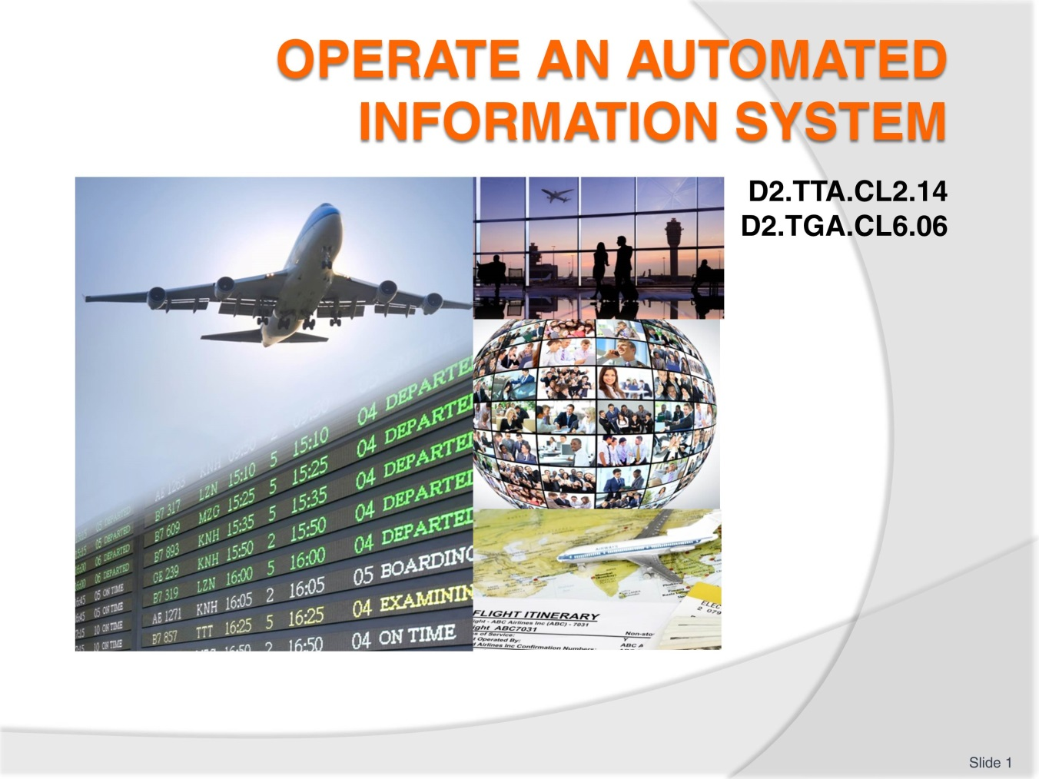
Slide No | Trainer Notes
 | Trainer introduces themselves and the unit.

Slide
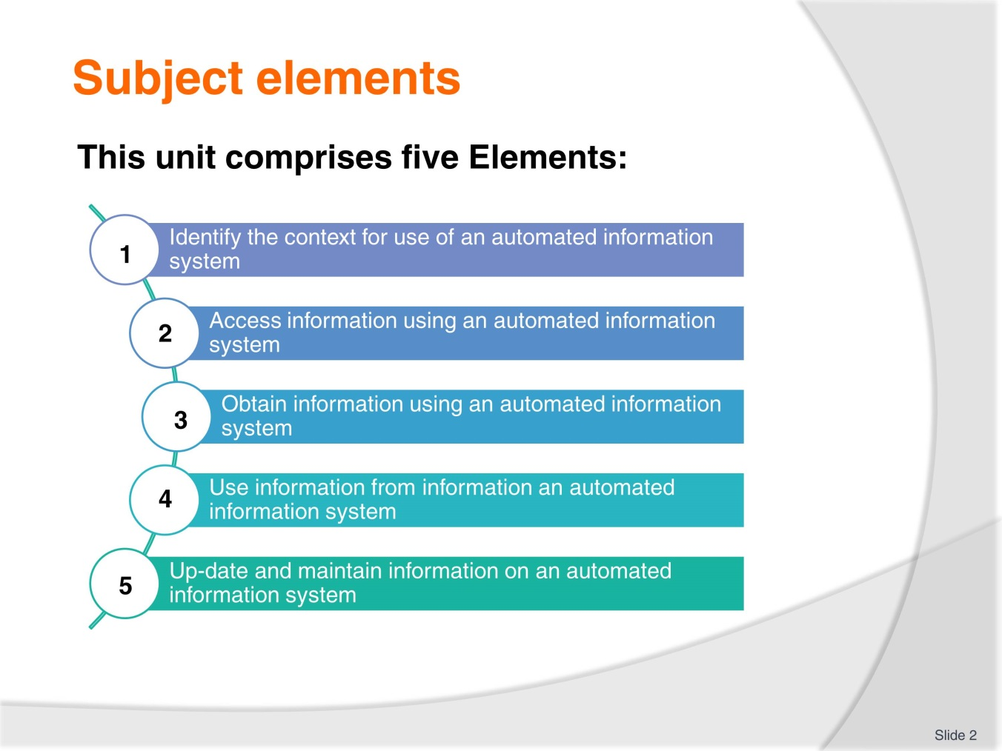
Slide No | Trainer Notes
Trainer advises this Unit comprises five Elements, as listed on the slide explaining:
- Each Element comprises a number of Performance Criteria which will be identified throughout the class and explained in detail
- Trainees can obtain more detail from their Trainee Manual(TM)
- At times the course presents advice and information about various protocols but where their workplace requirements differ to what is presented, the workplace practices and standards, as well as policies and procedures must be observed:
- Discuss housekeeping issues such as times of attendance, expected classroom behaviour, contact details, any resources required such as a calculator
- Explain that the trainees will be assessed and the requirements of those assessments.

Slide
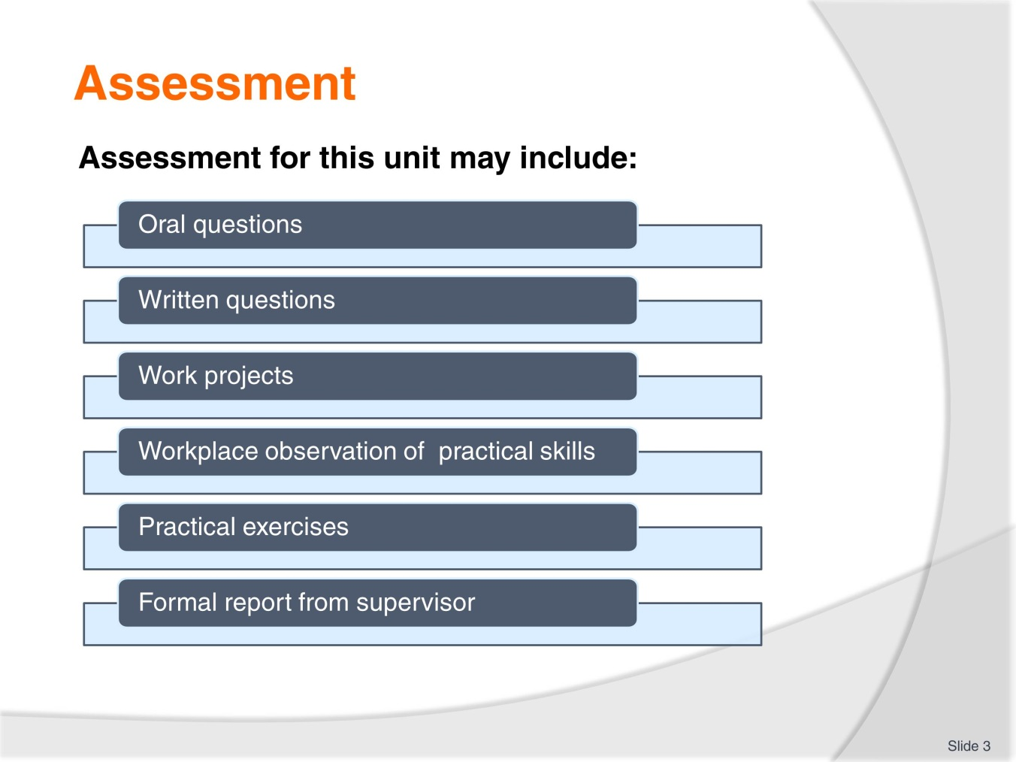
Slide No | Trainer Notes
Trainer advises that assessment for this Unit may take several forms all of which are aimed at verifying they have achieved competency for the Unit as required.
Trainer indicates the methods of assessment that will be applied to them for this Unit.

Slide
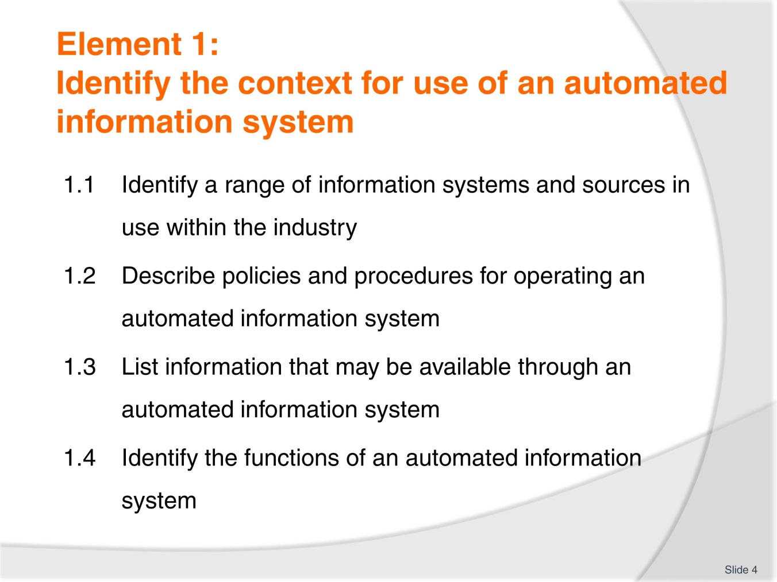
Slide No | Trainer Notes
 | Trainer introduces the four performance criteria which make up Element 1.

Slide
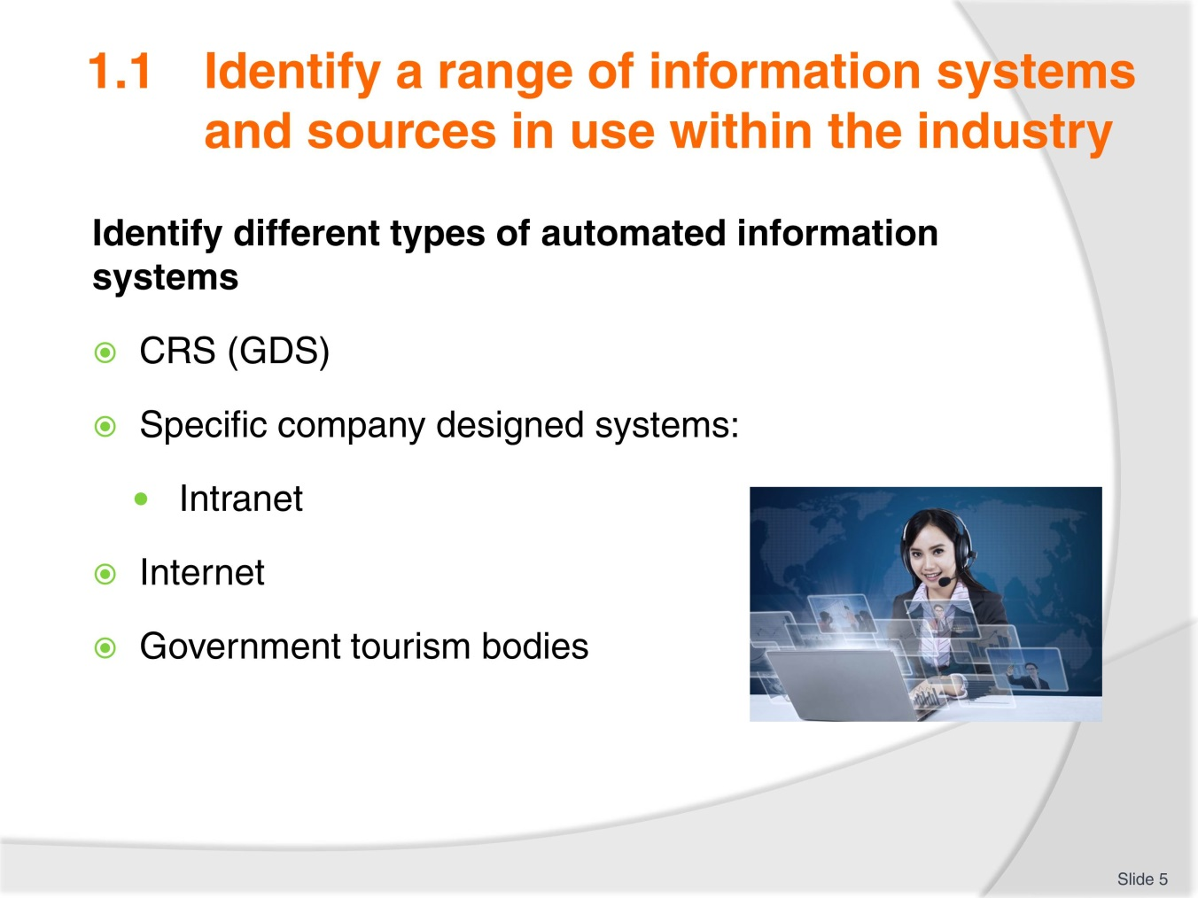
Slide No | Trainer Notes
Working through the associated pages in the Trainee Manual (TM) have discussion about each topic; types of information sourced. Regularity of use:
- (CRS image on next slide)
- You may choose for trainees to conduct searches from various systems if they are available to you
- Complete Activity 1.

Slide
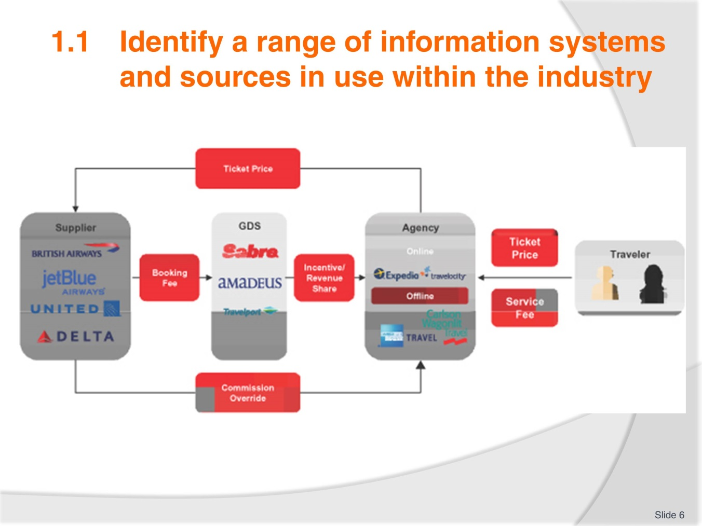
Slide No | Trainer Notes
 | Trainer to lead a class discussion to compile a list of systems and sources.

Slide
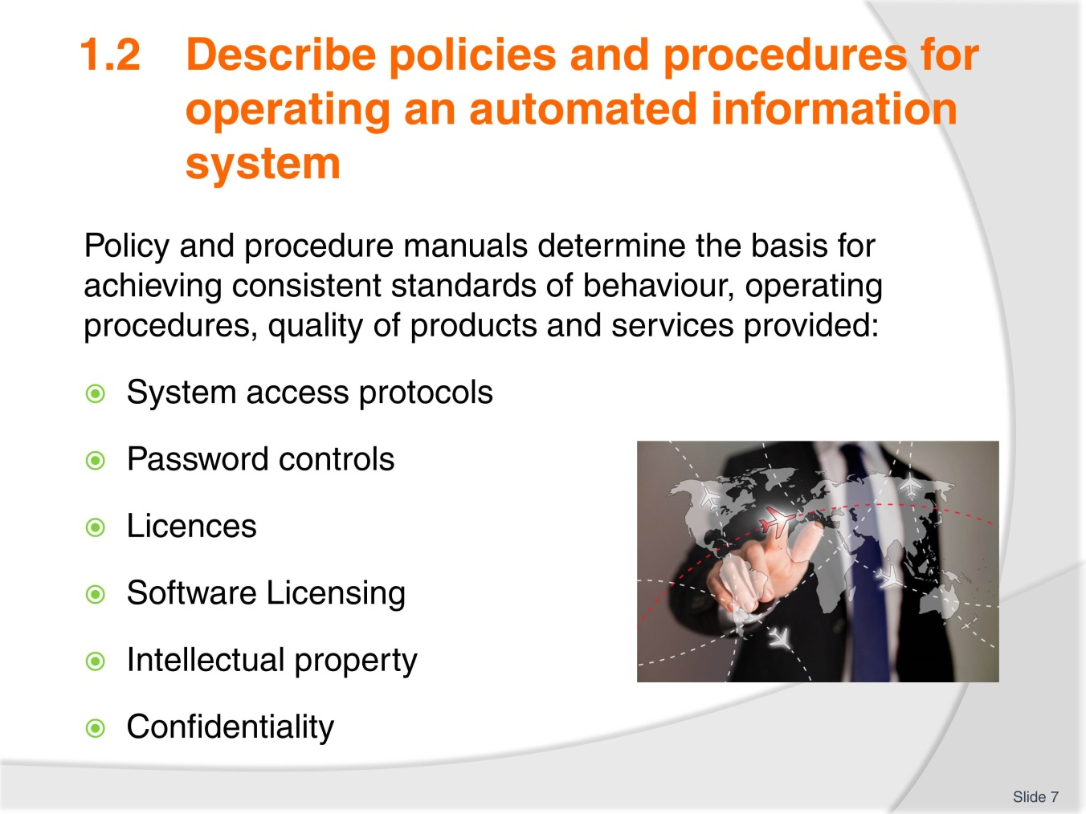
Slide No | Trainer Notes
- Obtain a copy of your IT policy and procedures for comparison
- Work through each of the points in the TM. Compare these notes against what is listed in your IT policy
- Check trainee knowledge and experience in this area – from current/previous workplace
- Ensure trainees are aware of the following:
- Licenses
- Software licensing
- Intellectual property (IP)
- Confidentially laws/requirements.

Slide
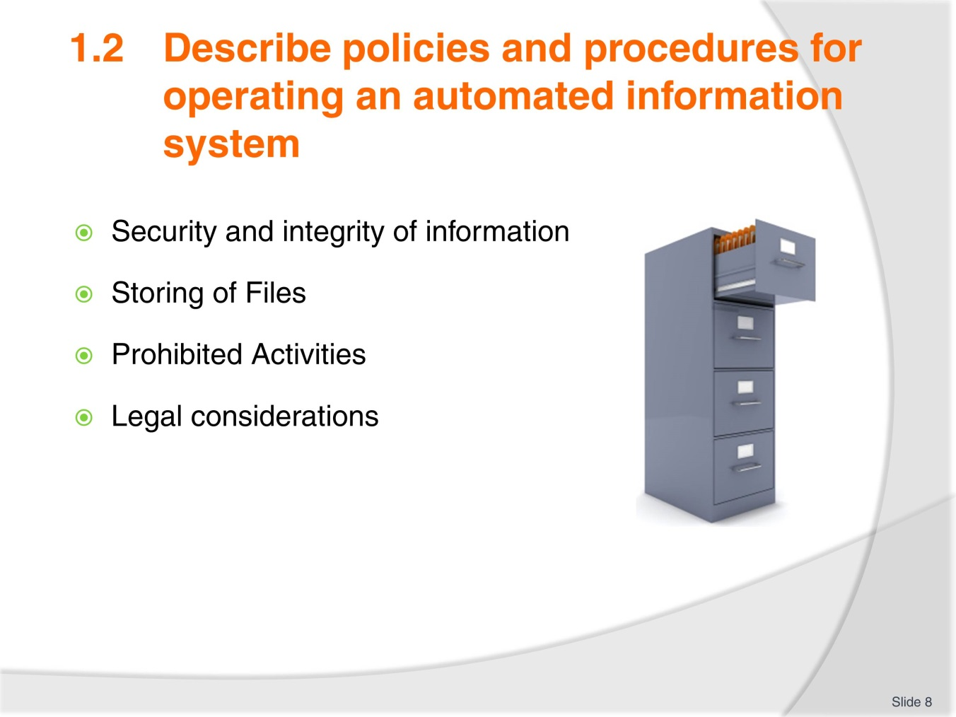
Slide No | Trainer Notes
- From previous slide
- Ensure trainees are aware of the following:
- Licenses
- Software licensing
- Intellectual property (IP)
- Confidentially laws/requirements
- Complete Activity 2.

Slide
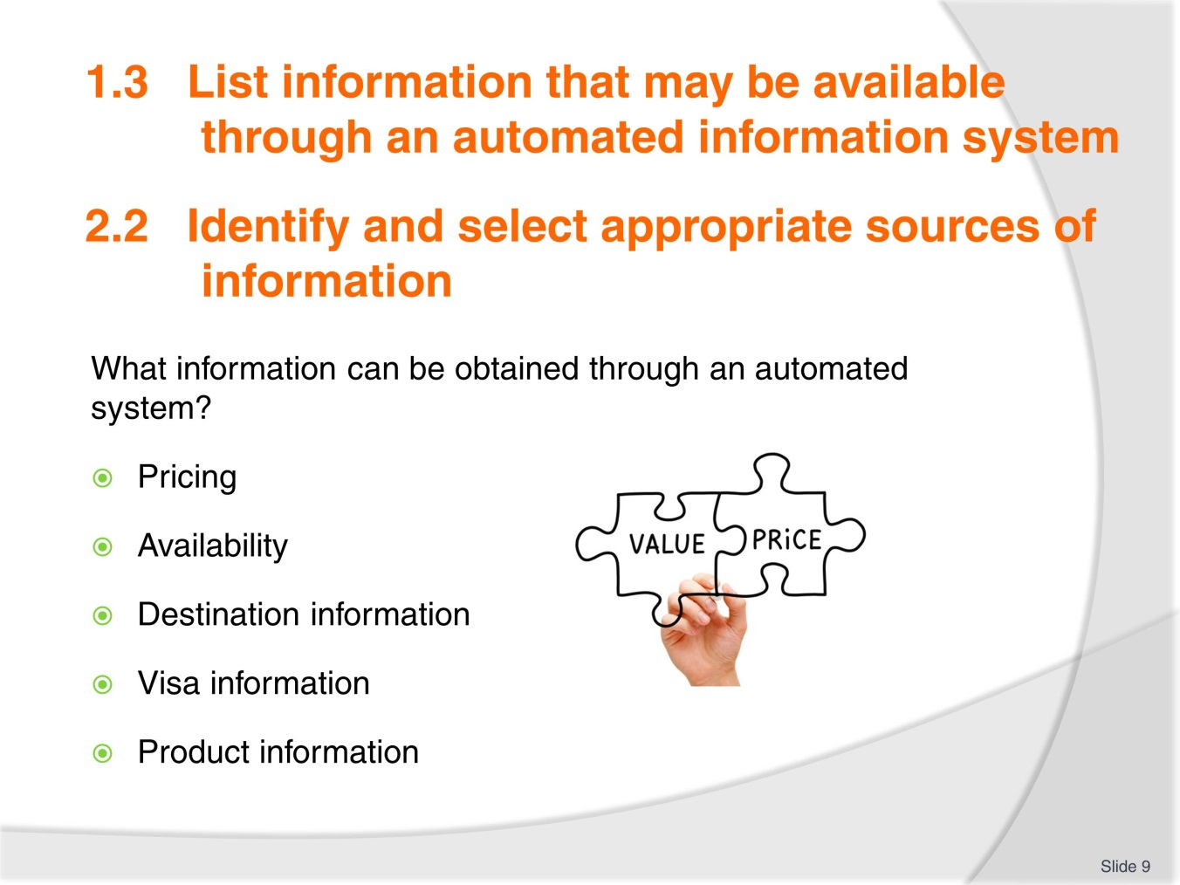
Slide No | Trainer Notes
 | Brainstorm what other information can be obtained. Will one system provide information that another cannot?

Slide
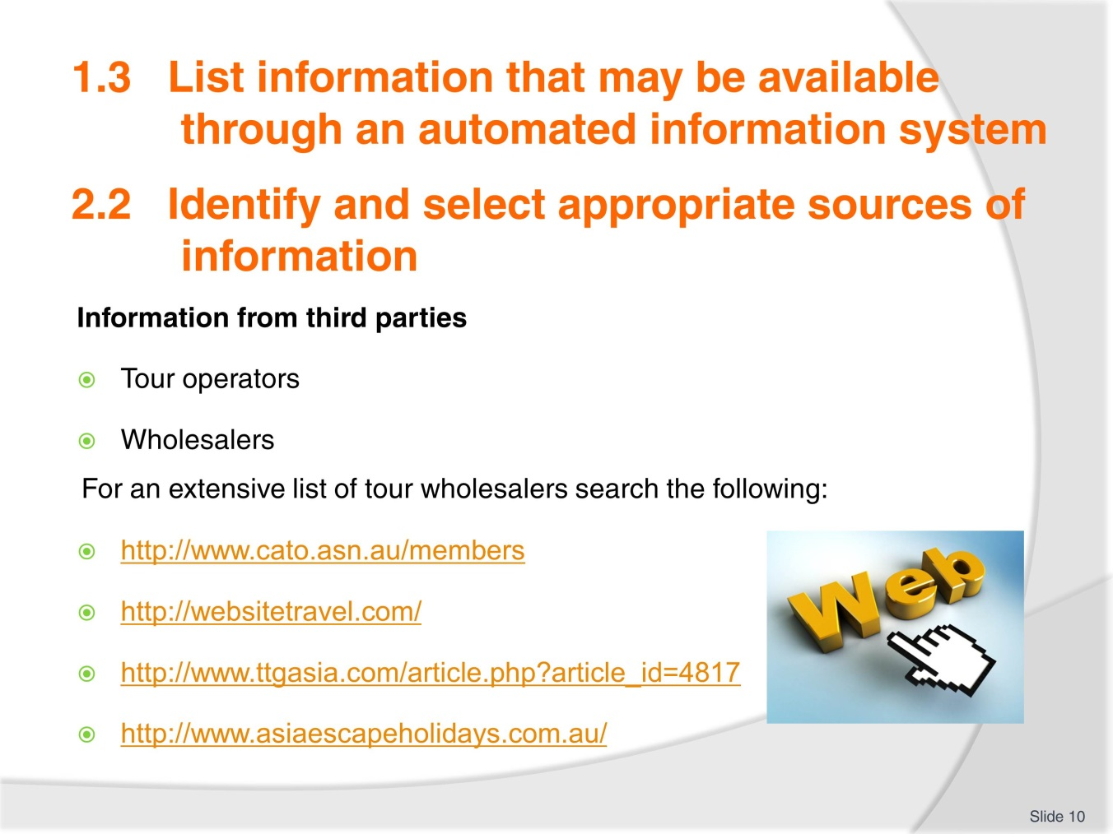
Slide No | Trainer Notes
- Provide information to trainees about the role of tour operators and wholesalers and the services they provide
- Log onto the websites listed in the TM to demonstrate services and offers available.

Slide
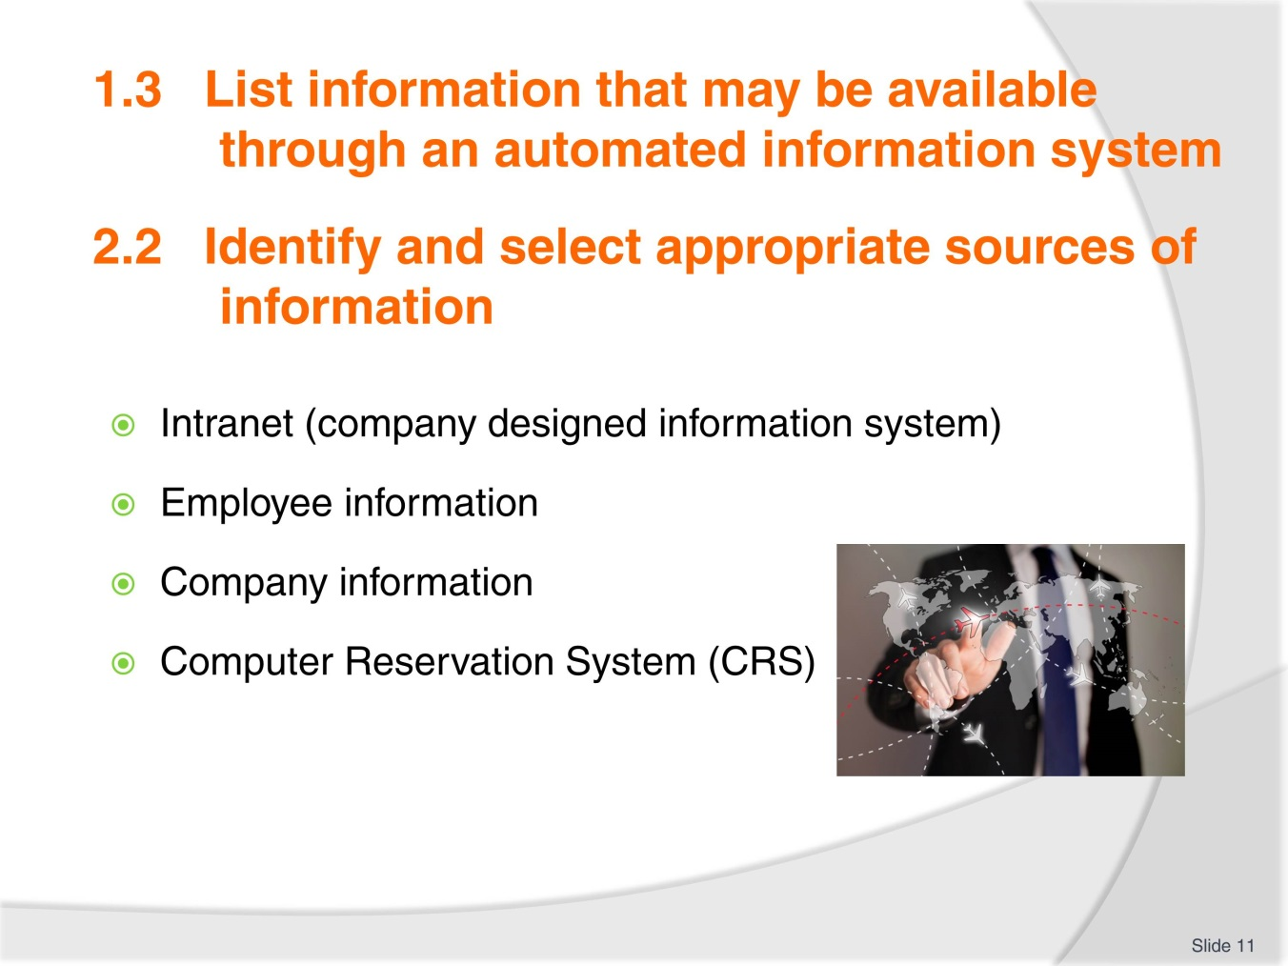
Slide No | Trainer Notes
- Have discussion about company intranets and any trainee knowledge or experience in this area
- Use the internet to demonstrate your own company intranet page and key information areas. (Trainees will need to access the student page for Activity 3.)
- Discuss the many types of information available from a CRS or have trainees brainstorm this on the board. (This is covered in detail on next slide)
- Complete activity 3
- Discuss Activity 4 to ensure trainees understand what is required
- Have trainees present this back to the group.

Slide
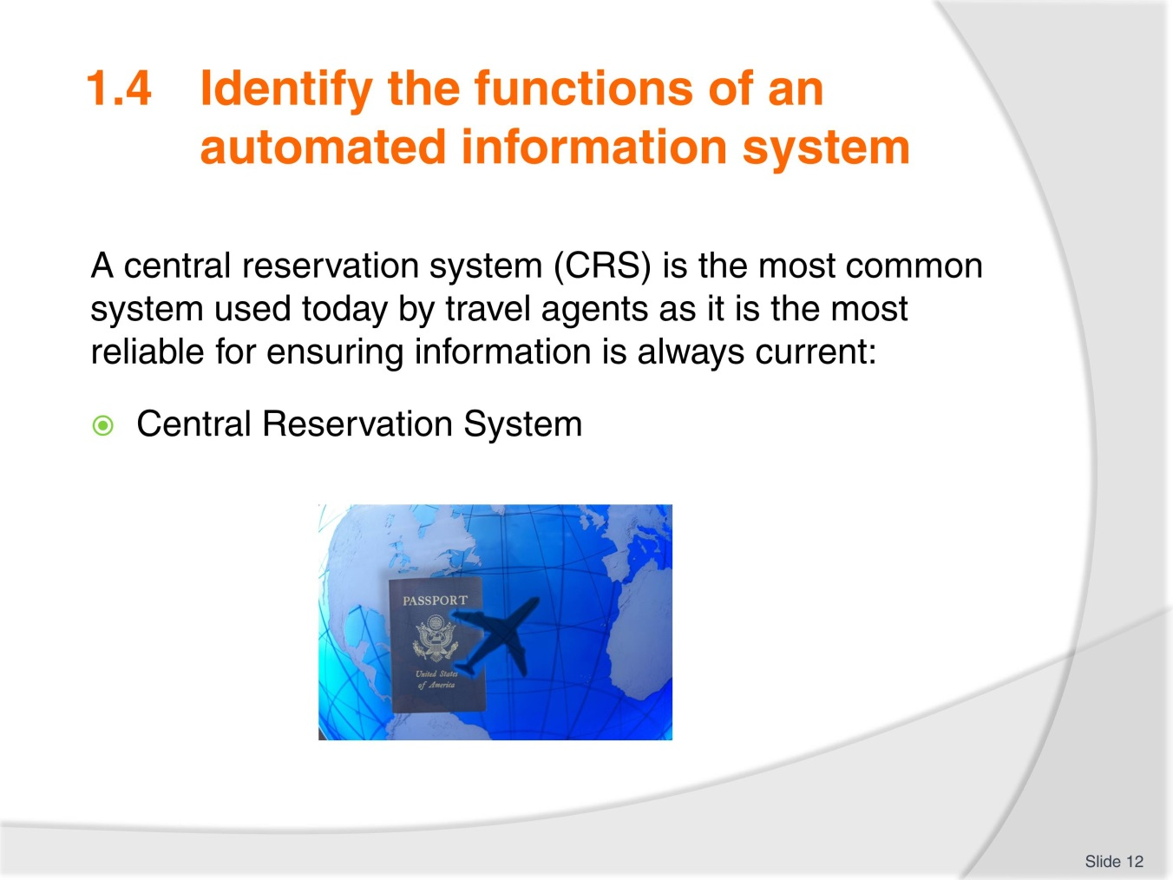
Slide No | Trainer Notes
- Take time to review the index of the Galileo training handbook as this indicates the functions of the system
- Ensure trainees understand all terminology used
- Review the pages in the TM which indicate how information is displayed including hotel and car reservations
- Discuss these pages as necessary.

Slide
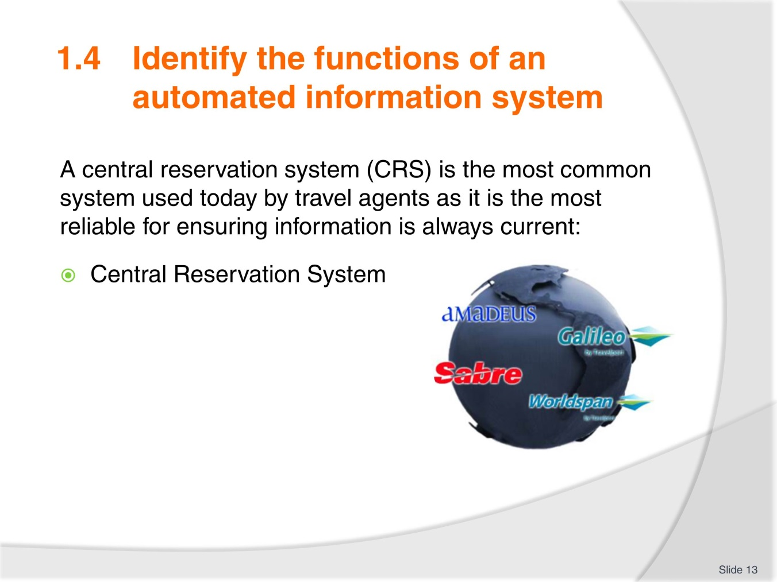
Slide No | Trainer Notes
- Take time to review the index of the Galileo training handbook as this indicates the functions of the system
- Ensure trainees understand all terminology used
- Review the pages in the TM which indicate how information is displayed including hotel and car reservations
- Discuss these pages as necessary.

Slide
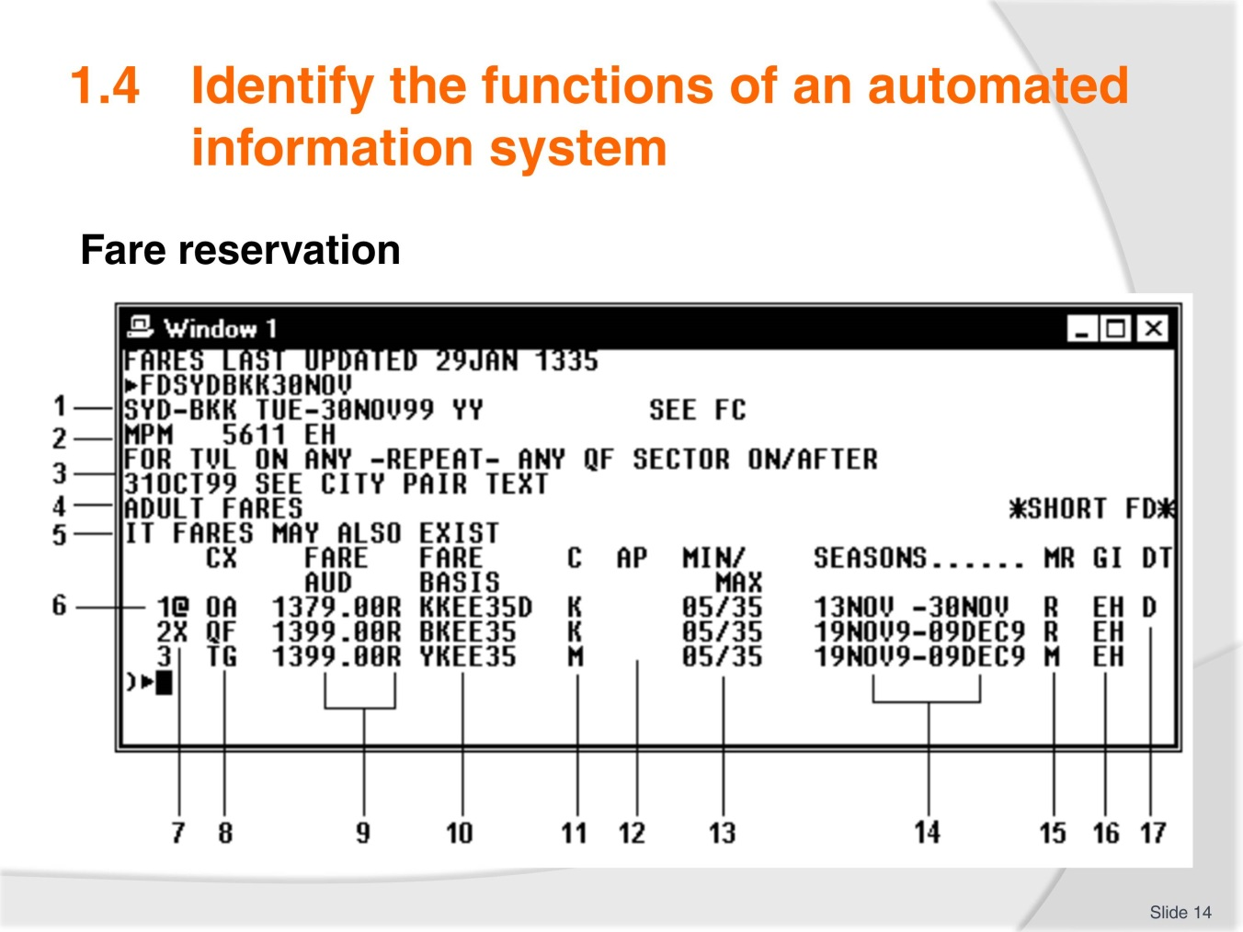
Slide No | Trainer Notes
 | Image from TM. Discuss as necessary.

Slide
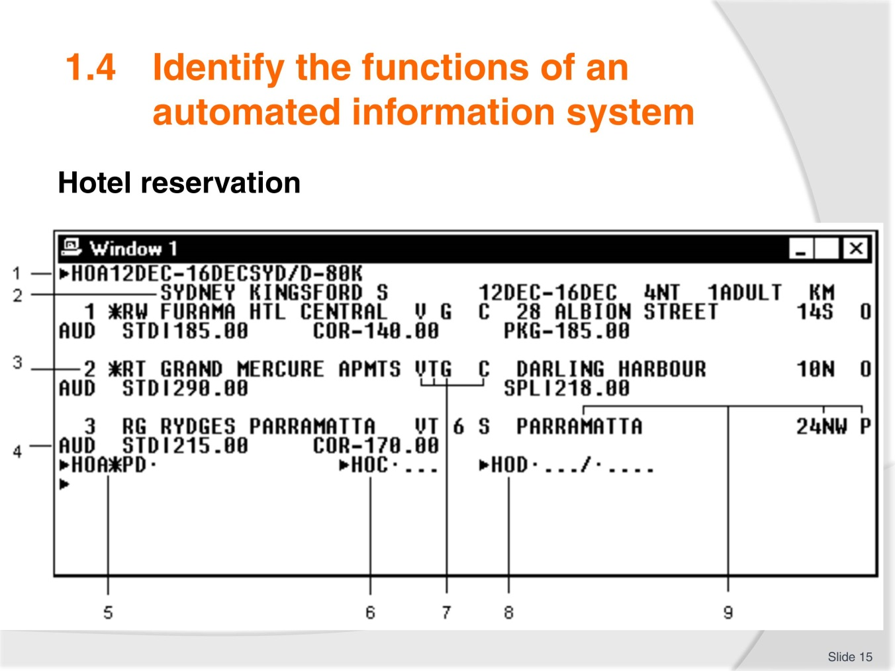
Slide No | Trainer Notes
 | Image from TM. Discuss as necessary.

Slide
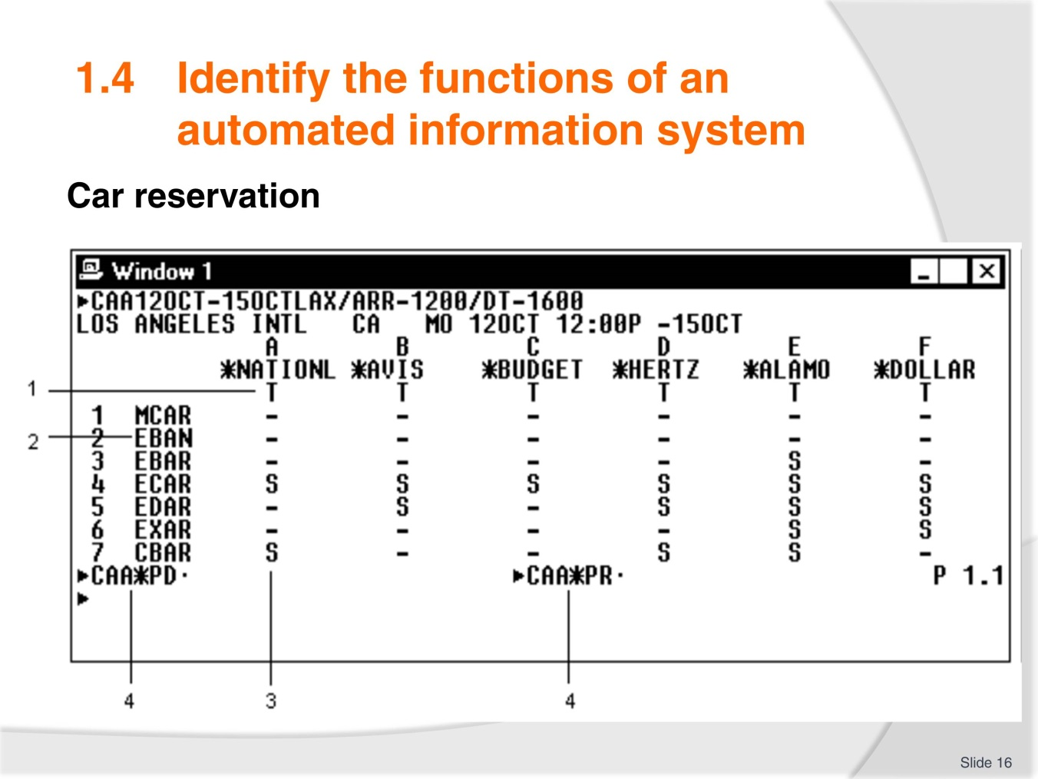
Slide No | Trainer Notes
 | Image from TM. Discuss as necessary.

Slide
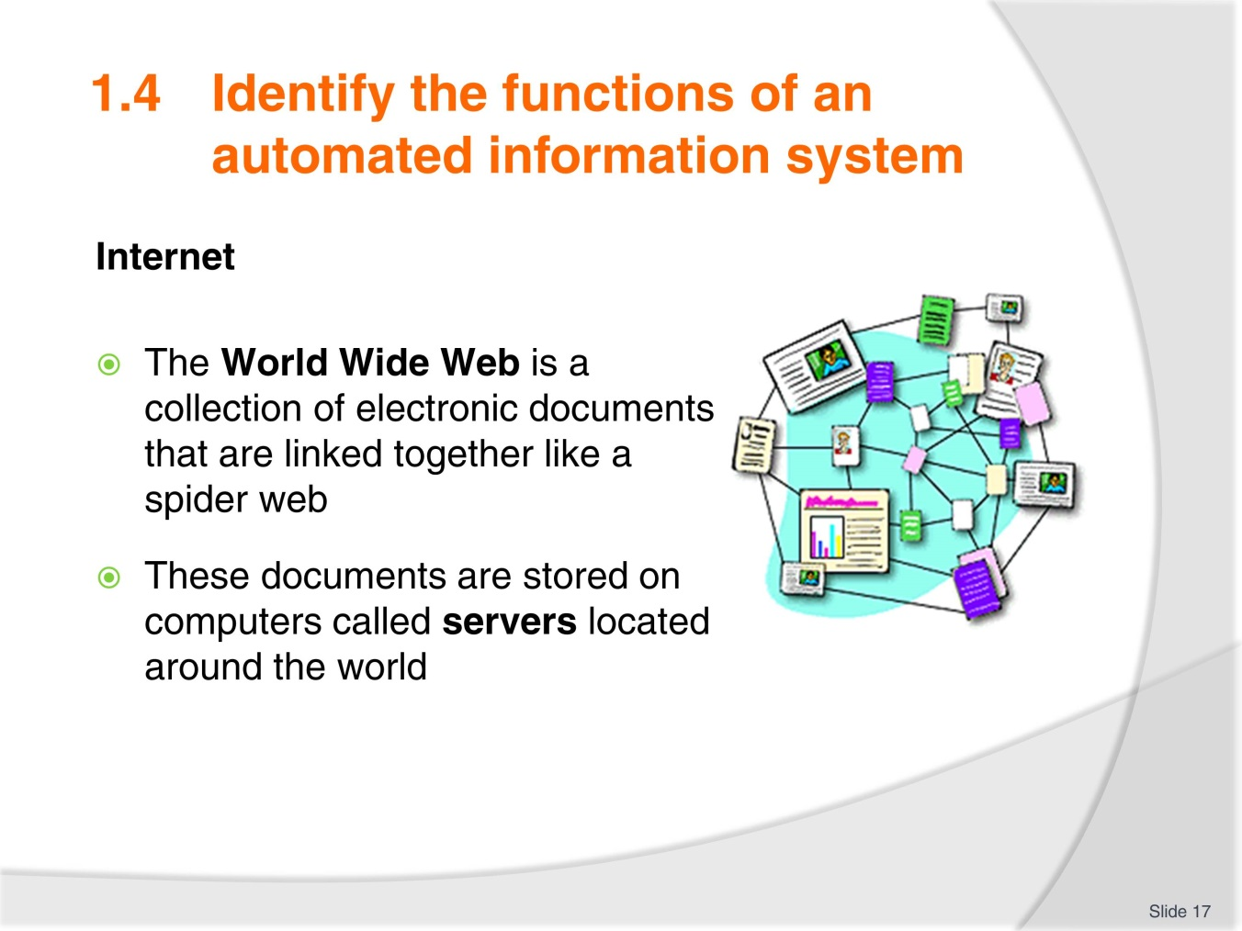
Slide No | Trainer Notes
- Take time to review the index of the Galileo training handbook as this indicates the functions of the system
- Ensure trainees understand all terminology used
- Review the pages in the TM which indicate how information is displayed including hotel and car reservations
- Discuss these pages as necessary.

Slide
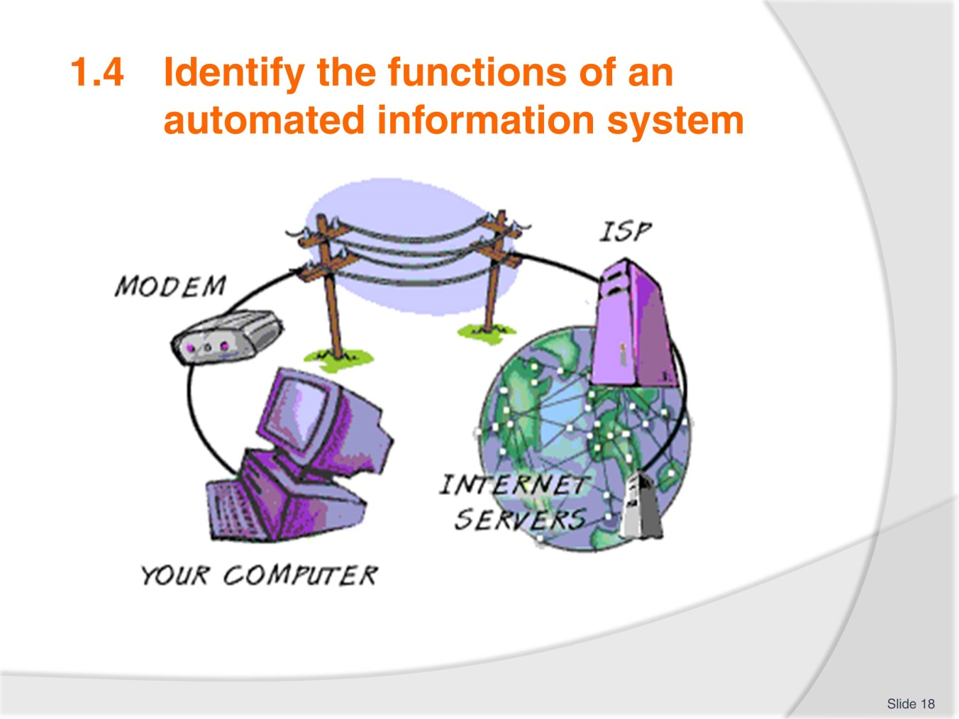
Slide No | Trainer Notes
 | A simple visual image of how it all works.

Slide
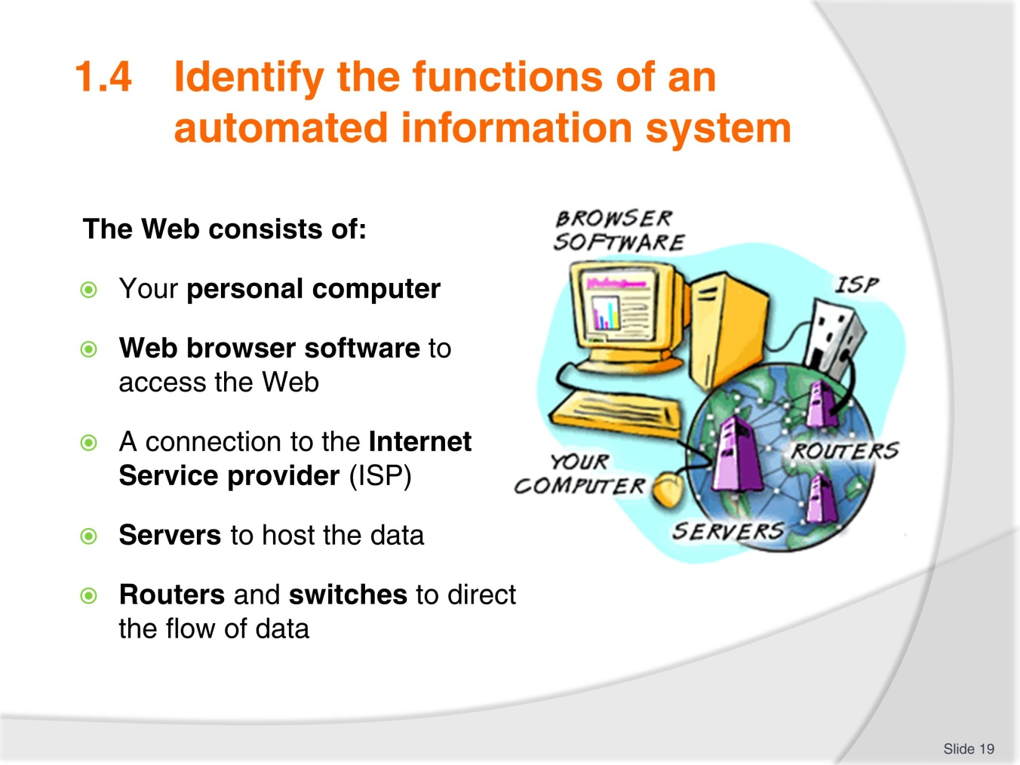
Slide No | Trainer Notes
 | Ensure trainees are familiar with terminology.

Slide
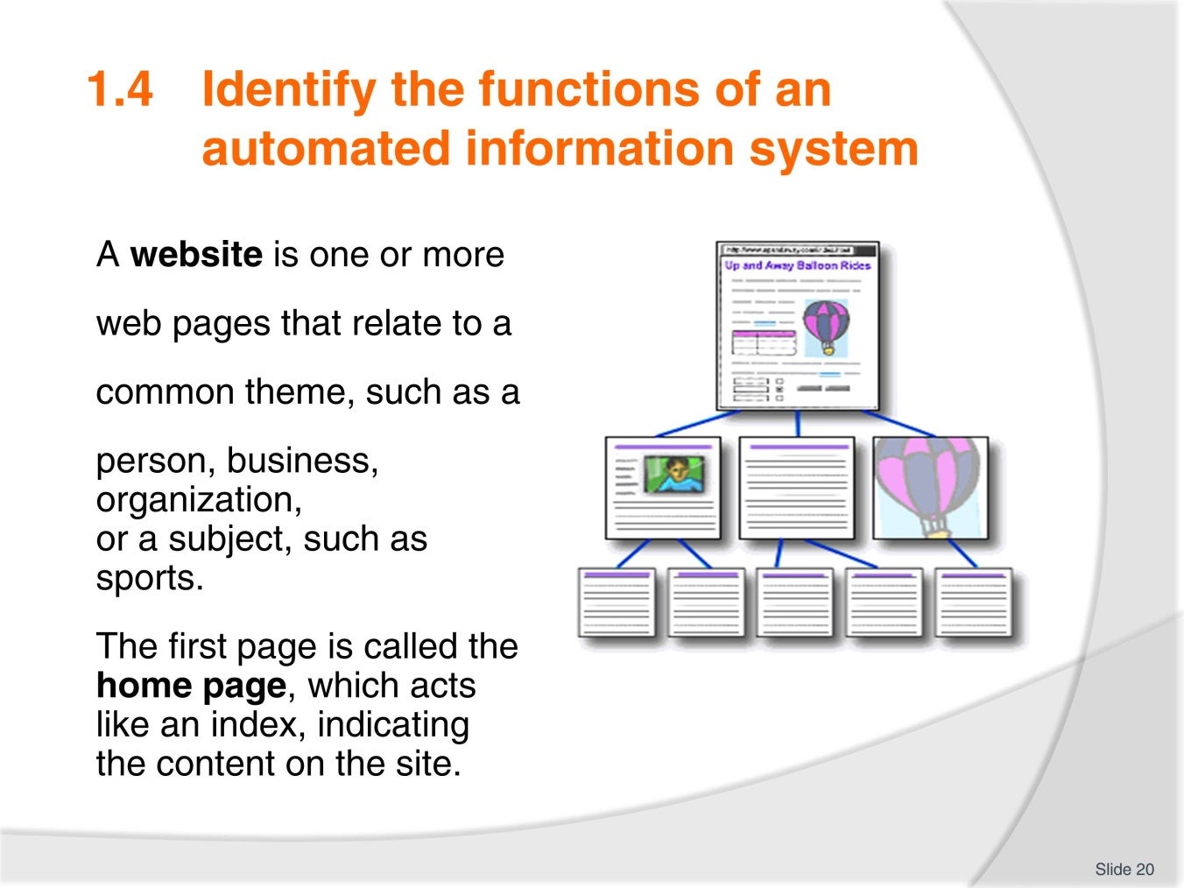
Slide No | Trainer Notes
 | Ensure trainees are familiar with terminology.

Slide
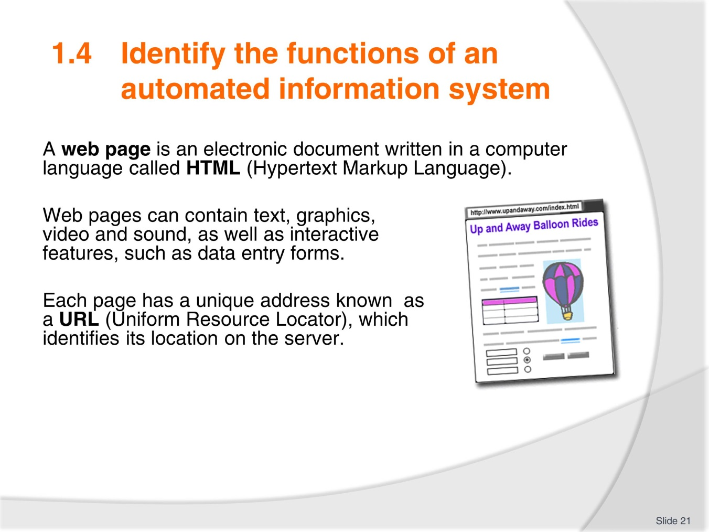
Slide No | Trainer Notes
 | Discuss as necessary. Bring attention to terminology.

Slide
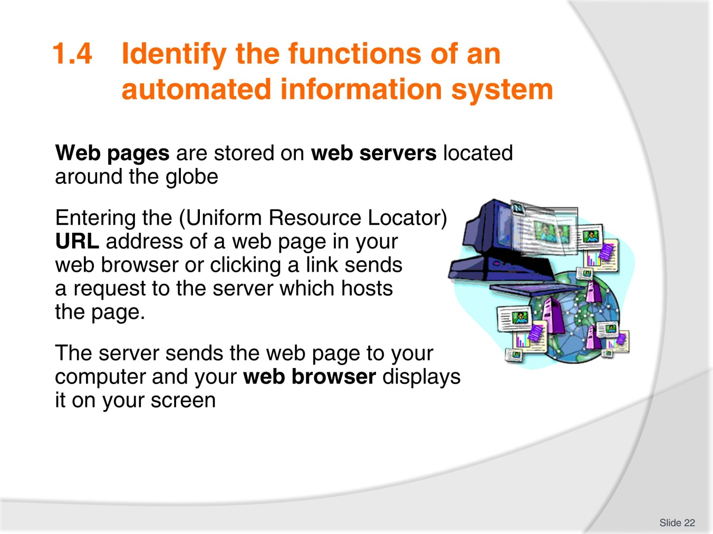
Slide No | Trainer Notes
 | Discuss as necessary.

Slide
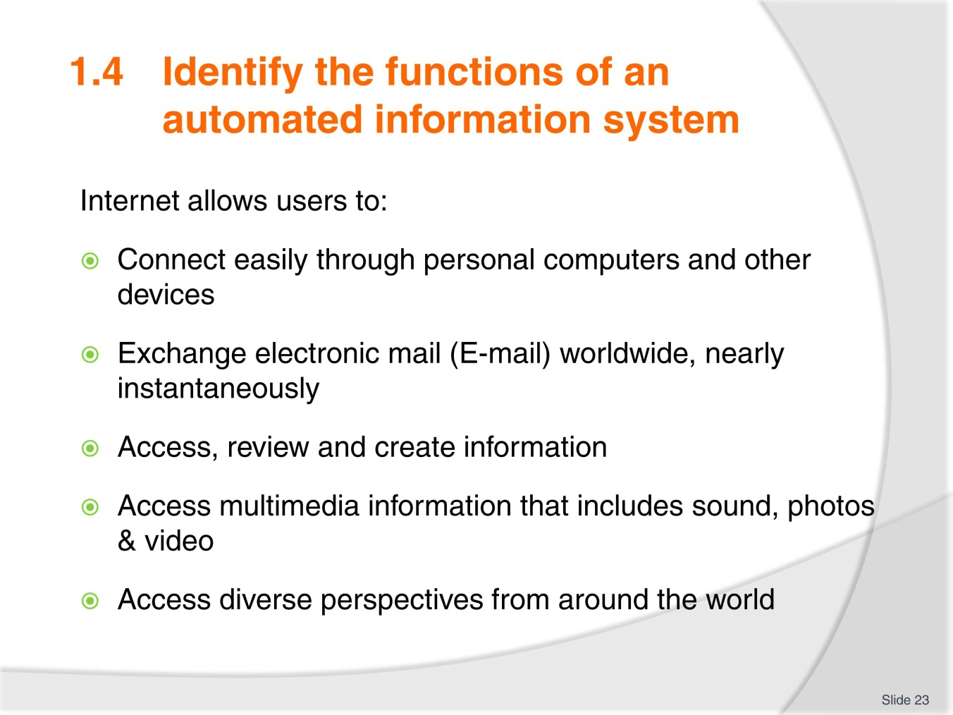
Slide No | Trainer Notes
 | Lead a class discussion on student’s use of the internet in their personal lives; then take the discussion to their professional lives.

Slide
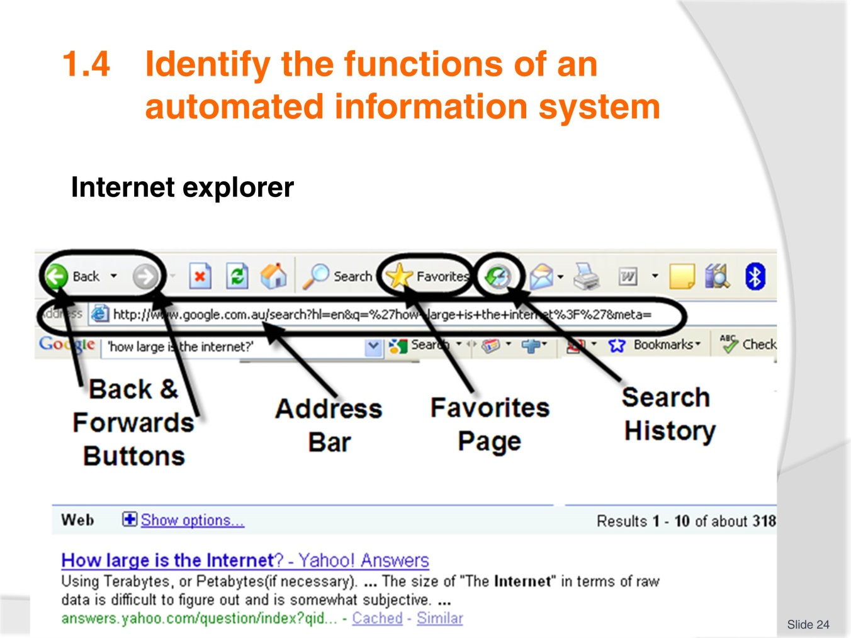
Slide No | Trainer Notes
- It is likely most trainees will be familiar with this content. If so, use this opportunity to have them explain their understanding
- Ensure everyone understands these functions as computer skills can vary greatly.

Slide
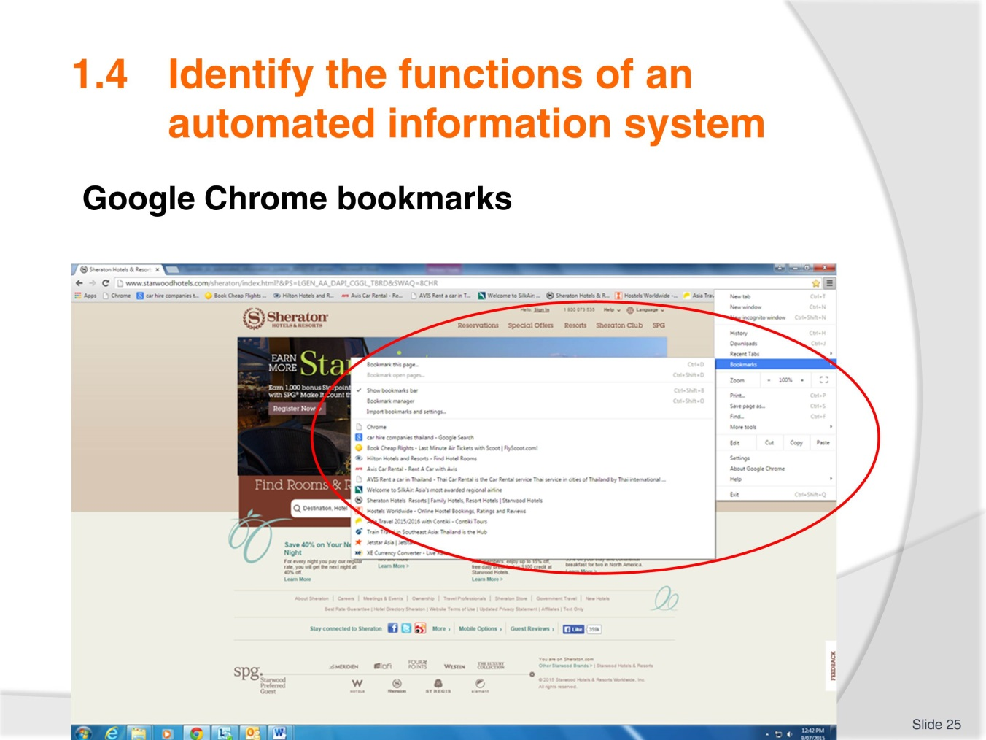
Slide No | Trainer Notes
 | Discuss as needed. Compare against program in use in your workplace or study area.

Slide
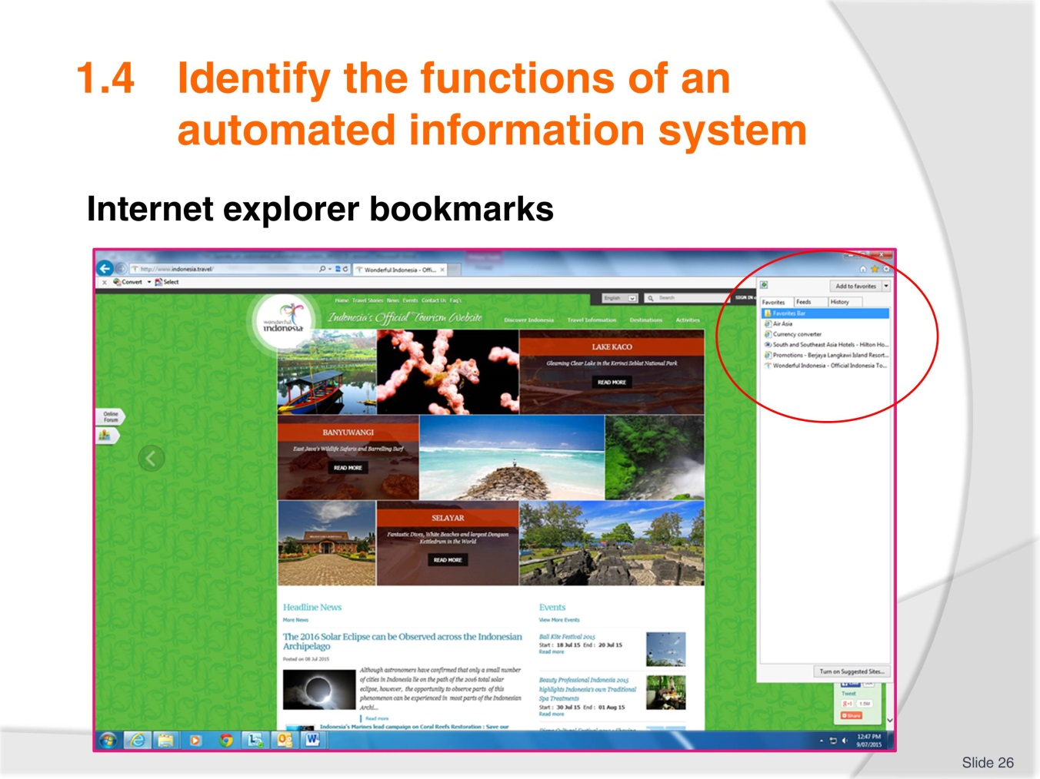
Slide No | Trainer Notes
 | Discuss as needed. Compare against program in use in your workplace or study area.

Slide
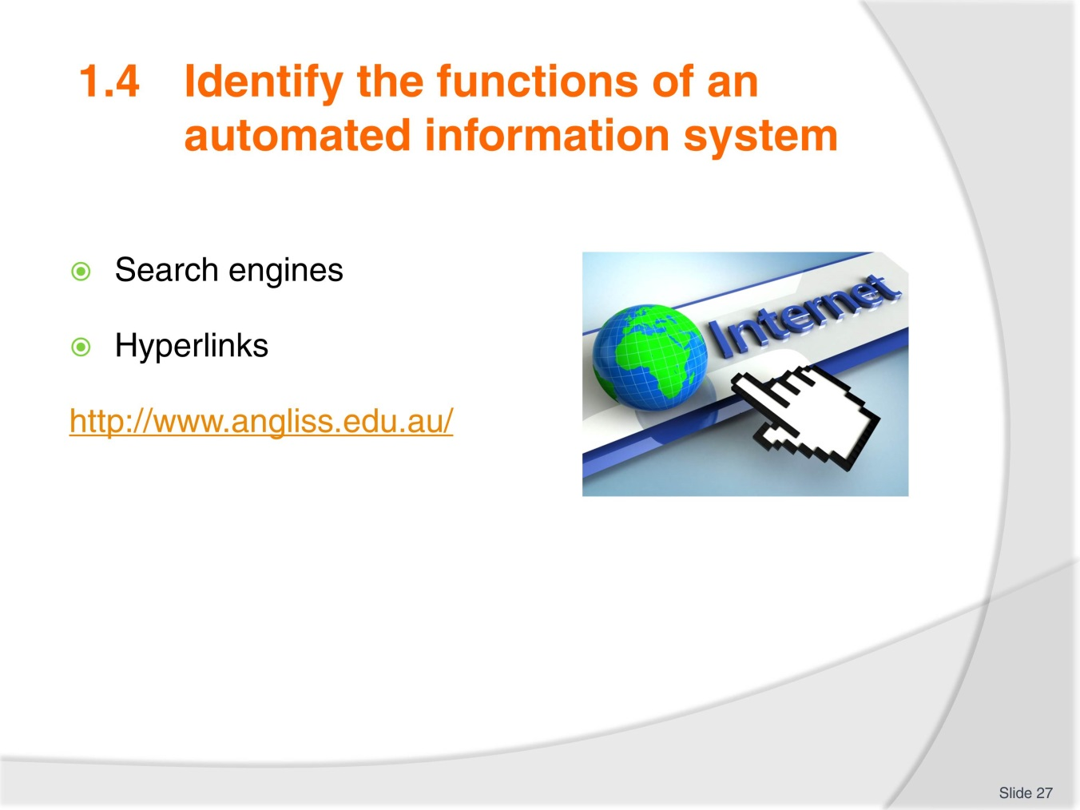
Slide No | Trainer Notes
- Access this web page will take you to the image displayed in the TM in order to demonstrate the hyperlinks. Many trainees will already be familiar with this function
- Complete Activity 5.

Slide
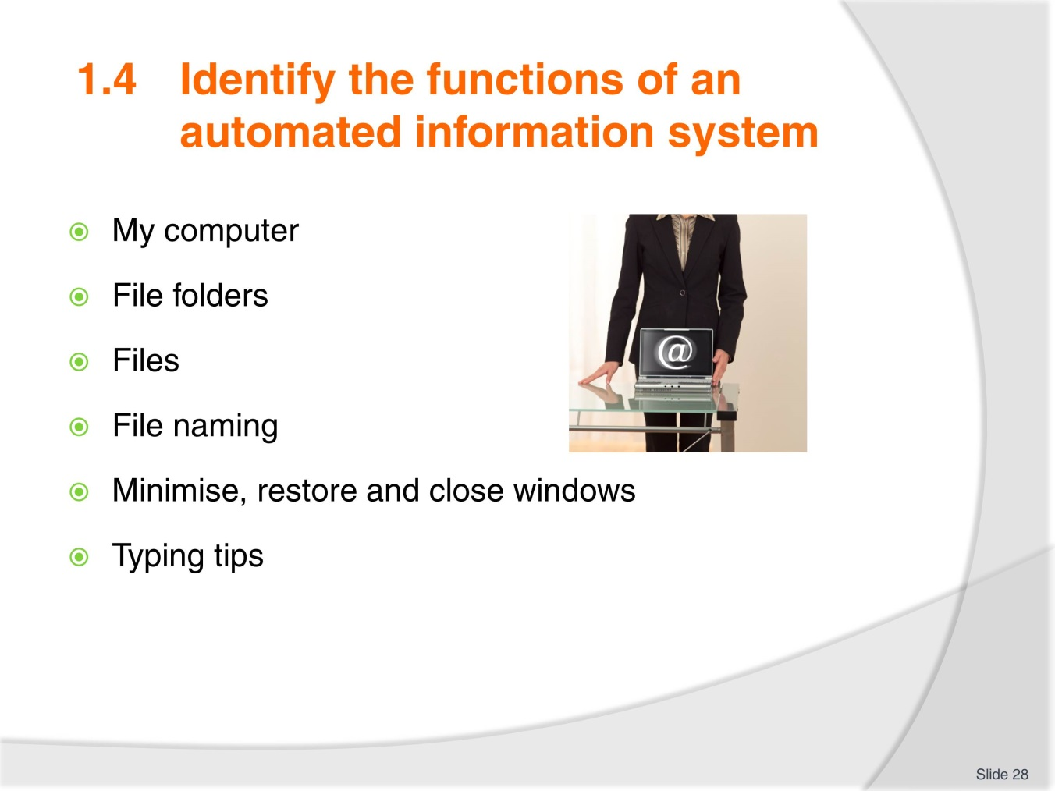
Slide No | Trainer Notes
Again, it is likely trainees will be familiar with this content however take time to ensure no one is left behind.
After reviewing the information ask trainees (even if they thought they knew it all) if they were able to learn one new thing they didn’t know before, no matter how small:
- Ensure all work projects have been completed and handed into trainer ensuring cover page details are attached for assessment tracking
- Review the summary page for Element 1 to confirm what has been completed for this element.

Slide
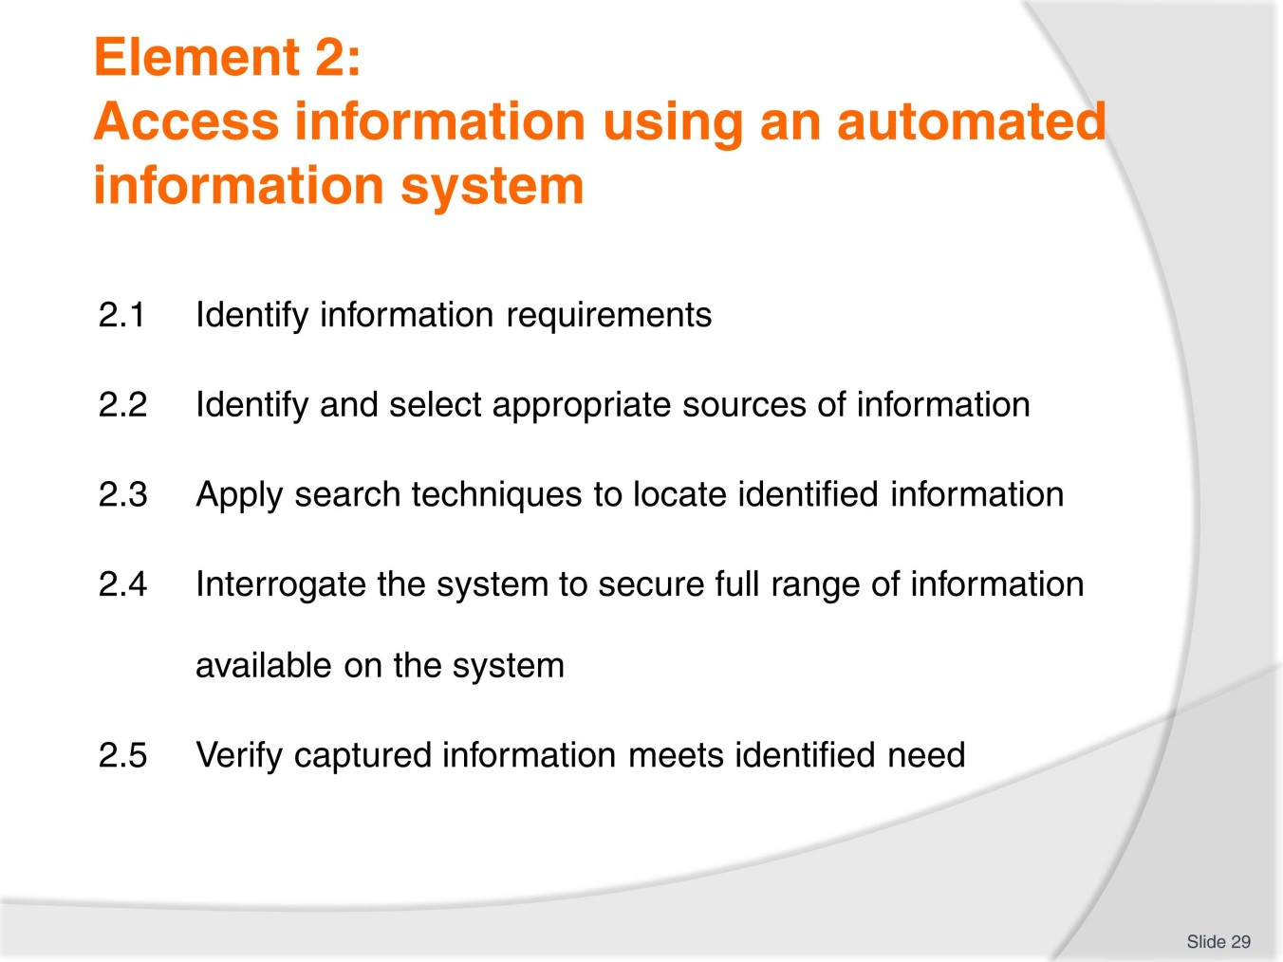
Slide No | Trainer Notes
 | Introduce the five performance criteria which make up Element 2.

Slide
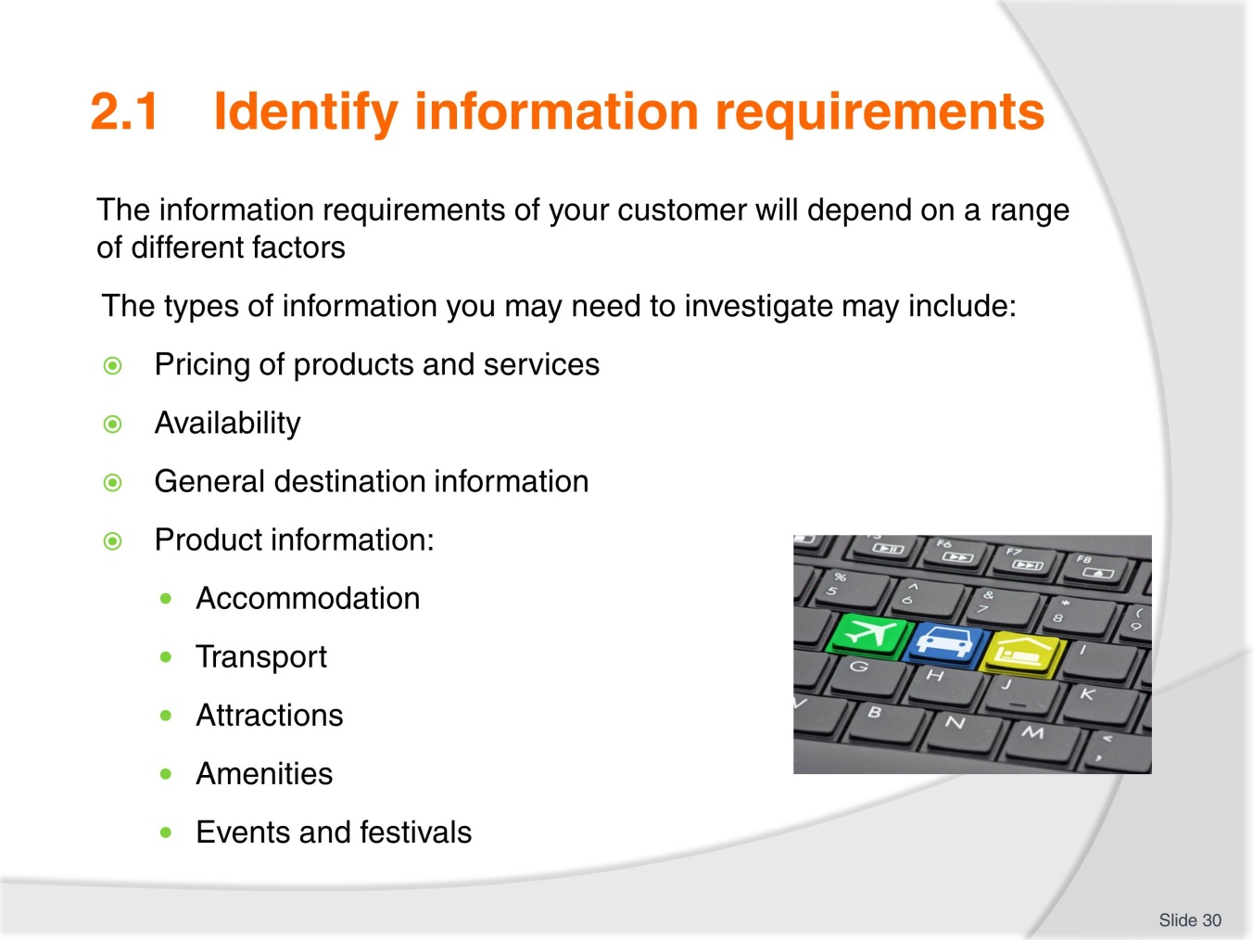
Slide No | Trainer Notes
- Can trainees add anything more to this list?
- Refer to the example in the TM of differing client needs.

Slide
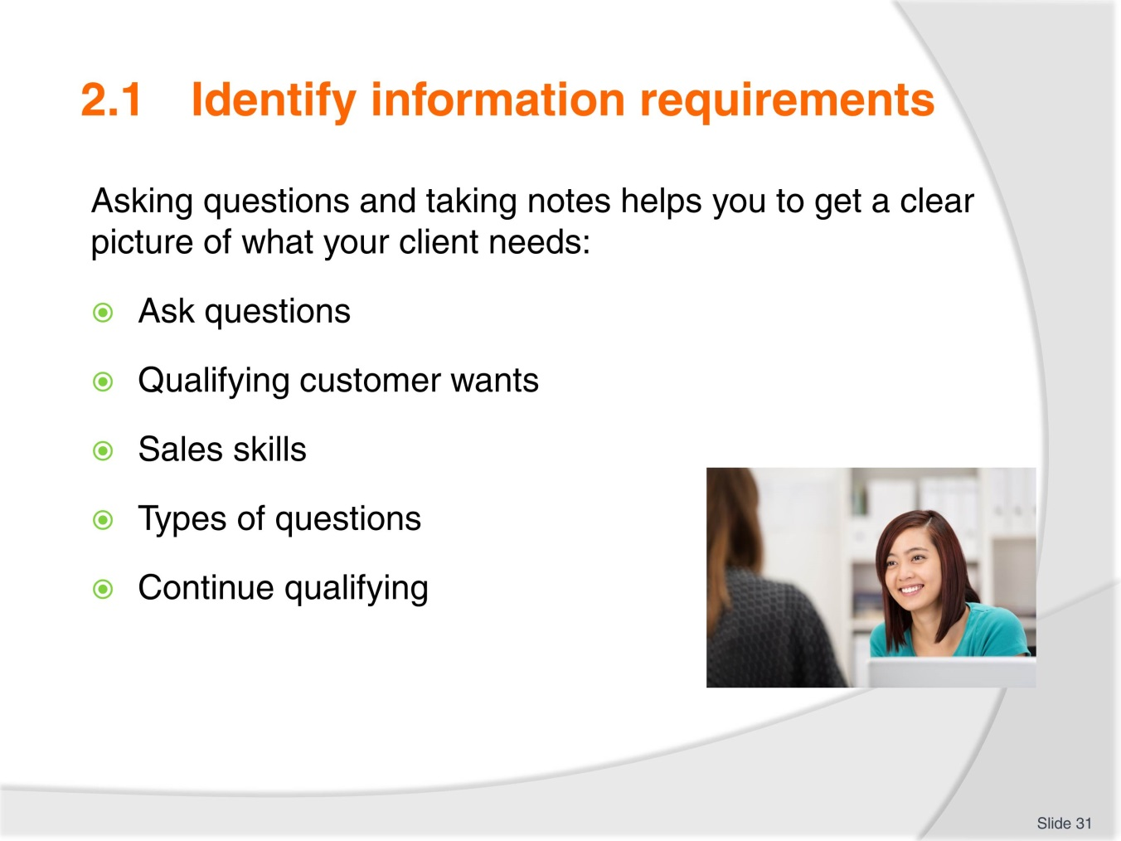
Slide No | Trainer Notes
- Take time to discuss customer service skills
- Refer to the example for consideration in TM
- Each client is different
- Discuss sales skills required when dealing with initial enquiries and clarifying wants and needs. Types of questions to use
- Provide examples of how to phrase questions to obtain more in-depth answers
- Importance of continuing to qualify client wants and needs to gain their satisfaction
- Role play in pairs or small groups a client enquiry and practice asking suitable questions to qualify client preference and offer suitable recommendation
- Complete Activity 6.

Slide
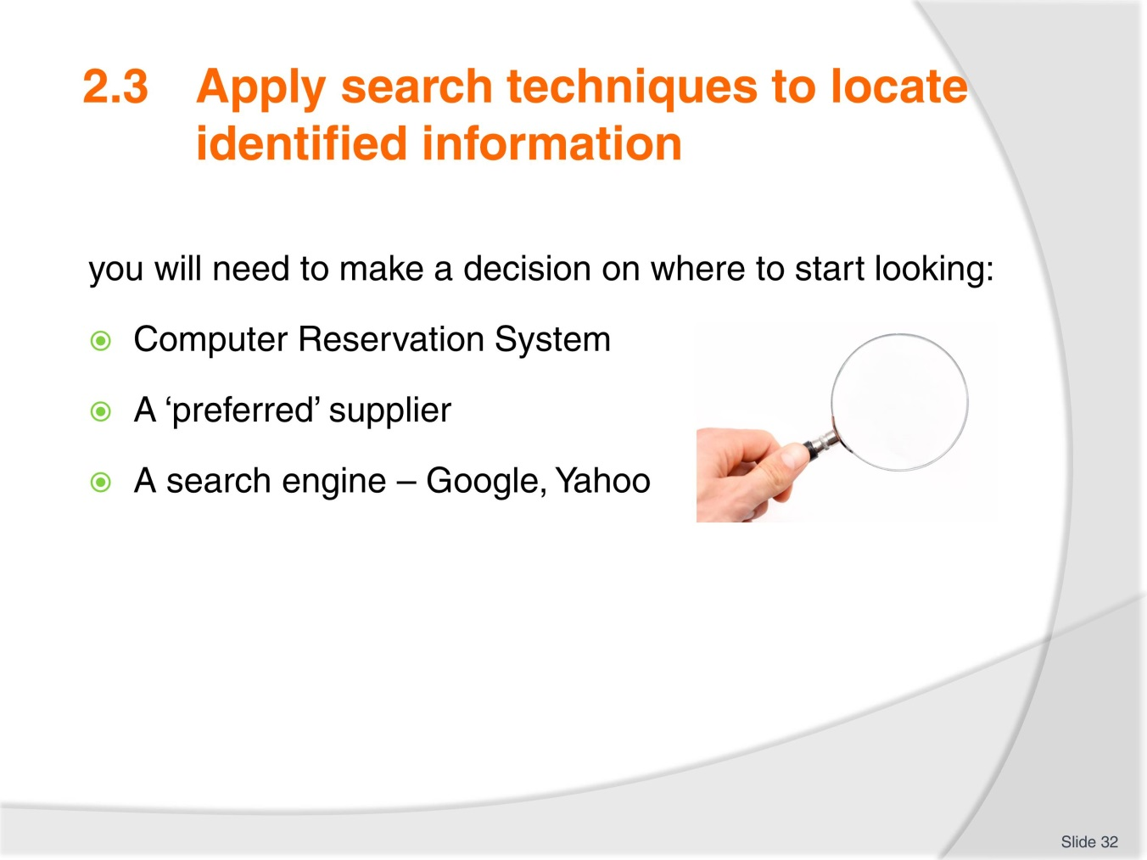
Slide No | Trainer Notes
- Share your experience with trainees on how to best approach enquiries and which search methods might be a best first approach. Ask trainees to share any experience they may have
- Enquire if trainees have a preferred search engine and why it is so
- Review the 5 most popular search engines in TM
- Review making an enquiry in a search engine and the results presented. If you have access to the internet conduct a different enquiry for the group and interpret the results page for them
- Answer any questions trainees may have about this before asking them to
- Complete Activity 7.

Slide
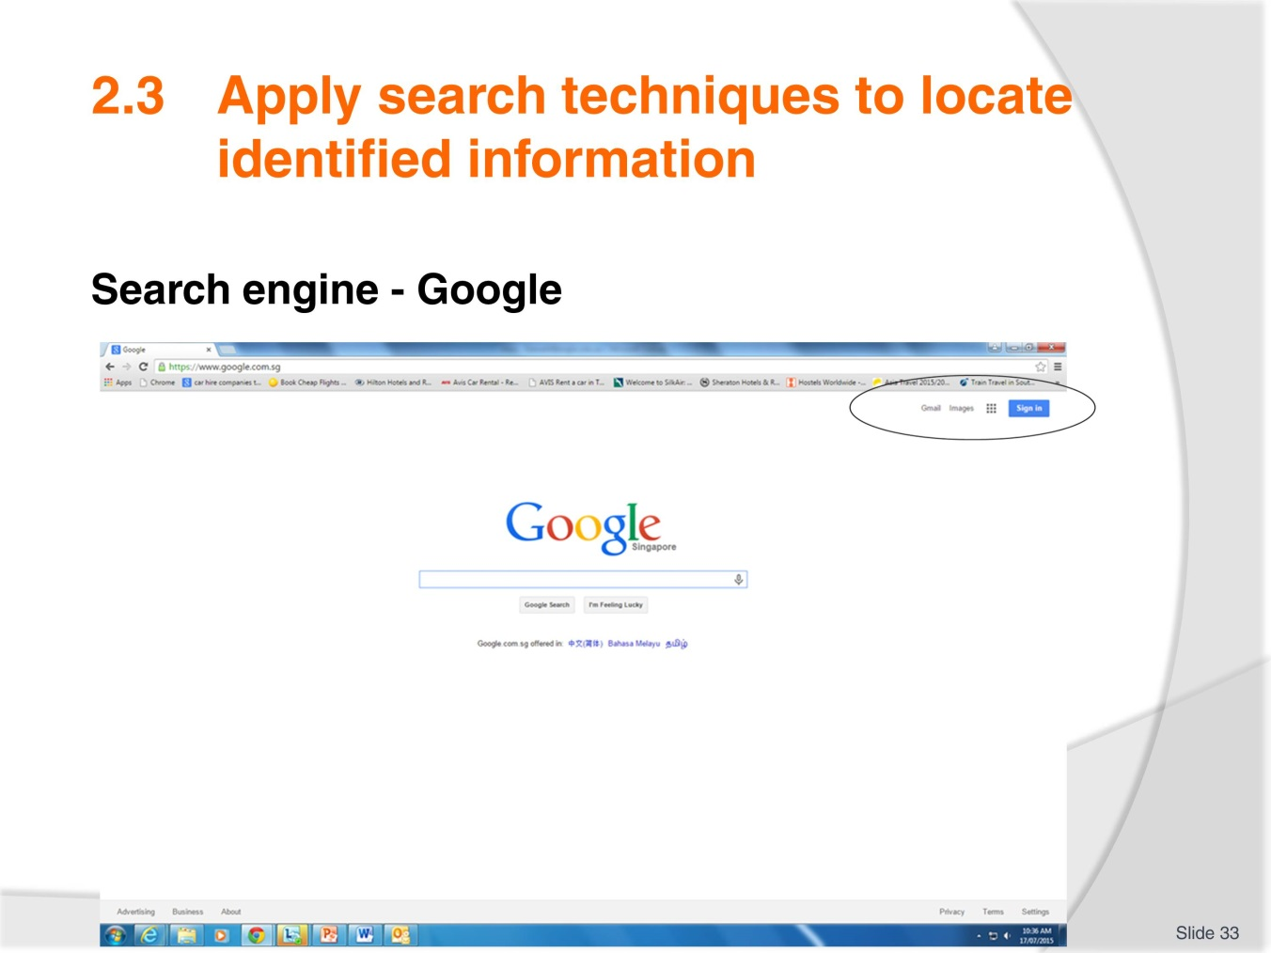
Slide No | Trainer Notes
 | Discuss as needed. Select images as needed.

Slide
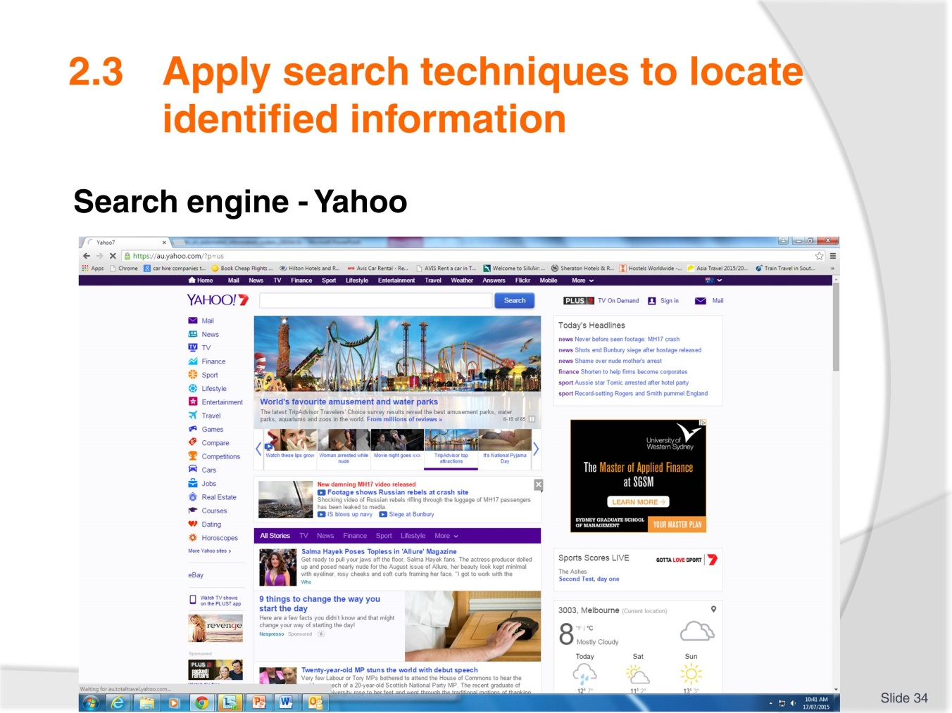
Slide No | Trainer Notes
 | If access to internet is available, enter a search topic to demonstrate how to access web pages and images.

Slide
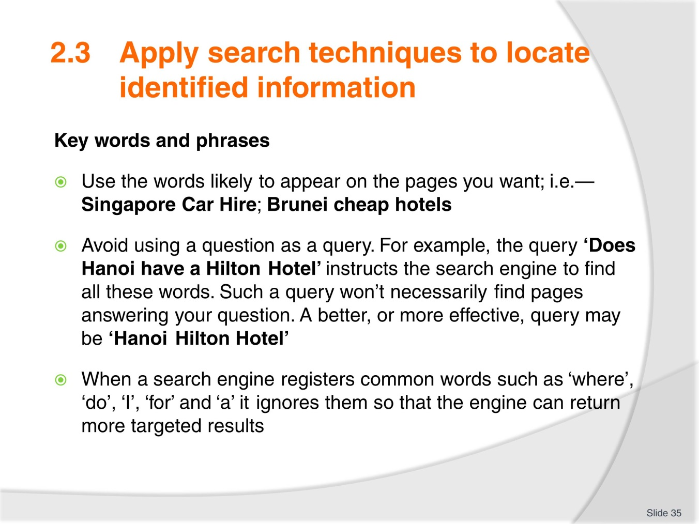
Slide No | Trainer Notes
 | Share your experience with trainees on phrasing enquiries and discuss further as needed.

Slide
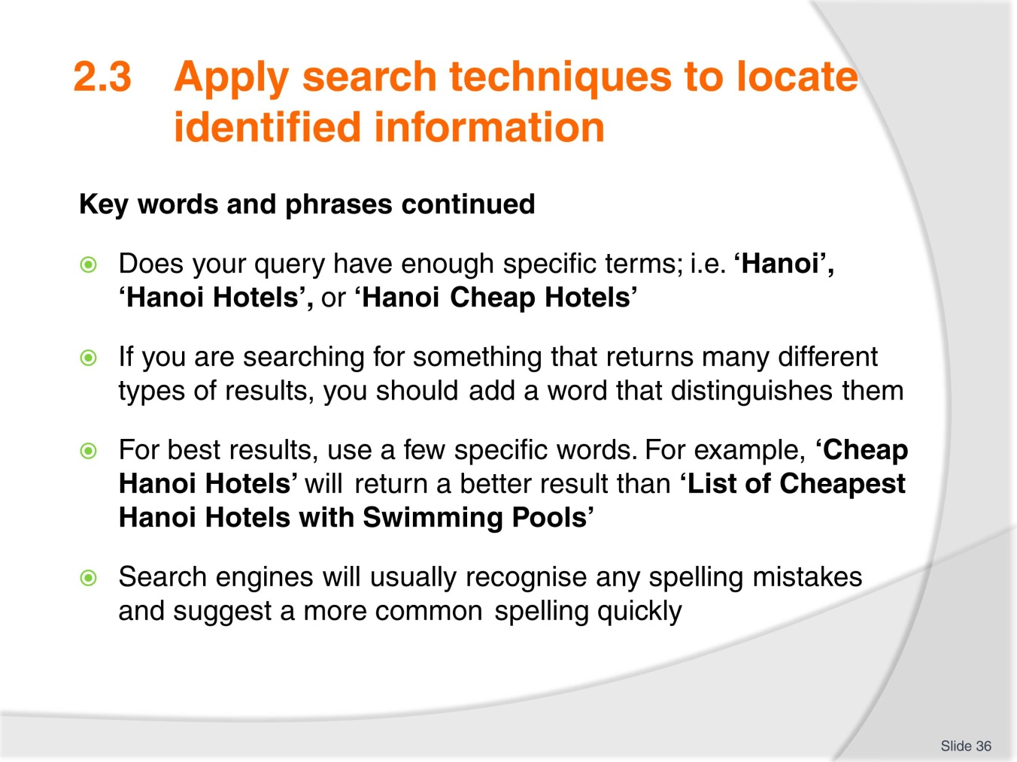
Slide No | Trainer Notes
- Continued from previous slide
- Ask trainees to consider their search enquiry phrase or key words for Activity 8. Provide a time allowance for completion
- Complete Activity 8. Once completed randomly ask for answers to each question. Did anyone approach the question differently? Which search engine was used?

Slide
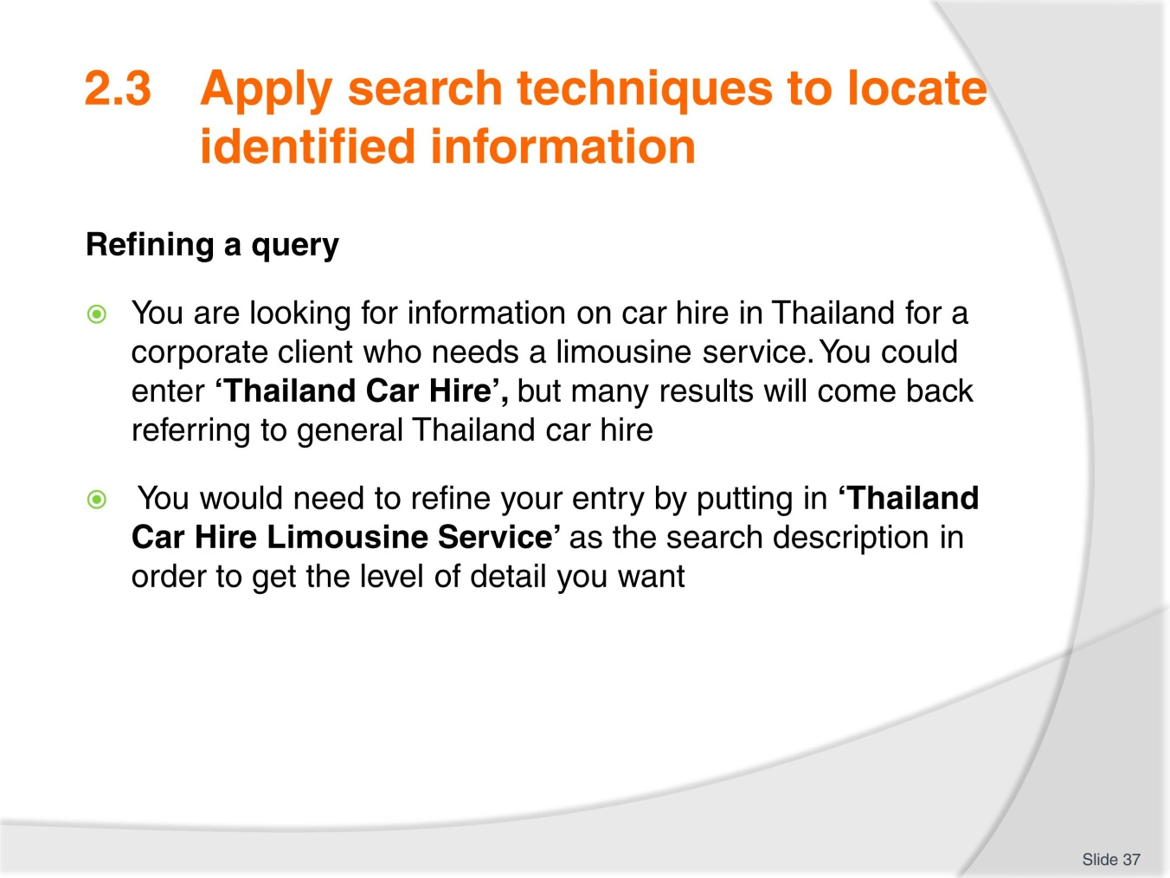
Slide No | Trainer Notes
- Discuss the example from the TM listed here
- Brainstorm suggestions for Activity 9. You may choose to provide more examples to highlight how you can refine queries to be time efficient
- Have trainees complete Activity 9.

Slide
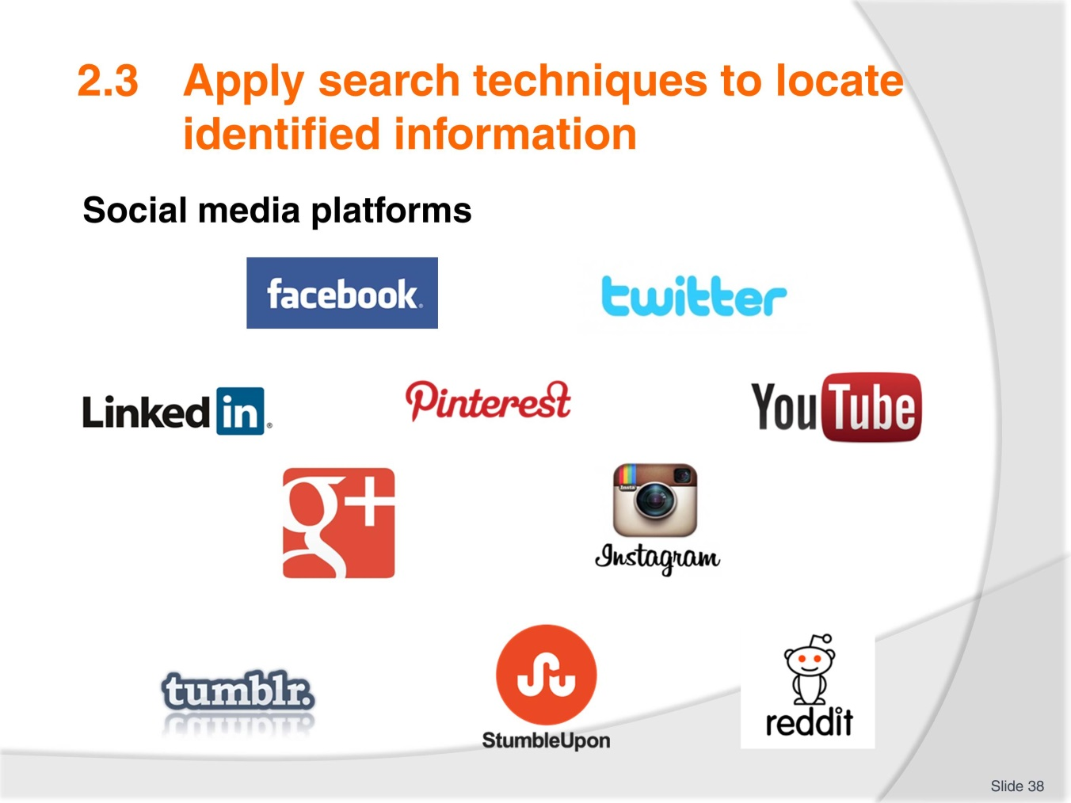
Slide No | Trainer Notes
- Enquire how many trademarks are recognised, how many used by trainee
- Work through each of the social media platforms discussing pro’s and cons of each
- Trainees will be able to offer personal opinion and experience here
- Complete Activity 10.

Slide
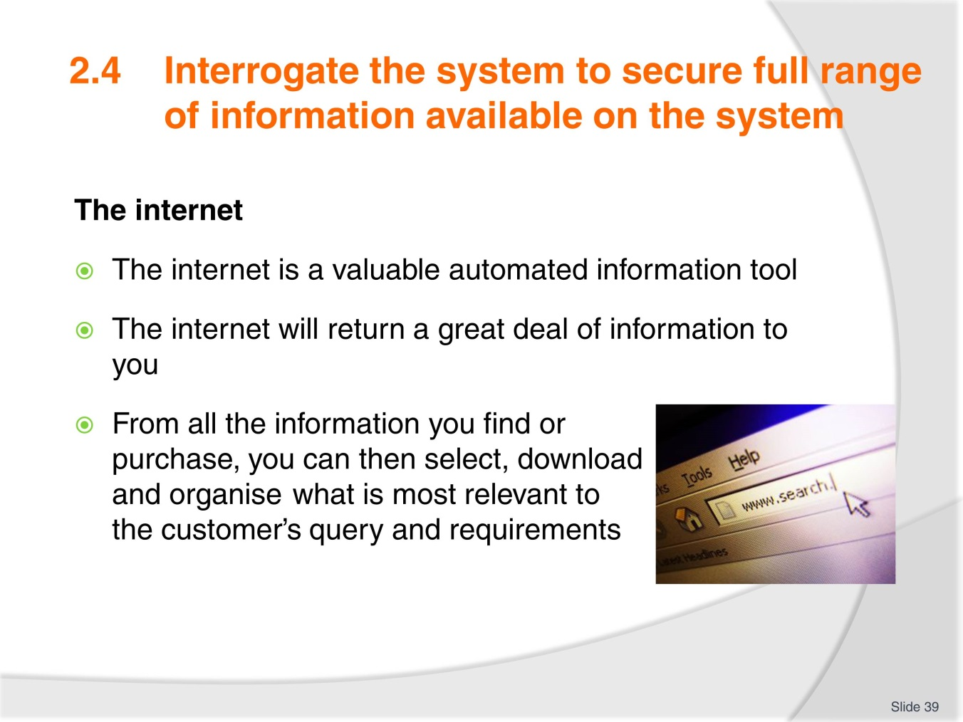
Slide No | Trainer Notes
 | Discuss as necessary, focusing on how to find your way through the maze of information to what is most suitable to you for your client.

Slide
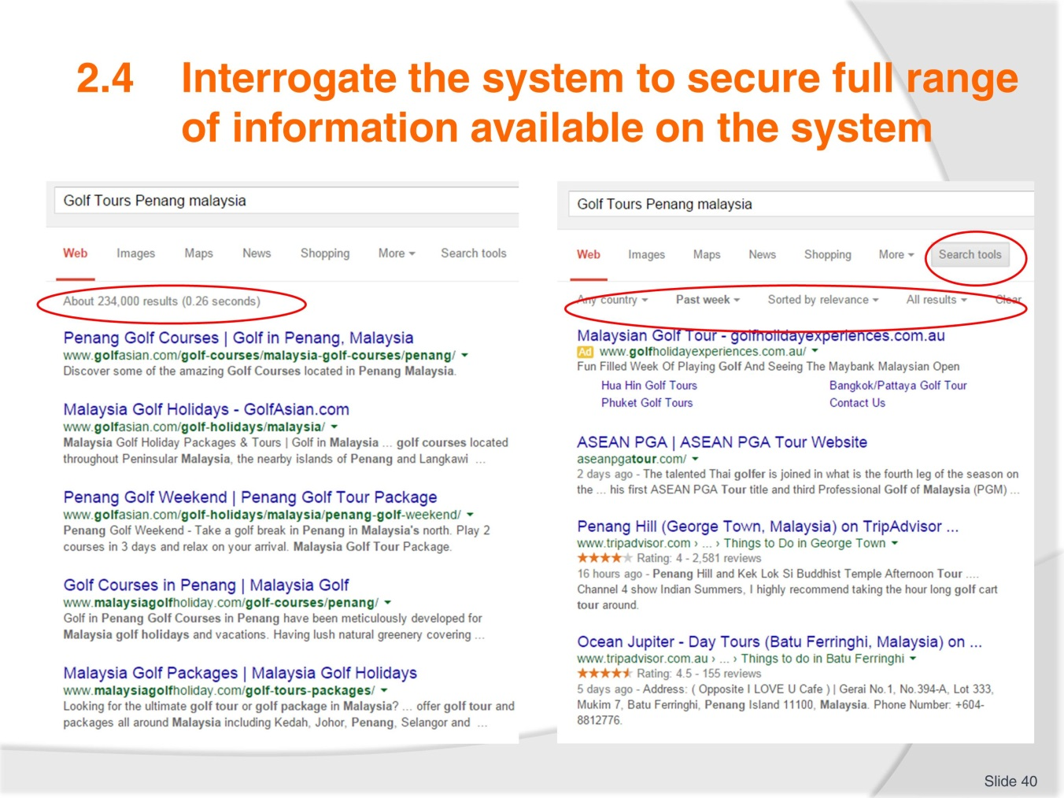
Slide No | Trainer Notes
- This slide demonstrates search tools. Use the next slide to show drop boxes within Search Tools options
- Discuss further as necessary
- If access to the internet conduct a different search and discuss as a group how to organise the returned content before asking trainees to complete Activity 11
- Complete Activity 11.

Slide
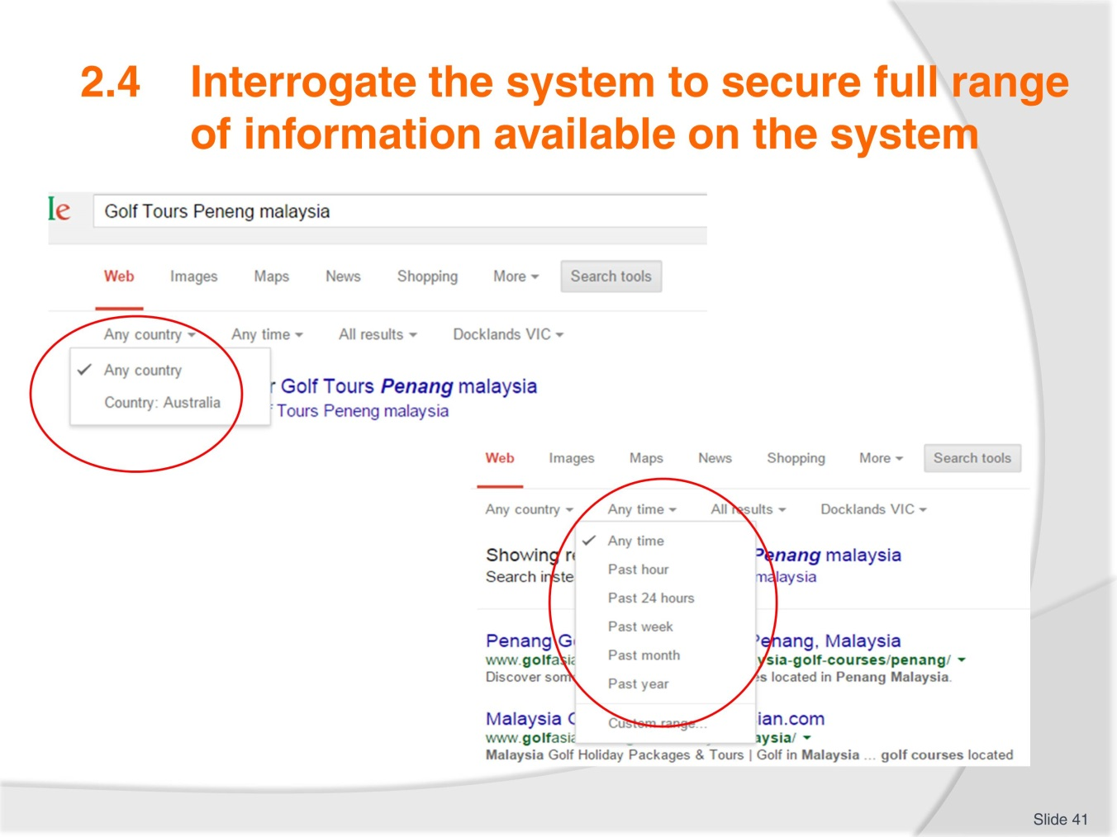
Slide No | Trainer Notes
- Links to previous slide
- Now discuss ‘conducting further search’
- If access to internet a search can be conducted to demonstrate these tools for the group
- Follow TM and discuss and explain the advanced search functions
- Complete Activity 12.

Slide
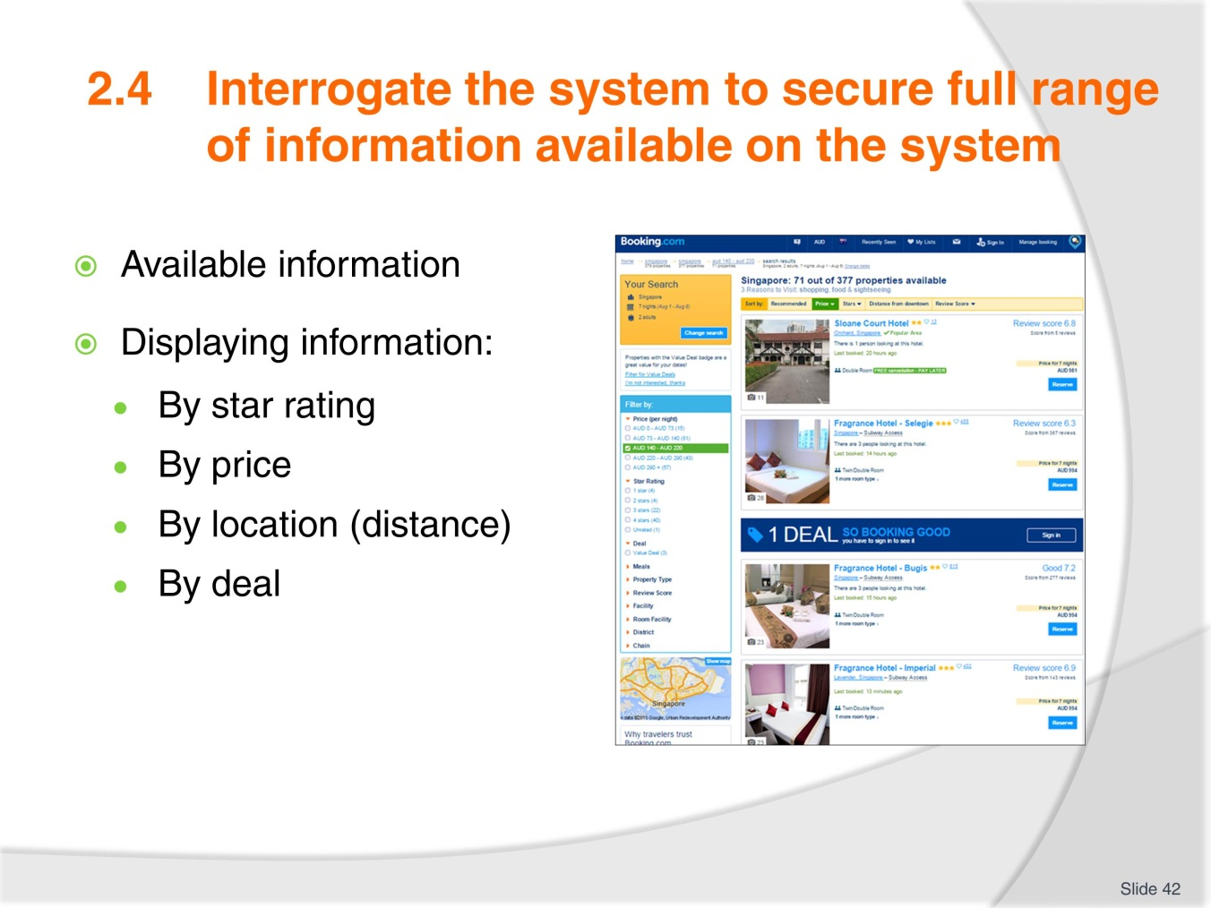
Slide No | Trainer Notes
- Working from the TM discuss the information displayed on this web page (which is from the TM)
- If access to internet, bring up the site and navigate it for the group showing the different information able to be sourced
- Demonstrate the ‘Back’ and ‘refresh’ buttons, hyperlinks and opening additional tabs
- Answer any questions trainees have
- Complete Activity 13 – provide a time allowance and have trainees present back to the group. Discuss search methods and findings.

Slide
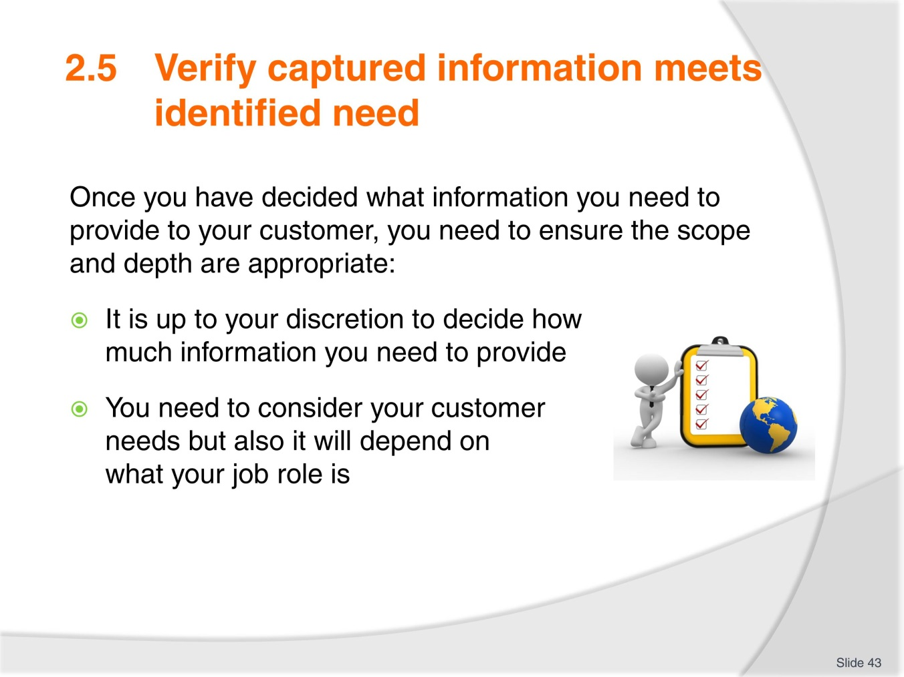
Slide No | Trainer Notes
- Discuss varying job roles from travel agencies to visitor information centres – small and large. How much would you need to know in a particular role?
- Discuss Activity 14:
- Wealthy couple/on a budget
- Retired/on holiday
- Easy going/very particular on preference
- Experienced golfers?
- Complete Activity 14
- Ensure all work projects have been completed and handed into trainer ensuring cover page details are attached for assessment tracking
- Review the summary page for Element 2 to confirm what has been completed for this element.

Slide
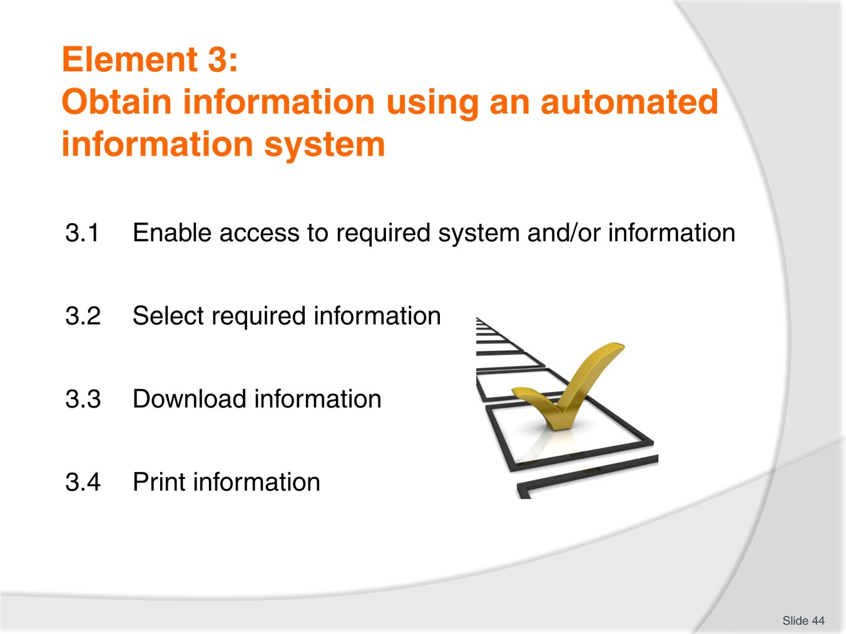
Slide No | Trainer Notes
 | Trainer introduces the performance criteria which make up Element 3.

Slide
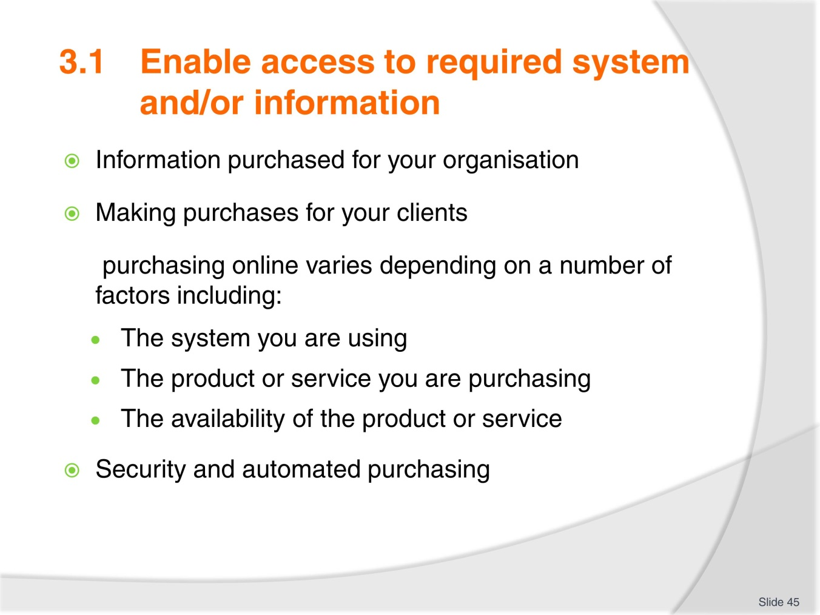
Slide No | Trainer Notes
- Share your experience on the most common purchases made
- Discuss purchasing processes and protocols:
- Using a CRS
- Using a wholesaler
- Booking tours and cruises
- Hotel booking
- Car hire booking
- Quote or receipts for payment
- Discuss security when purchasing online
- If access to the internet search a hotel or airline website and demonstrate the various screens to the payment page.

Slide
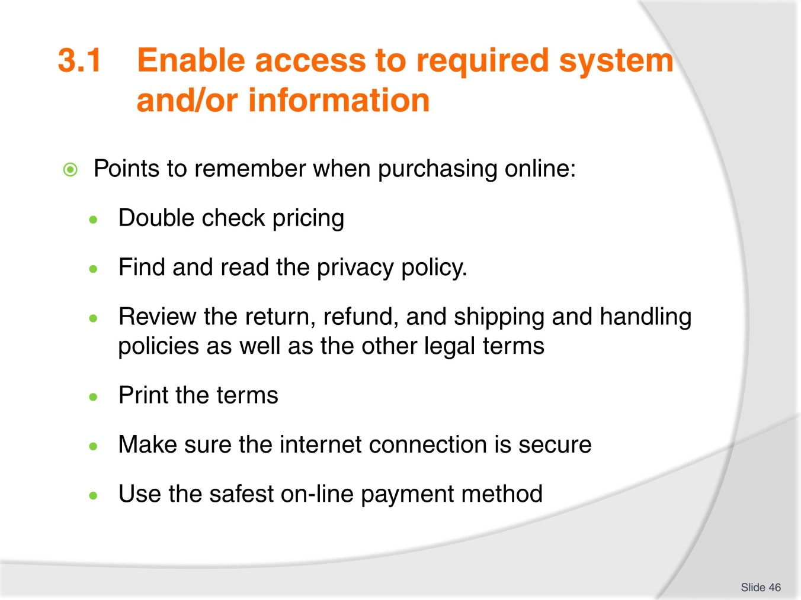
Slide No | Trainer Notes
- Discuss as necessary adding any personal knowledge or experience of things that may have gone wrong
- Ensure all trainees are familiar with the security icons to look for when making payment online.

Slide
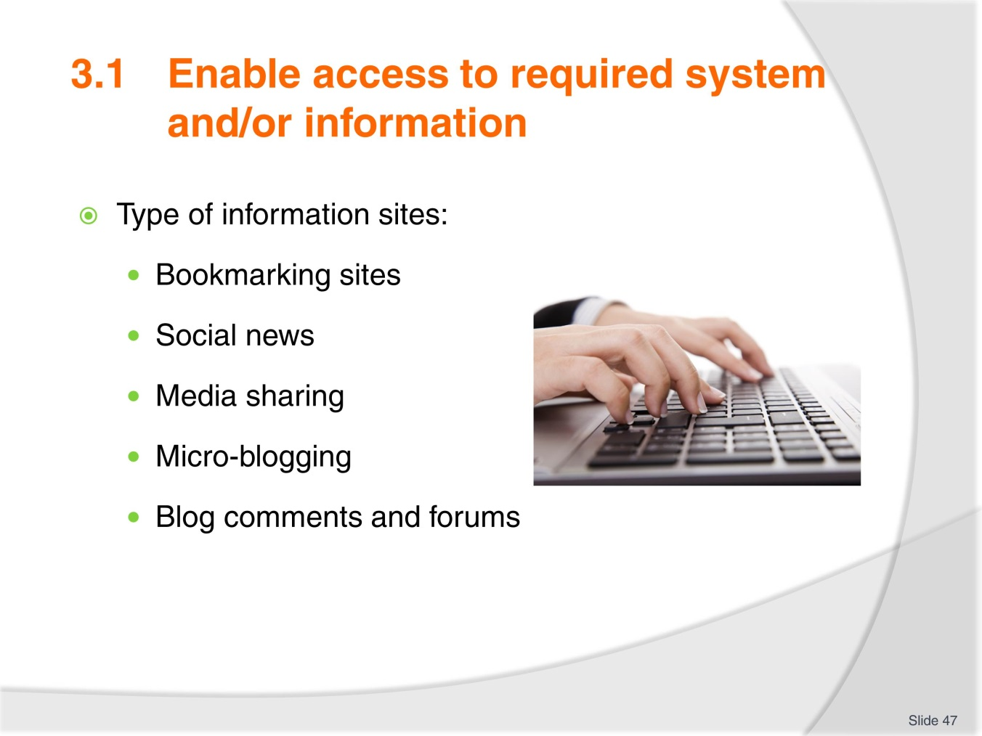
Slide No | Trainer Notes
- Work through each of the types of information sites seeking any knowledge or experience trainees have in these fields
- Include the CRS as one of the information systems
- Complete Activity 15.

Slide
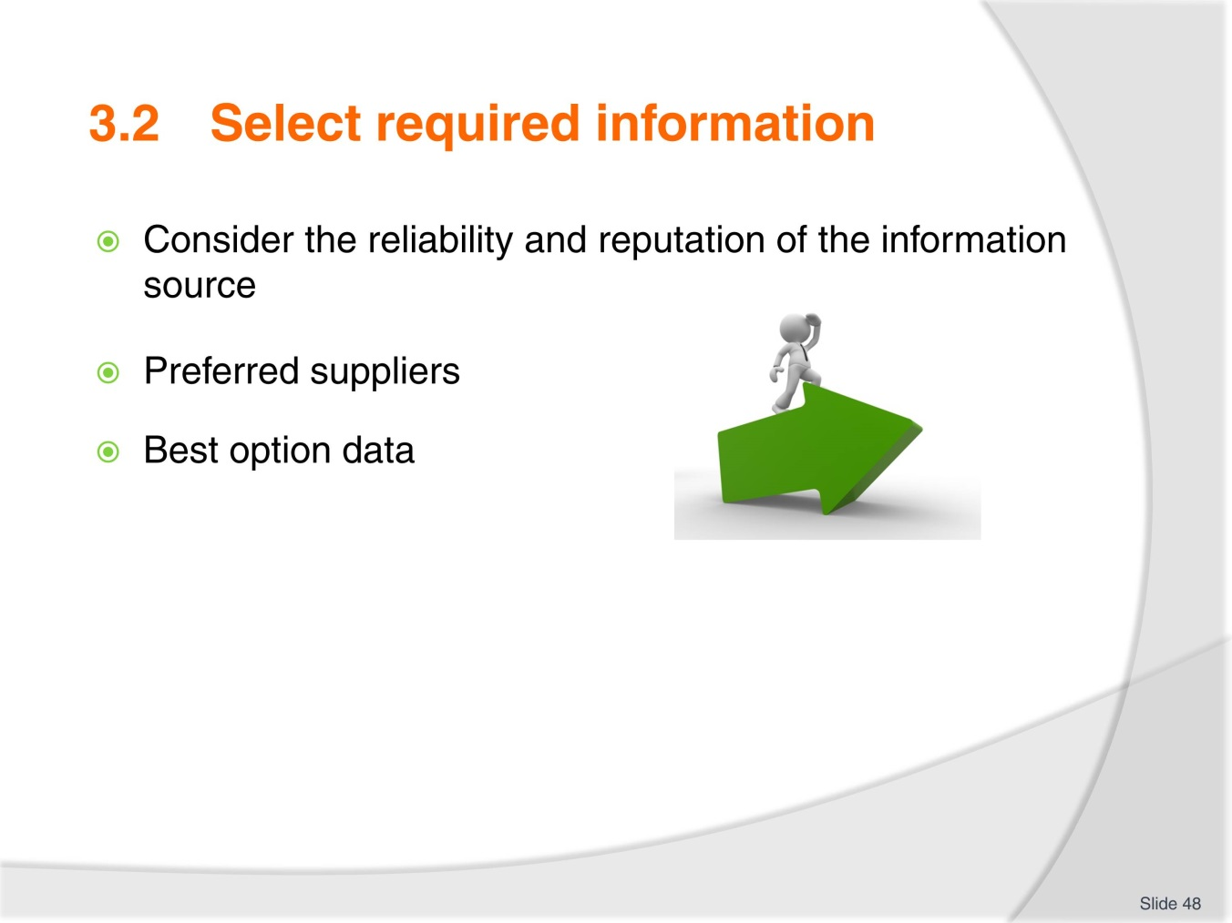
Slide No | Trainer Notes
- This performance criteria revisits material already covered and the opportunity can be taken to have trainees share their new knowledge on what process they would follow
- Complete Activity 16 – (you may wish to indicate different ages for the children in the scenario to different trainees in order to vary the information returned).

Slide
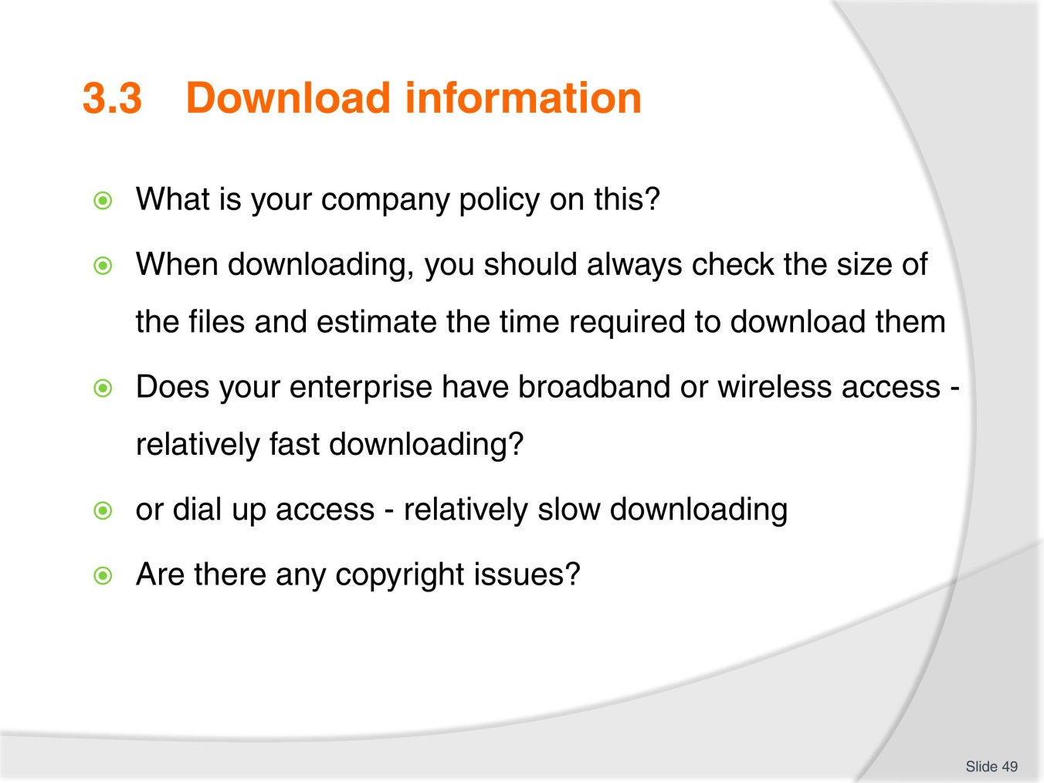
Slide No | Trainer Notes
 | Break class into smaller groups and have groups work through these questions from their knowledge of their workplaces. Each group then to present on their responses.

Slide
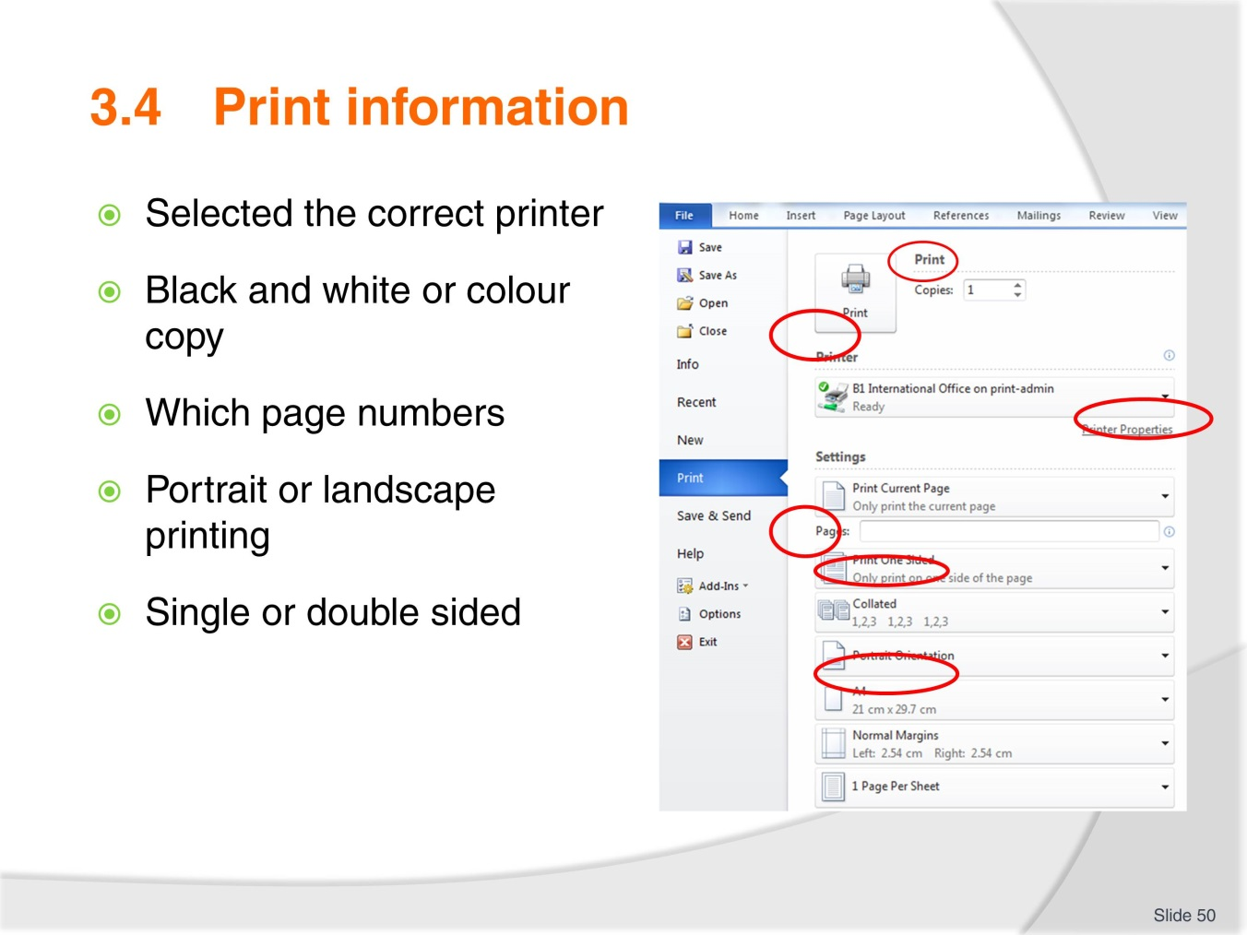
Slide No | Trainer Notes
- Explain the printing page and emphasise the areas where people generally make silly mistakes:
- Too many copies
- Wrong page numbers
- Not printing a sample copy
- Printing in colour when not necessary
- Not doing a print preview.

Slide
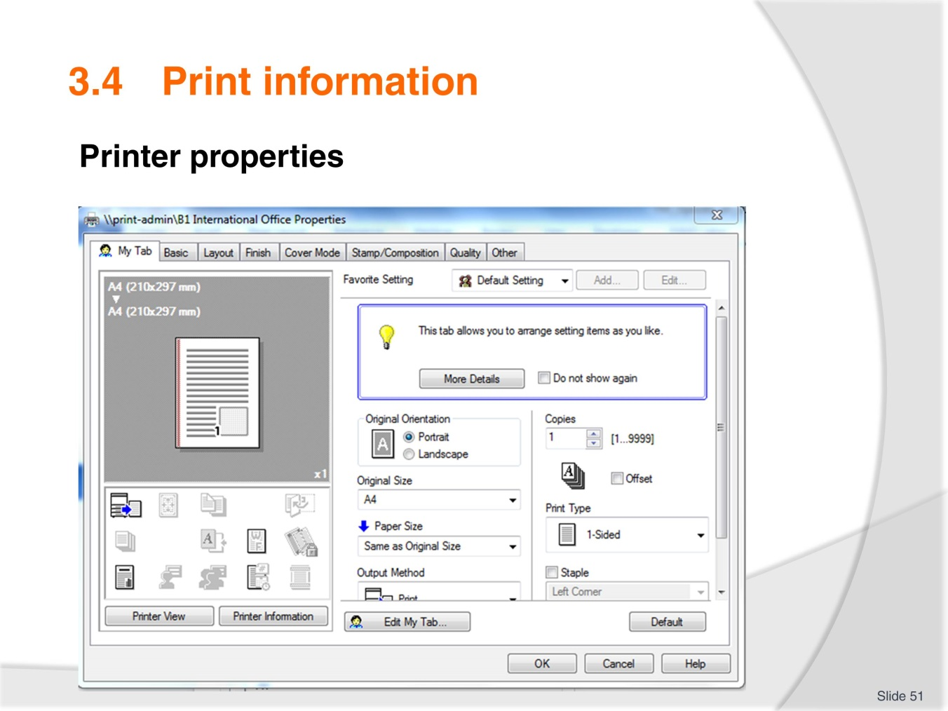
Slide No | Trainer Notes
- Explain various basic uses from this page
- Always review you have selected all the correct choices before activating large print jobs
- Have samples available for trainees to view:
- Double sided
- Two pages on one page (2in1)
- Stapled – top corner, two on left side
- Hole punched and stapled
- Water marking
- Complete Activity 17
- Ensure all work projects have been completed and handed into trainer ensuring cover page details are attached for assessment tracking
- Review the summary page for Element 3 to confirm what has been completed for this element.

Slide
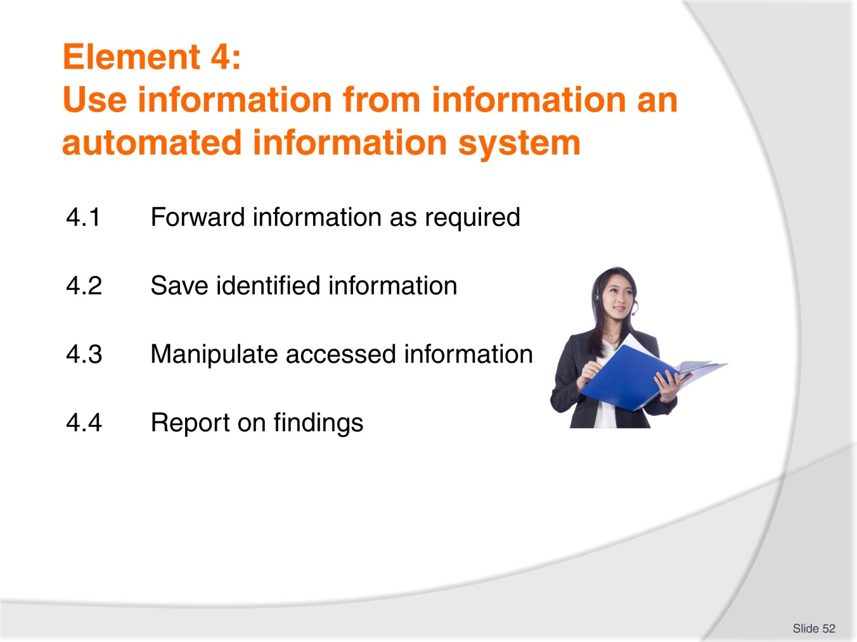
Slide No | Trainer Notes
 | Trainer to introduce the performance criteria which make up Element 4.

Slide
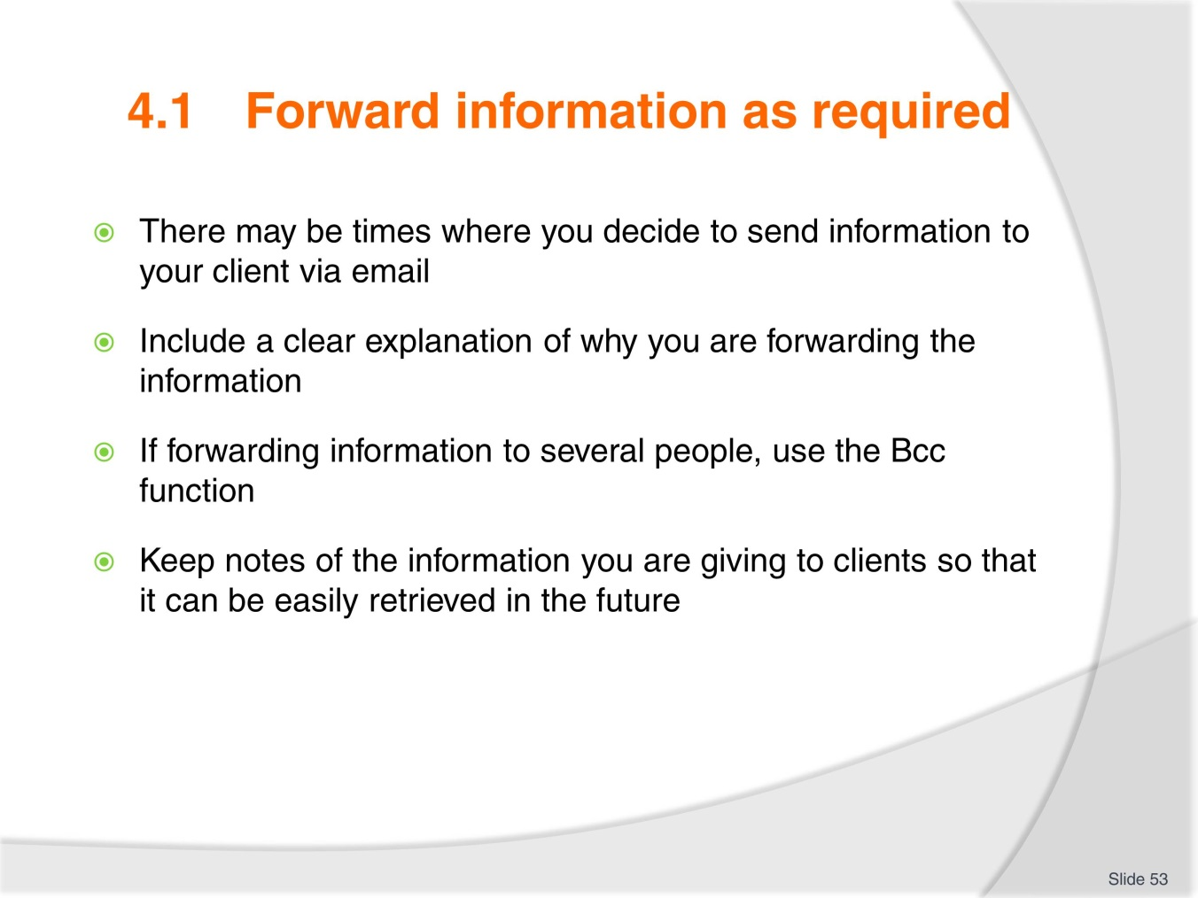
Slide No | Trainer Notes
- Discuss as needed taking into consideration requirements required for Activity 18
- Complete Activity 18.

Slide
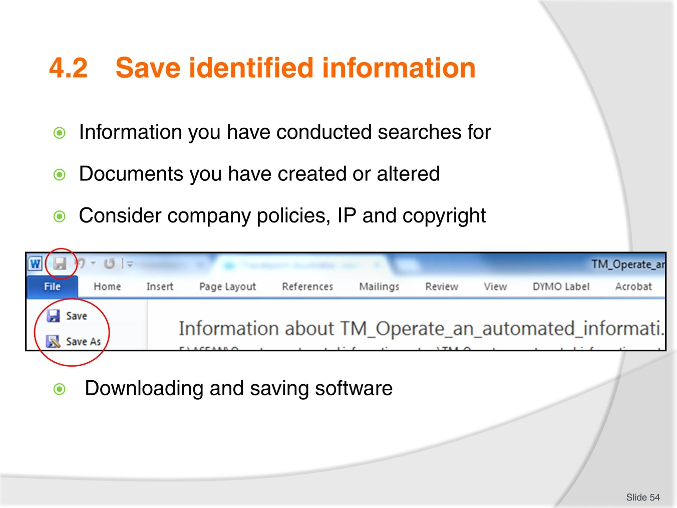
Slide No | Trainer Notes
- Explain why you need to consider company policy, Intellectual property and copyright
- Discuss as needed paying attention to the importance of clicking ‘save’ on software that is downloaded (and approved by management to do so). It is important to save material to suitable locations so maintain order to your filing systems.

Slide
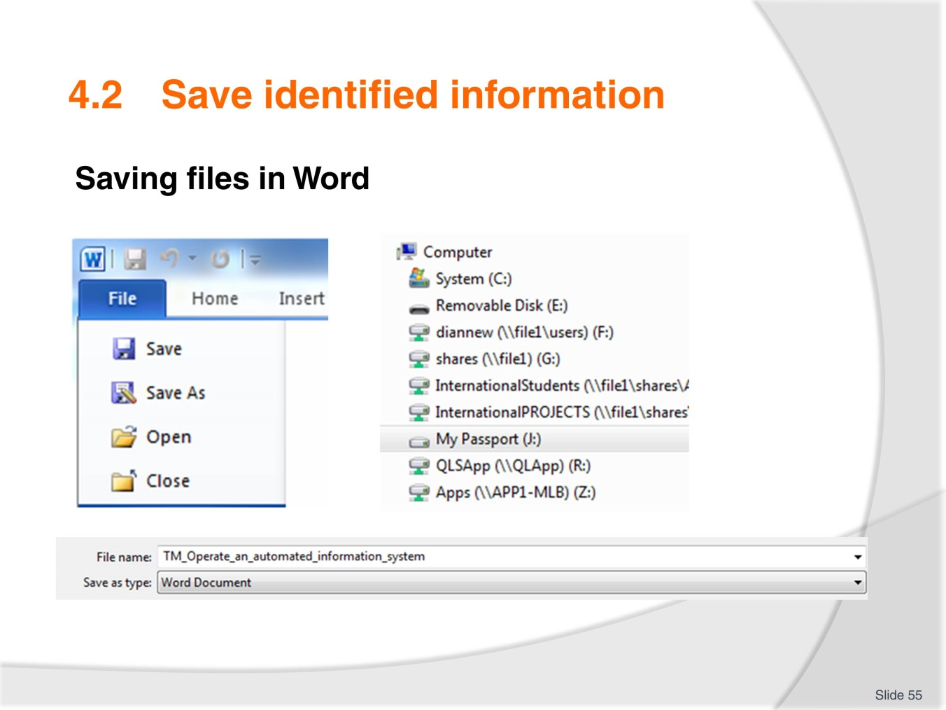
Slide No | Trainer Notes
- It is likely trainees will be familiar with these procedures however take time to explain correct procedures to anyone who may be new to the information
- In this example ‘my passport’ is an external hard drive and the removable disk is of course a USB stick (thumb drive)
- Auto save is useful as a backup but don’t rely on it!
- Again emphasise the importance of labelling and saving files to correct locations. It doesn’t take long for your computer to become a filing mess because you thought you would fix it later
- Complete Activity 19.

Slide
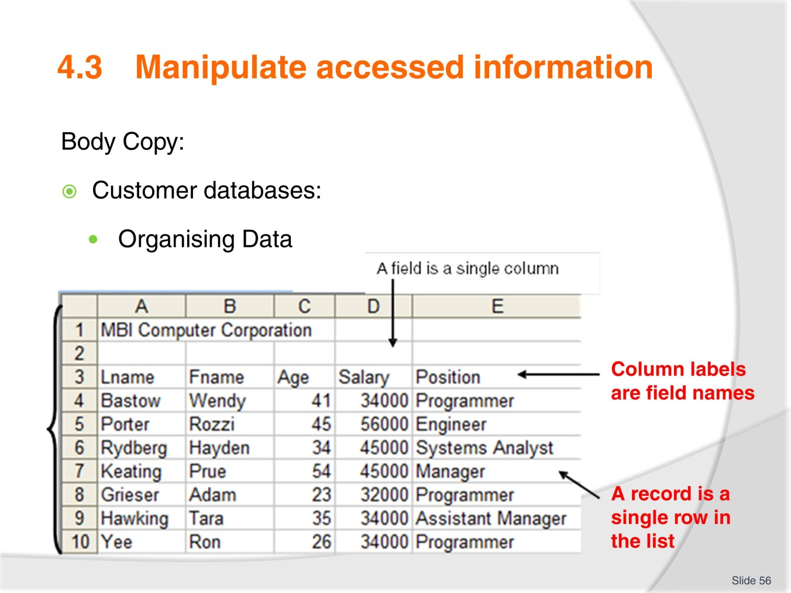
Slide No | Trainer Notes
- Ideally this training should be conducted in a computer room or an area where trainees can work into a computer or personal laptop
- Some trainees may be familiar with Excel already. If this is the case ask them to assist someone who is new to the program.

Slide
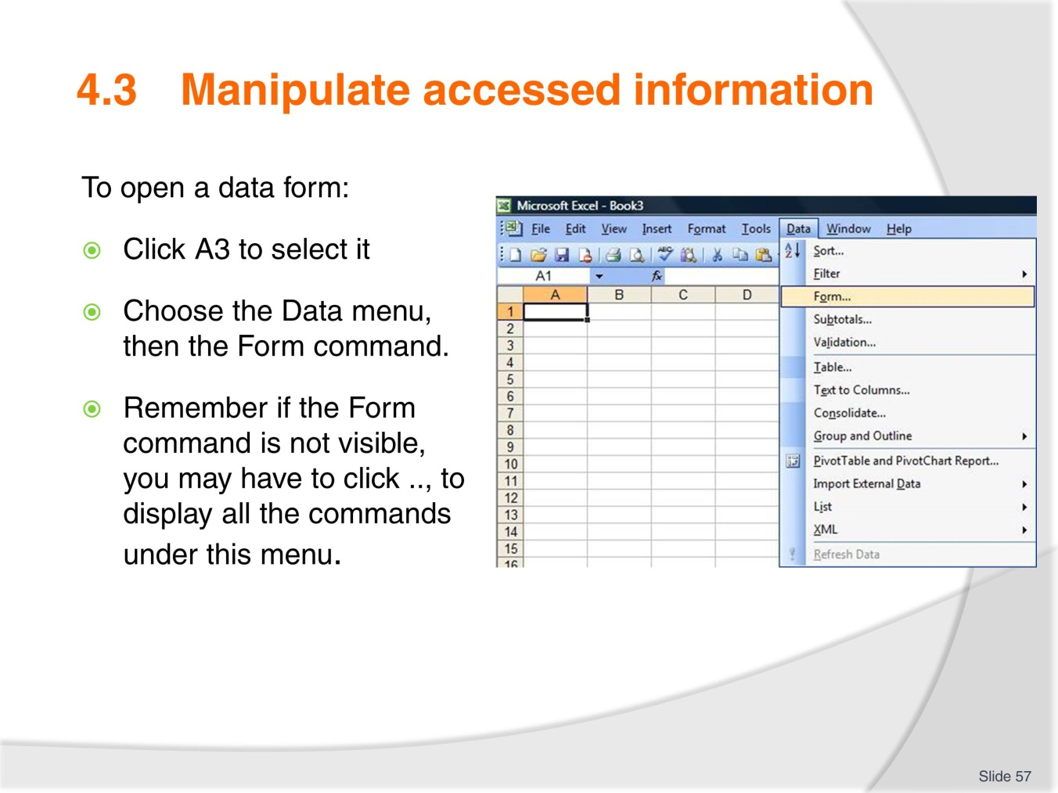
Slide No | Trainer Notes
 | Trainer to lead students through the process, or ask an experienced student to do so.

Slide
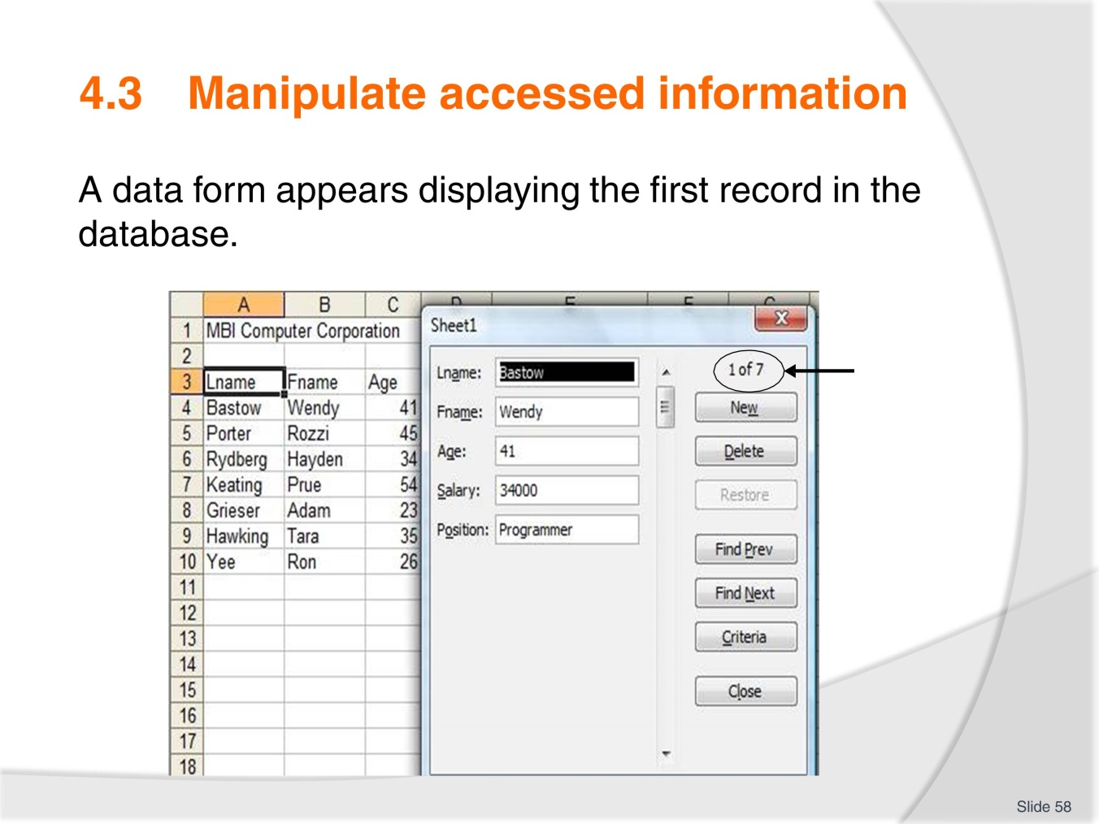
Slide No | Trainer Notes
- Record Number Indicator
- A data form can display up to 32 fields
- The record number indicator is displayed in the upper right-hand corner of the data form. This indicates which record is being displayed and how many records are in the database
- Explain the command tabs as listed in the TM.

Slide
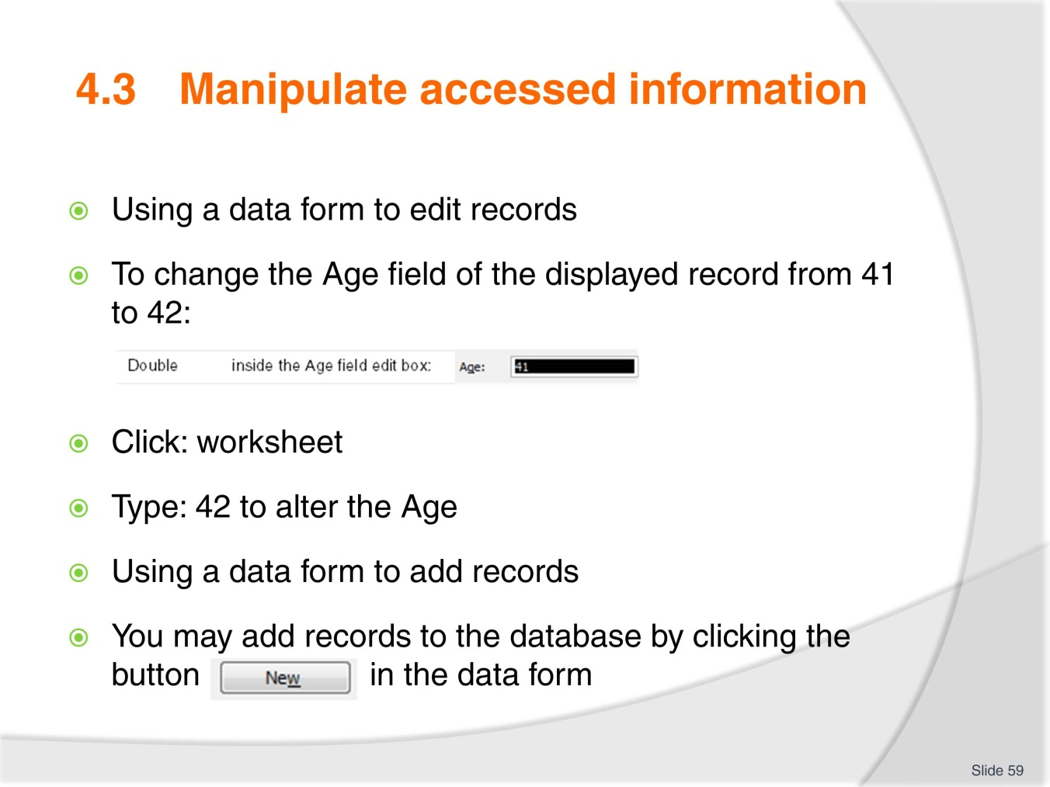
Slide No | Trainer Notes
 | Follow the exercise in the TM explaining each step to trainees.

Slide
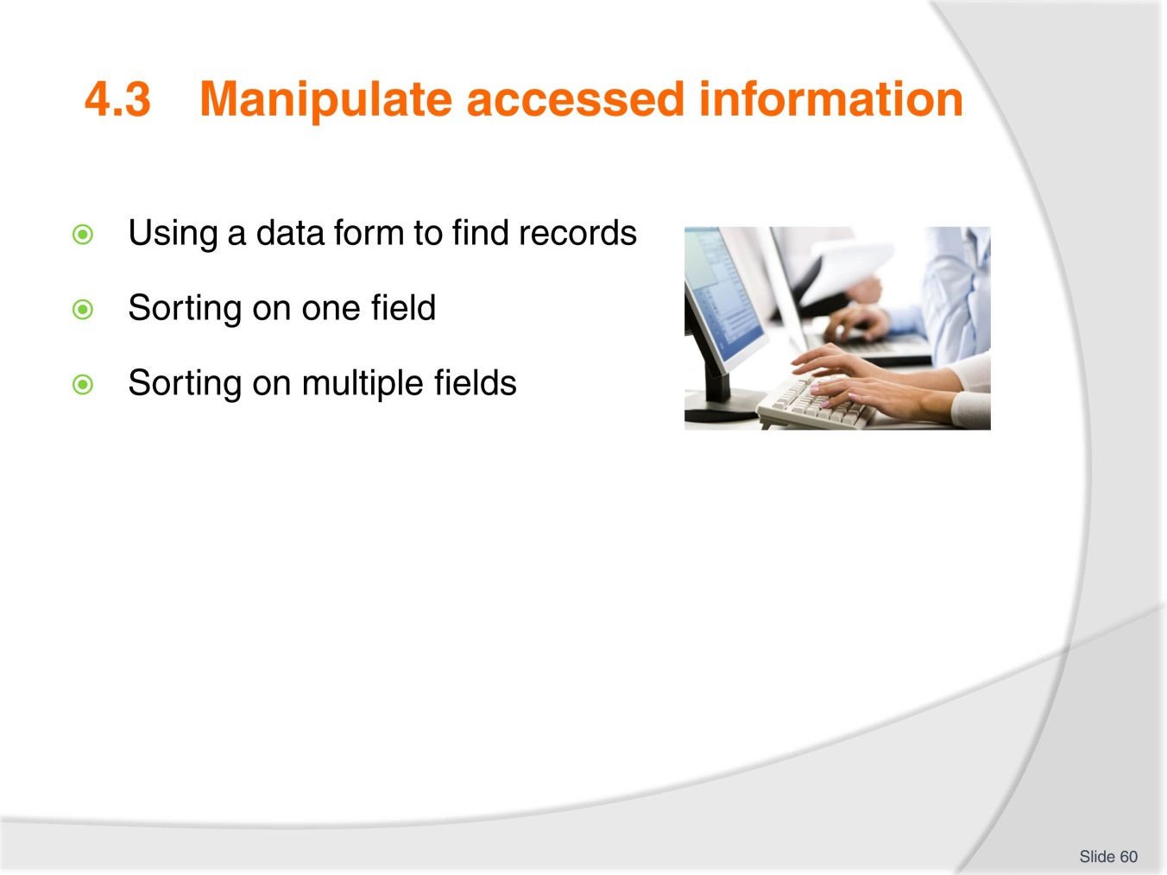
Slide No | Trainer Notes
 | Using your laptop and data projector display an excel spread sheet for the group and demonstrate each of the above listed steps. If trainees have access to computers or laptops have them work through each step with you.

Slide
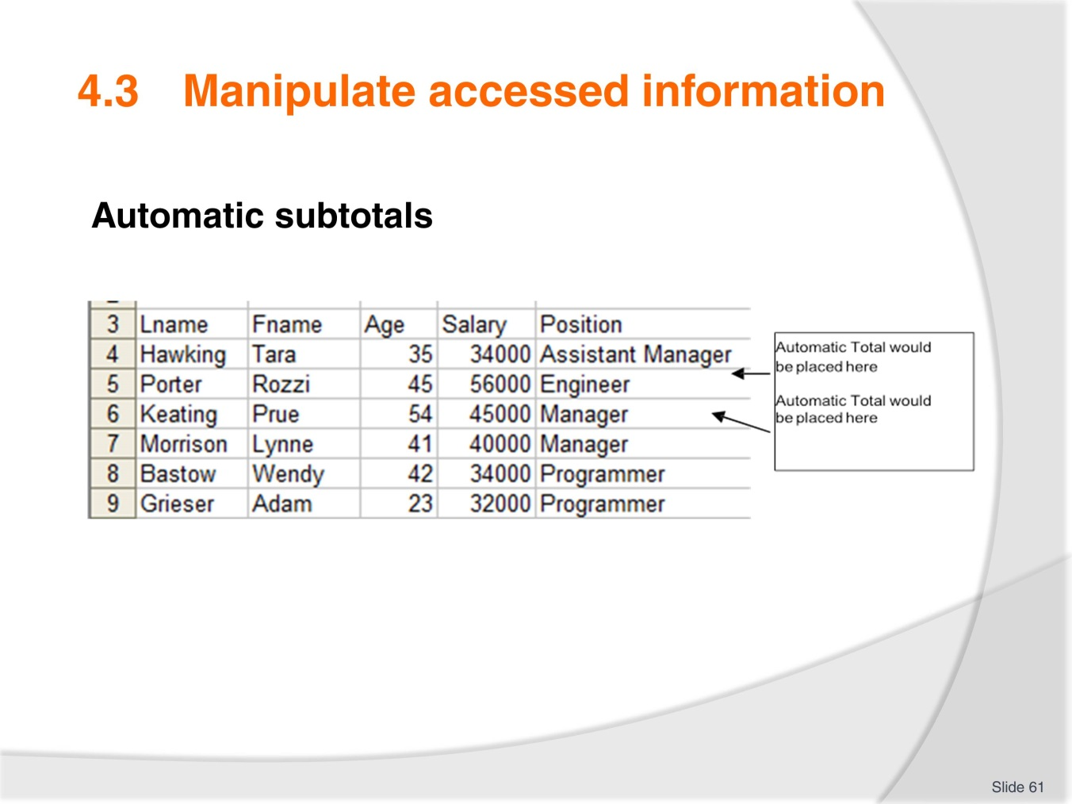
Slide No | Trainer Notes
- Work through automatic subtotals and subsequent steps as listed in TM. Allow trainees to follow each step on the computer screen having time for questions along the way. Ensure everyone is at the same point of progression
- Have trainees save their work to a USB
- Complete Activity 20.

Slide
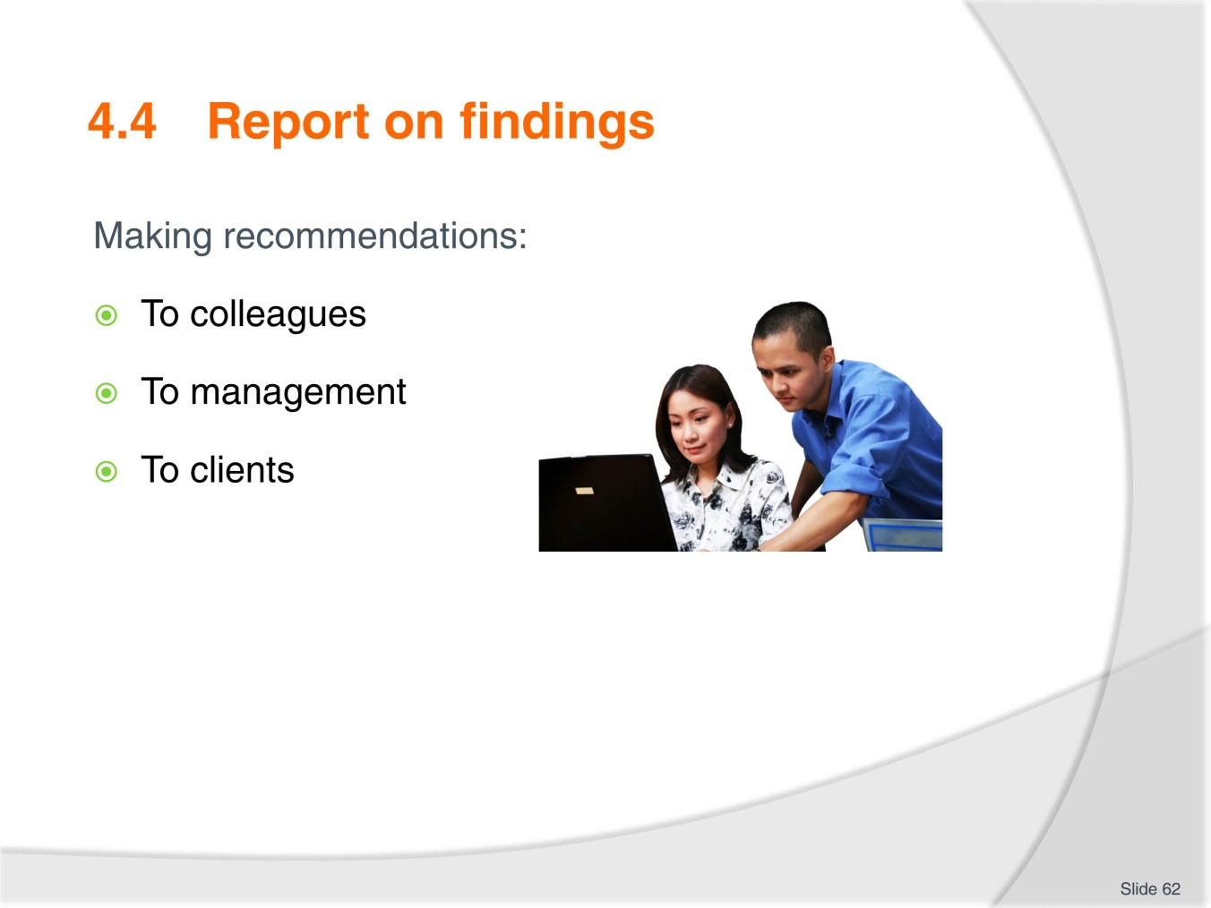
Slide No | Trainer Notes
- Have discussion on the various types of reporting that may be required in the workplace
- Most common is likely to be to clients
- Explain how to create sequence and structure so the client is not lost along the way
- Have a copy of the report for the client to follow and make any notes on as explanation is conducted
- Complete Activity 21
- Ensure all work projects have been completed and handed into trainer ensuring cover page details are attached for assessment tracking
- Review the summary page for Element 4 to confirm what has been completed for this element.

Slide
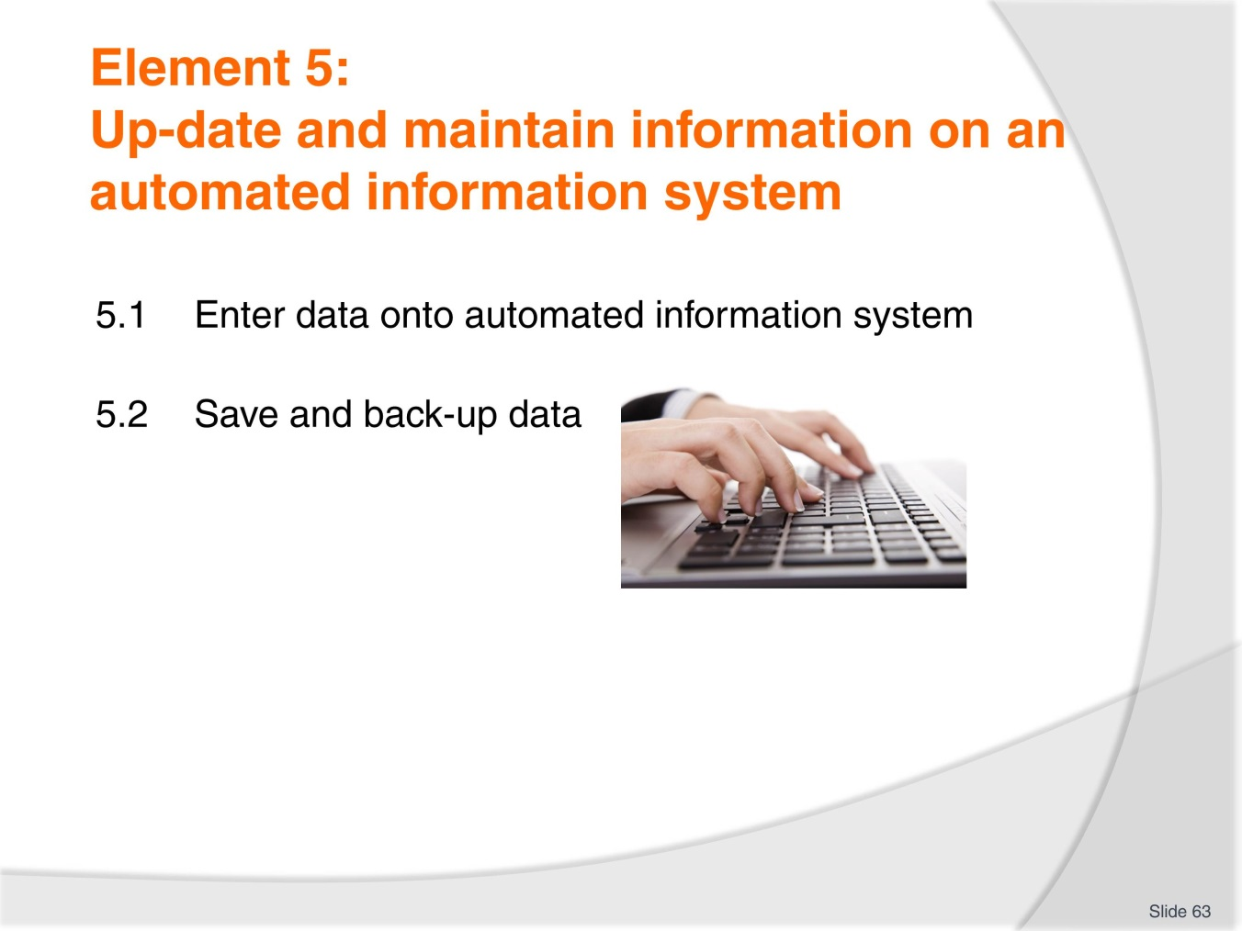
Slide No | Trainer Notes
 | Trainer to introduce the performance criteria which make up Element 5.

Slide
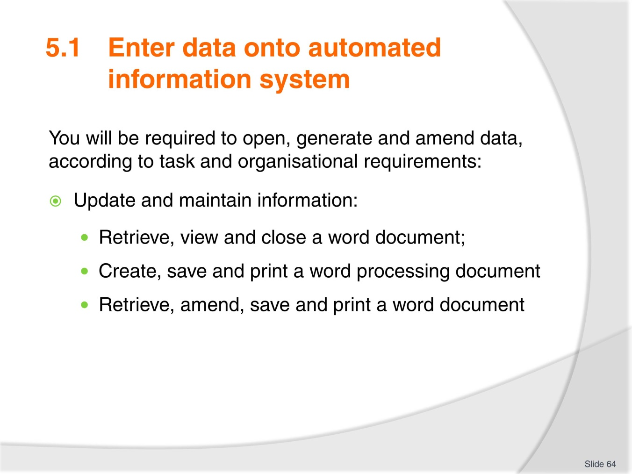
Slide No | Trainer Notes
 | It is likely trainees will know how to complete these tasks. Confirm this as fact before moving on.

Slide
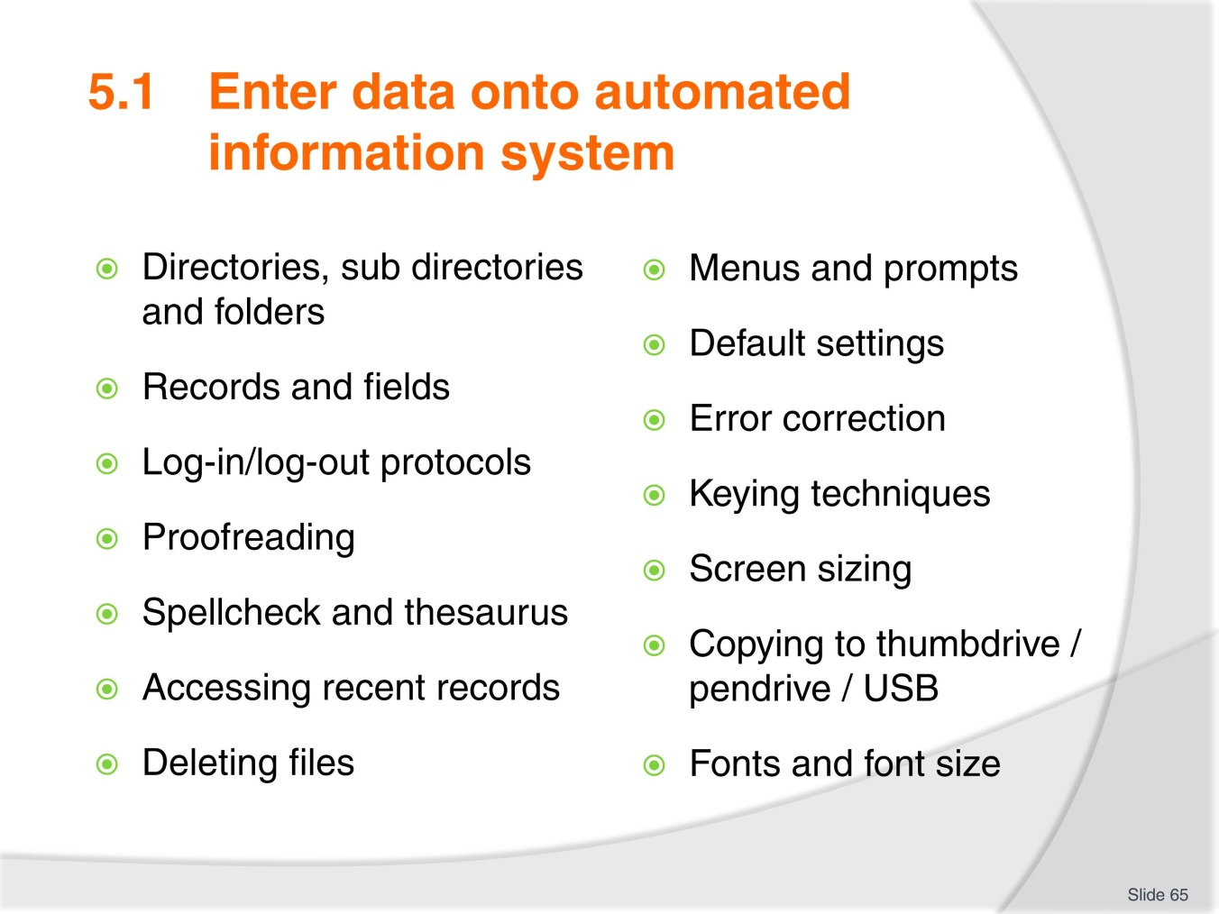
Slide No | Trainer Notes
- The previous slide contained relatively basic skills there is likely to be one or more skill identified here that not all trainees are familiar with
- Take time to identify where each of these tools are located on the tool bar and how to use them.

Slide
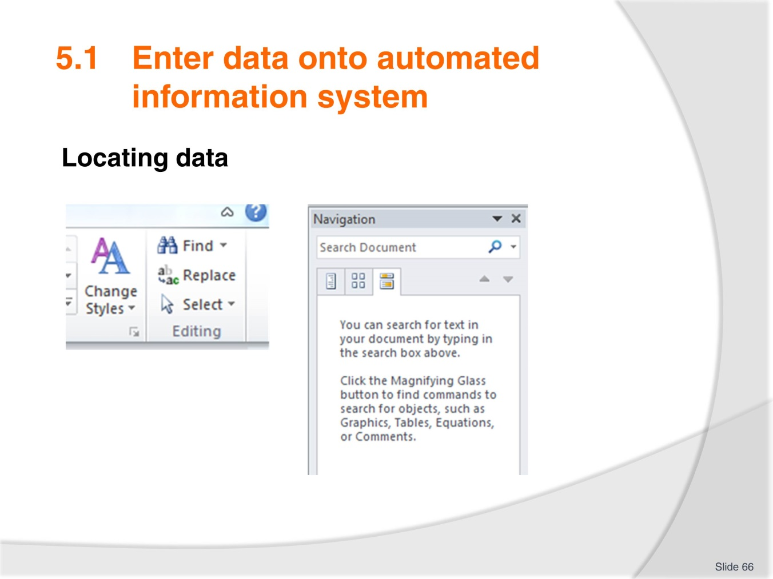
Slide No | Trainer Notes
- Demonstrate how to conduct a ‘Find’ search
- Click on “Find’ and enter a phrase or key words in the search bar to demonstrate that it will take you to a particular part of a document.

Slide
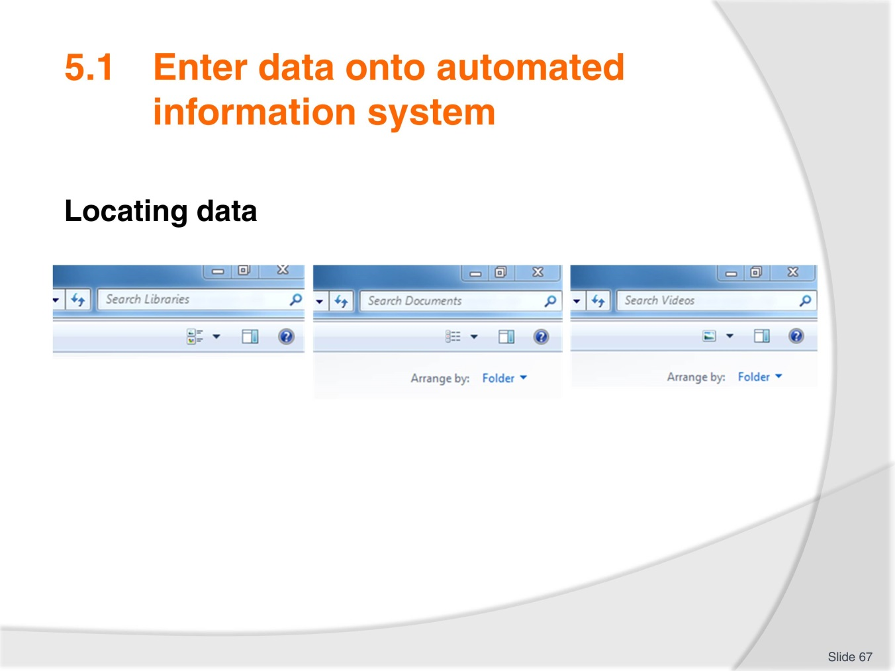
Slide No | Trainer Notes
- Demonstrate searching for documents
- Have something prepared that you can suitably demonstrate on your own folders or computer
- Activity 22 should have been completed already.

Slide
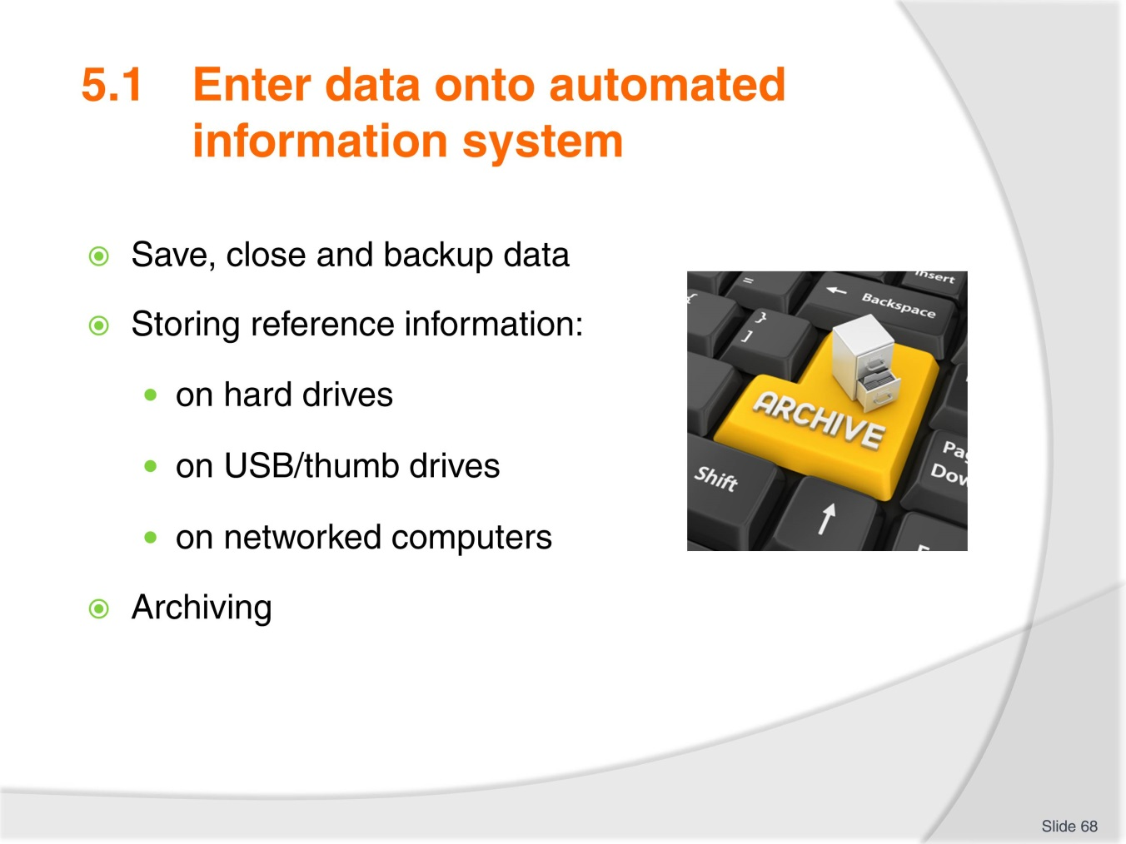
Slide No | Trainer Notes
Have discussion on where trainees save files to:
- Any trainees who have work experience? – What is or was the company policy in this area?
- Who backs up their work?
- Does anyone keep a hard copy as backup?
- Who has lost files due to computer crashing, virus, fire or other problem?
- Have discussion on archiving and the importance of this being conducted to company standards
- Discuss the common ways of archiving and associated business/tax law for your country
- Complete Activity 23 – ensure trainees understand requirements. Demonstrate how to do a screen shot if needed
- Ensure all work projects have been completed and handed into trainer ensuring cover page details are attached for assessment tracking
- Review the summary page for Element 5 to confirm what has been completed for this element.

Slide
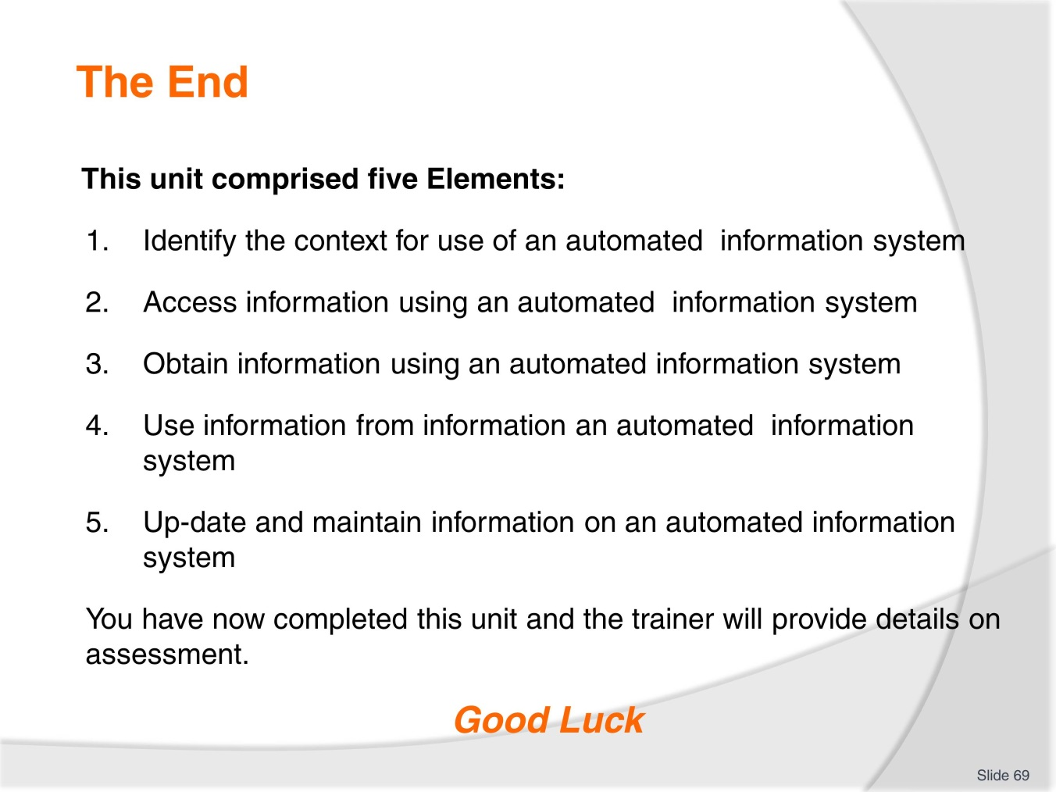
Slide No | Trainer Notes
 | Trainer advises learners on what assessment is required and how it is to be conducted.

Activities for work projects
Name: ______________________________________________________________
Date: ______________________________________________________________
Activity 1 – Information sources
- List five possible sources of information which you may use to capture knowledge to give to visitors.

- Answer ‘True’ or ‘False’ to the following statement: “Most festivals and events vary in their exact date from year-to-year”.

- List five websites you believe can be important to you for obtaining visitor information.

- List five ways you can access required visitor information.

Name: ______________________________________________________________
Date: ______________________________________________________________
Activity 2 – Policy and procedure
NOTE: It is a requirement of this unit that you attempt this Training Activity.
- A new staff member (trainee) commences work at your travel agency. You are responsible for ensuring that this trainee is familiar with the purposes for which the automated information system in the office may be used. Explain to this staff member the circumstances in which they might need to use the system and the types of information that may be accessed.
Explain the basic do’s and don’t’s that relate to use of the system. Remember you are dealing with a trainee so don’t overload them with too much to begin with.
In bullet point form, what will you say to the trainee?

- Match each term to its definition:
- Privacy policy |  | The right of an author to decide how their original work is published, distributed and adapted.
- Copyright |  | Refers to creations of the mind, such as ideas or inventions that have commercial value.
- Intellectual property |  | A legal document that discloses what personal information is collected from customers and how it is used.
- Access the privacy policy from the following website:
www.wotif.com.au
- Cut and past the two paragraphs under the heading ‘Our privacy policy’ into this box:

Name: ______________________________________________________________
Date: ______________________________________________________________
Activity 3 – Types of information
- List four different types of information you are able to access from your CRS.

- Access your organisation’s intranet home page to see what information is available for you.
- List three examples of information for employees of the organisation.

- List four examples of information provided for clients of the organisation.

Name: ______________________________________________________________
Date: ______________________________________________________________
Activity 4 – source information
NOTE: It is a requirement of this unit that you attempt this Training Activity.
“I want to find out which domestic tour wholesalers are promoting their products on the web and what they are promoting” says your Manager. He/she needs the information in an hour for an important internal meeting. Source and print the information, with a very brief summary of what you have found.

Name: ______________________________________________________________
Date: ______________________________________________________________
Activity 5 – Internet search
Try to answer these questions by using a search engine (e.g. www.google.com.au). Try practicing using shorter key word searches, instead of typing the whole question into the search engine. Place your answer & the website you found it on in the spaces provided.
TIP: Copy & paste the website address directly off the webpage (found in the "address bar") straight into your document!
No. | Questions | Answers | Website
1 | What is the capital city of Vietnam?
2 | What is the national sport of Thailand?
3 | When is the Water Festival in Cambodia and what is it about?
4 | I want to go to the Great Lantern festival in the Philippines. Can you tell me about it?
5 | Which SE Asian countries conduct a marathon?
6 | When is the Dragon Boat Festival in Penang?
7 | I am a Grand Prix fan. Where and when are they held in SE Asia?
8 | Name the three largest countries in SE Asia?
9 | Is it possible to travel by train from Johor Bahru to Mandalay?
10 | I have a one night stopover in Brunei. What could I do?

Name: ______________________________________________________________
Date: ______________________________________________________________
Activity 6 – Access information
- What general information may a client require about a destination?

- What kind of information do you think a client may need about the following products?
Accommodation:

A cruise:

A flight:

Name: ______________________________________________________________
Date: ______________________________________________________________
Activity 7 – Search engines
Use three different search engine and compare results
Search engine used_____________________________________________
Search for ‘budget beach accommodation Thailand’. List the below details, for the first result you get.
Page title:
What page extract is listed?
Web address:
Search engine used__________________________________________________
Search for ‘budget beach accommodation Thailand’. List the below details, for the first result you get.
Page title:
What page extract is listed?
Web address:
Search engine used__________________________________________________
Search for ‘budget beach accommodation Thailand’. List the below details, for the first result you get.
Page title:
What page extract is listed?
Web address:

Name: ______________________________________________________________
Date: ______________________________________________________________
Activity 8 – Find the answers
Using key words in a search engine, find answers to the following questions:
- What is the address for the palace of the Sultan of Brunei?

- What are the opening hours of Singapore zoo?

- What is the name of the main international airport in Kuala Lumpur?

- What is the exchange rate for 1 Philippine peso to the Singapore dollar?

- What is the main form of transport between Myanmar and Malaysia?

Name: ______________________________________________________________
Date: ______________________________________________________________
Activity 9 – Refining a query
Scenario – Refining a query
A customer requests information on beach accommodation in Thailand. She is travelling in a party of eight people and they can only travel in April.
Show in the space below a basic query to start the search for information for this customer, and then show one way in which you could refine the query.
Basic query
SEARCH

Refined query
SEARCH

Print screen the final results and attach it to this activity and hand in to your trainer.

Name: ______________________________________________________________
Date: ______________________________________________________________
Activity 10 – Determine social media platforms for information
NOTE: It is a requirement of this unit that you attempt this Training Activity.
Please identify:
- Which social media platforms that you will use as a preferred source of information
- Identify what type of information each platform would be useful for.
SOCIAL MEDIA PLATFORM | Type of information

Name: ______________________________________________________________
Date: ______________________________________________________________
Activity 11– Determine most suitable search query results
From the list of results below, place in order the most suitable to the least suitable result for the query.
Golf Tours Penang Malaysia SEARCH
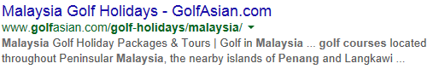



Name: ______________________________________________________________
Date: ______________________________________________________________
Activity 12 – Determine most suitable search query result
Give two examples of queries using the +, or and numrange options.
Attach your answers to this activity and hand in to your trainer
+

OR

Numrange

Find pages on surfing that are not about ‘surfing the World Wide Web’. Write down how you would phrase your search query.

Find a studio apartment to rent in Singapore and list the web address.

Fine tune the above query to a studio apartment located near the Singapore Botanical Gardens and list the web address.

Name: ______________________________________________________________
Date: ______________________________________________________________
Activity 13– Search information
- Imagine that you are working in a travel agency specialising in booking transport around South-east Asia. Make a list of ten websites you would include as ‘Favourites’. The list must include three airlines and three car hire companies, two coach companies and one train service

- When searching for accommodation on a wholesaler website, list three different ways that the information could be filtered to narrow your search.

- Use a search engine to complete the following activity.
Scenario
You have a client tell you that they heard about a place in Indonesia where they can go whale watching but they don’t know the name of the place and neither do you! You use Google to help you. You type in the words ‘whale watching Indonesia’ which helps you to discover that Komodo is the name of the place.
Look at the client questions below, list three words you could put into Google to help you find information and then list the correct answer.
a) I heard you can do elephant trekking in SE Asia.
Three search words:
Answer:

b) I heard there is a great theme park in SE Asia for kids. Where is it?
Three search words:
Answer:

- Go to www.expedia.com.
- What is the minimum amount of information you need to input in order to get a price for a hotel?

- There are a number of ways that you can make your information search more specific. List six hotel facilities that you are able to select to refine your search?

- List four other products or services that can be booked for clients through Expedia.

Name: ______________________________________________________________
Date: ______________________________________________________________
Activity 14 – Verify captured information meets identified criteria
Complete the example; Golf Tours in Malaysia
Mature age couple in their 50’s. On holiday for 6nights. Require hotel accommodation in 4-5 star hotel. Would like to play 2 different golf courses but open to suggestion. Would like to meet or compete against others.
What information would you return to the couple to verify you are meeting their requirements?

Name: ______________________________________________________________
Date: ______________________________________________________________
Activity 15 – Information sites
Using a different source each time copy a sample of tourism based information that you may use for clients from each of the following sites:
- Social news
- Bookmarking sites
- Media sharing
- Microblogging
- Blog comments and forums.

Name: ______________________________________________________________
Date: ______________________________________________________________
Activity 16 – Select information
A family holidaying in the local region enters your visitor information centre. They have arrived by car earlier in the day and at this stage have not chosen any accommodation in which to stay. They request information from you about the major attractions of the town and immediate surrounding area and indicate that they are particularly interested in outdoor activities which may be suitable for their young children. In a couple of days they will travel north, and would also like information on the area into which they are travelling. Access and print information for this family regarding:
- Suitable accommodation options
- Major attractions
- Outdoor activities.

Name: ______________________________________________________________
Date: ______________________________________________________________
Activity 17 – Download and print information
Scenario
You have booked your clients on an Air Asia flight from Bali to Cebu. They have requested some additional information from you.
Use the Air Asia website to answer their questions and to find the information they require.
- What is the name of the Air Asia frequent flyer program?

- Is there a cost to join this program?

- Access the application form. Either print the application form and attach it to this page or write down the web address to access this page.

- Search ‘Cebu city guide’. Identify two sites you would source information from and indicate how reliable you think the information is.

- List two other ways of presenting this information to your client.

Name: ______________________________________________________________
Date: ______________________________________________________________
Activity 18 – Forward information
You have been researching information on children’s activities in Singapore for a couple with three children aged 8, 12 and 14 who will be travelling in January.
Provide a copy of your research and detail how you will forward this information to the family and check its suitability.

Name: ______________________________________________________________
Date: ______________________________________________________________
Activity 19 – Downloading information
Download from an automated information system, and print out, a list of conferences being held in Singapore in September 2016. Attach your list to this Learner Guide for assessment.

Name: ______________________________________________________________
Date: ______________________________________________________________
Activity 20 – Manipulating information
Create a database using Excel, with the following 15 column headings:
- Title
- Given Name
- Last Name
- Position
- Company
- Address1
- Address2
- Suburb/City
- State
- Country
- Postcode
- Phone Bus
- Phone Mobile
- Email
- Work Address
Input Data.
Save to your USB as Singapore 2016 delegate list.
Adjust the column width so that all data is displayed in the cells, change the page set-up to Landscape and Print a copy to submit .

Create a simple database query
Create a copy of the above file and save it using a different name e.g. delegate list 2.
Condense the database by keeping only the following 6 column headings and data:
- Title, Given Name, Last Name, Position, Company, Email.
Add in 2 more column headings titled Registration type, Value: and input the data from the attached sheet.
Run a query that sorts the data by Registration type, then Organisation, then Last name. Print this document.
Title | Given Name | Last Name | Registration Type | Value
Mr | George | Tran | Early Bird | $275.00
Dr | Christopher | Short | Full Registration | $300.00
Ms | Julia | Marriott | Early Bird | $275.00
Dr | Michelle | Jenkins | Tuesday Day | $143.00
Mrs | Julie | Mitchell | Full Registration | $300.00
Ms | Emma | Brown | Early Bird | $275.00
Dr | Patrick | Chan | Full Registration | $300.00
Dr | Tony | Wong | Full Registration | $300.00
Ms | Rosalie | Nguyen | Tuesday Day | $143.00

Name: ______________________________________________________________
Date: ______________________________________________________________
Activity 21 – Report to clients
You have a group of ten people who are attending the Green Energy Asia exhibition in Kuala Lumpor in June 2016. They will be travelling to the city and staying 5 nights. You are requested to put together a calendar of events to entertain the group whilst they are there. They enjoy dining out, playing golf, some wish to see a few sights. They are all in their forties and fifties. They don’t wish to be extravagant but reasonable pricing will not be an issue. Four star accommodation is preferred. They are travelling from Jakarta.
Report back to the group via email on your findings.

Recommended training equipment
- Galileo Training Handbook
- Computer access
- Stationary items.

Instructions for Trainers for using
PowerPoint – Presenter View
Connect your laptop or computer to your projector equipment as per manufacturers’ instructions.
In PowerPoint, on the Slide Show menu, click Set up Show.
Under Multiple monitors, select the Show Presenter View check box.
In the Display slide show on list, click the monitor you want the slide show presentation to appear on.
Source: http://office.microsoft.com
Note:
In Presenter View:
You see your notes and have full control of the presentation
Your trainees only see the slide projected on to the screen
More Information
You can obtain more information on how to use PowerPoint from the Microsoft Online Help Centre, available at: http://office.microsoft.com/training/training.aspx?AssetID=RC011298761033
Note Regarding Currency of URLs
Please note that where references have been made to URLs in these training resources trainers will need to verify that the resource or document referred to is still current on the internet. Trainers should endeavour, where possible, to source similar alternative examples of material where it is found that either the website or the document in question is no longer available online.

Appendix – ASEAN acronyms
AADCP | ASEAN – Australia Development Cooperation Program
ACCSTP | ASEAN Common Competency Standards for Tourism Professionals
AEC | ASEAN Economic Community
AMS | ASEAN Member States
ASEAN | Association of Southeast Asian Nations
ASEC | ASEAN Secretariat
ATM | ASEAN Tourism Ministers
ATPMC | ASEAN Tourism Professionals Monitoring Committee
ATPRS | ASEAN Tourism Professional Registration System
ATFTMD | ASEAN Task Force on Tourism Manpower Development
CATC | Common ASEAN Tourism Curriculum
MRA | Mutual Recognition Arrangement
MTCO | Mekong Tourism Coordinating office
NTO | National Tourism Organisation
NTPB | National Tourism Professional Board
RQFSRS | Regional Qualifications Framework and Skills Recognition System
TPCB | Tourism Professional Certification Board





